**The National Association of American Veterans, Inc. (NAAV)**

**3rd Quarter 2024**

**Summer’s End Testimonies**

[1]

Welcome to the **National Association of American Veterans (NAAV)** Summer, 2024 Testimonial features. We are going to borrow a portion of our sentiment from 2022 as we were transitioning from and through COVID-19, because for those of us who experienced the life changing and altering events during that national crisis, by God’s grace, we pulled through another time of uncertainty. This past summer, NAAV has also pulled through yet another season of requests, low resources, short funds all the while staying on task and mission. So, we can still celebrate by sharing testimonies as a witness to what perseverance, dedication, and support from even just a few can do. Thankfully, it has been warm but not too hot outside. NAAV has been sizzled full steam ahead with juggling of resources and catering to our American veterans and their family members. Pleased that the weather has been pleasant and tolerable, NAAV always stands in a position of gratitude and appreciation for whatever comes our way as a veteran centered and veteran focused organization, we recognize that any and all contributions are a blessing. Our energy is fueled by people and organizations like the ones we partner with and by those who lend a helping hand no matter the season. Most grateful to those who have shaded our efforts with simple treasures, volunteer time, and personal talents exercised throughout the summer days.

* **Into the peak of summer:**

It is NAAV’s pleasure to share with you all the sincerely warm and heartfelt testimonial topics we have received and able to share because of the support received and gathered during July, August, and September months: “*O taste and see that the Lord is good…”***~** **(Psalm 34:8 JKV)**

**Sunflower Highlights**:

* **July Shines On**-- Making a difference through partnering with others ~
* "Dear National Association of American Veterans, Inc. (NAAV). **Thank you  
  for supporting the Mission...** and for caring about the people around us  
  who are suffering in poverty, hunger, or homelessness. So many -  
  including hard-working families - continue to experience real hardship.  
  They need your compassion!

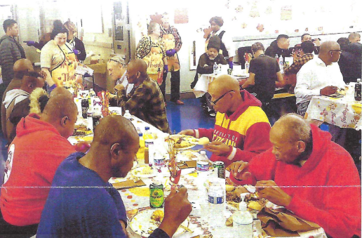 Thank you for your continued support to  
provide meals, shelter, and other vital services for people in desperate  
need. **-- Joe Mettimano, President & CEO, Central Union Mission,  
Washington, D.C.**

* **August**— **Sprinkling seeds:**
  + ***"Thank you NAAV, Inc.*** *for your continued support in providing assistance  
    with housing for my family residing in Gulf Port, Mississippi. We have  
    been homeless since October 2021 to present."* ***Craig and Cynthia  
    Veterans, Ocean Springs, MS***
  + ***"Thank you NAAV, Inc.*** *taken my call to your organization when I call  
    with thoughts of suicide this week. The VA and NAAV, Inc. came to my  
    rescue immediately sending an Arizona Emergency Team to provide the  
    medical attention I needed. Again, thank you."* ***-- Christopher K. Veteran  
    of Arizona City, AZ***
  + ***"Thank you NAAV, Inc.*** *for providing your resources and referrals help  
    with my hospital bills. Your support is greatly appreciated."* ***-- S.  
    Roberts, Army National Guard, Louisiana***
  + ***"I want to thank the National Association of American Veterans, Inc.  
    (NAAV)*** *for paying my utilities bills over $570.00 paid in August 2024. I  
    made many calls before reached your organization and my lights and water  
    were turned back on within a few hours after I called NAAV, Inc. for  
    emergency assistance. I am a senior without family support and your help  
    is greatly appreciated. Thank you again."* ***--  
    W. Davis, Disabled Veteran, Herndon, Virginia***
  + ***"Thank you NAAV, Inc.*** *for getting the Bank to give me credit for overdue  
    mortgage payment a total of 14, 461,43 or 5 months including late fees."  
    Thank you for your support and professional assistance for getting them  
    to grant me mercy and grace from the Lord God." I am truly blessed!"* ***--  
    Thomasina, Disabled Veteran, South Carolina***
* **September to Remember— Let the sunshine through—YOU:**
  + *I would like to thank Constance Burns for saving our home. She is  
    very knowledgeable about the importance of us keeping our home. As well  
    as our son. We are eternally grateful and blessed for her support and  
    efforts. My husband is a veteran who served his country proudly. We hope that  
    Ms. Burns efforts continue to help more families like ours.*

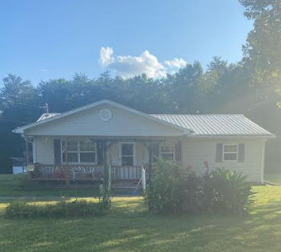  
  
*Thank you from the Nottingham Family of Jamestown, Tn. Jeff, Laura and  
Gabriel*

* + *"Greetings,  
    I am extremely grateful for Constance A. Burns, President and CEO,  
    NAAV, Inc. expertise in helping to obtain information about my deceased  
    husband’s headstone and receiving certified honor certificates from our  
    current President Joe Biden. I appreciate her compassion, thoughtfulness, and kindness. May God bless her for the love she shows to those who are in bereavement."* ***-- Lillie P. Lindsey, Daughter, of Louis Lindsey, Jr., SGT MAJ U.S.  
    Army, Mississippi***

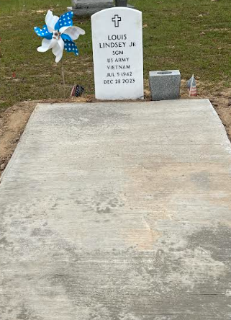

* **The Soul’s Soil of Gratitude:**

[2]What are little sunflower made of:

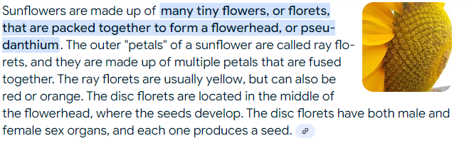*An {AI} concept:

*“NAAV, Inc. President and CEO helped Laura Nottingham, and her disabled  
veteran spouse make settlement arrangement with the Matt Daugherty, Vice  
President and Special Assists Manager at Smart Bank to keep their home  
from foreclosure this month. NAAV, Inc. paid $2,281.79 on September  
16, 2024.”*

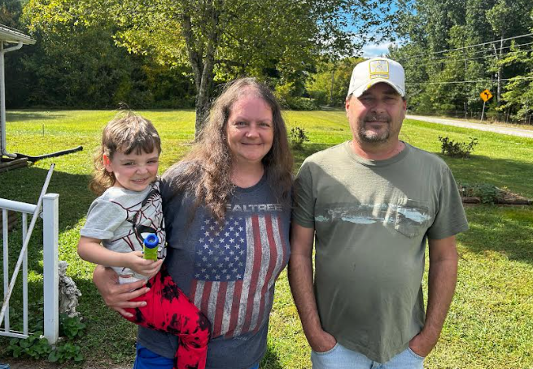

*Thanks to Constance A. Burns, President and CEO of NAAV, Inc. for  
helping me from being homeless and preventing foreclosure of our home  
this month. We thank God for NAAV, Inc. and its supporters nationwide.”  
--* ***Jeff Nottingham, U.S. Army, Gulf War Veteran, Spouse Laura Nottingham  
and Family, Jamestown, Tennessee***

…All together as one: you are our hand full of sunflower seeds… Planting your seed produces the evidence of sowing and reaping ~ Thank you!

*"Thank you, Constance Burns, for supporting the Women Veterans United  
Committee, Inc. and thank you for the literature and financial  
contribution you sent me to read for encouragement, comfort and hope.  
Your support is greatly appreciated." Thank you.  
--* ***Dr. JoAnn Fisher, President and CEO, Women Veterans United Committee,  
Oxen Hill, Maryland***

* **End of Summer Harvest: Testimonial Poem --**

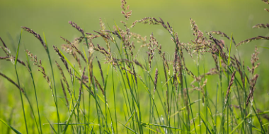[3] **Feel the breeze:**

“*I can feel the breeze as the warm wind blows dandelion particles flying past my nose. Butterflies fluttering here and there; children skipping and laughing without a care. It is summer that breathes life into every source, you are the breeze we need to partner with NAAV, of course. Like nature is to earth, you are the source helping direct our course to fulfilling the pleas for assistance we receive. Thank you for being a warm gentle breeze this summer—for without you we could not succeed. American veterans and their family members are happy and pleased by the donations they retrieve through your generous offering, prayers, and volunteer time—So, we genuinely thank you and ask that you continue to share and give as you please.”* Anonymous

**Third Quarter Sunset** ~

NAAV received over # calls for emergency assistance in July, August, and September. Your generous monthly financial support is most needed to continue NAAV Community Outreach to those who served and are serving in the U.S. Armed Forces with emergency assistance and words of encouragement 24/7.  To donate visit [www.naavets.org](http://www.naavets.org/).

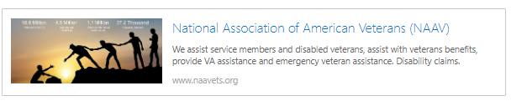

Thank you for what could have been a summer draught, but instead was completed so well by the rain of faith and consistent breeze of service. In out next and final quarter of 2024, we will close out with a fall in transition and winter highlights endeavoring to “leaf” no one behind.

Kindest regards,

Constance A. Burns

Founder, President, and CEO

NAAV, Inc.,

Washington, DC

**\**Sunflower: The Eye of Sunshine -3rd Quarter Newsletter***

1. Sunflowers: <https://www.dreamstime.com/sunflower-field-sunset-nature-landscape-prints-posters-wall-art-generative-ai-vibrant-bathed-warm-glow-image336018064>; 9/28/2024.
2. <https://www.dreamstime.com/realistic-sunflower-bouquet-sunflower-flowers-seasonal-sales-realistic-sunflower-bouquet-sunflower-flowers-seasonal-sales-image216248558> , 9/28/2024
3. <https://www.dreamstime.com/stock-photo-wild-grasses-blowing-breeze-grass-seeds-thin-stalks-gentle-grand-teton-national-park-image74060601>; pulled 9/30/2022.