Note from the Editor: “The Sum of All Seasons”
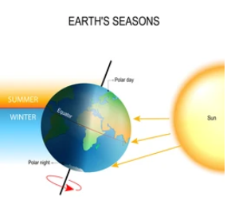
https://www.shutterstock.com/image-vector/tilt-earths-axis-northern-southern-hemispheres-658162897; pulled 09.30.23

Tilted - Energy draws you, gravity pulls and holds it all together

…Four Seasons of Change: Our tilt towards the Sun. Welcome to NAAV’s 3rd Quarter News- letter. Orbit or axes… Jesus says, “if I be lifted up, I will draw all men (mankind) unto Me” John 12:32 (KJV). Just like the earth, throughout its 365 days of rotation, it is drawn or tilted towards the sun be natural processes. When the earth tilts towards the sun we experience warmer days felt during the spring and summer. Yet when the earth is tilted or drawn away from the sun, we experience cooler or cold days like during the fall and winter. We are all considered God’s children. While some choose to accept the Son of God others refuse. Some draw closer, learning and experiencing the warmth and acceptance of God’s love, while other’s turn away and deny His existence. But that doesn’t change the facts nor the fact that He exist… That God is the Force and Source of our nature and natural existence. . The sun and the earth, the moon and the stars are ordered. They change and create phenomenal processes as the world turns. We see it, we know it, and we live it. The earth doesn’t have a choice on whether or not it well tilt towards or away from the sun during any given season like you and I do towards the Son of Man. So then, as the Lord God is lifted up, He will draw and we will receive the ray of light given in the mist of our season of life. To you, thank you for joining us now for [your] seasons… Of change. Oh “tilt” and See…

Content: Editor’s Message: The Sum of All Seasons

This Quarter’s Feature ♦ NAAV Scoop ♦ Moments of Meditation and Scripture ♦
Our Seasons of Change [BE]come a Sponsor A Taste of a Testimony
Veteran news:What’s Happening Veteran Highlights CFC and Closing (Kindness & Change)
-Page: 2-7 -Page: 8-9 - Page: 9-11
Season Facts: https://www.weather.gov/dvn/Climate_Astronomical_Seasons

The Seasons
We all know that the Earth makes a complete revolution around the sun once every 365 days, following an orbit that is elliptical in shape. This means that the distance between the Earth and Sun, which is 93 million miles on average, varies throughout the year. During the first week in January, the Earth is about 1.6 million miles closer to the sun. This is referred to as the perihelion. The aphelion, or the point at which the Earth is about 1.6 million miles farther away from the sun, occurs during the first week in July. This fact may sound counter to what we know about seasons in the Northern Hemisphere, but actually the difference is not significant in terms of climate and is NOT the reason why we have seasons. Seasons are caused by the fact that the Earth is tilted on its axis by 23.5°. The tilt's orientation with respect to space does not change during the year; thus, the Northern Hemisphere is tilted toward the sun in June and away from the sun in December, as illustrated in the graphic below.
* Courtesy: NASA

The Equinoxes (Vernal & Autumnal)
There are only two times of the year when the Earth's axis is tilted neither toward nor away from the sun, resulting in a "nearly" equal amount of daylight and darkness at all latitudes. These events are referred to as Equinoxes. The word equinox is derived from two Latin words - aequus (equal) and nox (night). At the equator, the sun is directly overhead at noon on these two equinoxes. The "nearly" equal hours of day and night is due to refraction of sunlight or a bending of the light's rays that causes the sun to appear above the horizon when the actual position of the sun is below the horizon. Additionally, the days become a little longer at the higher latitudes (those at a distance from the equator) because it takes the sun longer to rise and set. Therefore, on the equinox and for several days before and after the equinox, the length of day will range from about 12 hours and six and one-half minutes at the equator, to 12 hours and 8 minutes at 30 degrees latitude, to 12 hours and 16 minutes at 60 degrees latitude.

The Solstices (Summer & Winter)
The summer solstice occurs at the moment the earth's tilt toward from the sun is at a maximum. Therefore, on the day of the summer solstice, the sun appears at its highest elevation with a noontime position that changes very little for several days before and after the summer solstice. The summer solstice occurs when the sun is directly over the Tropic of Cancer, which is located at 23.5° latitude North, and runs through Mexico, the Bahamas, Egypt, Saudi Arabia, India, and southern China. For every place north of the Tropic of Cancer, the sun is at its highest point in the sky and this is the longest day of the year.
The winter solstice marks the shortest day and longest night of the year. In the Northern Hemisphere, it occurs when the sun is directly over the Tropic of Capricorn, which is located at 23.5° south of the equator and runs through Australia, Chile, southern Brazil, and northern South Africa.
Now, picture your stance in this world and how you might tilt as the seasons change? How is God, through His Son drawing you? Jesus also said, “He promised to never leave nor forsake us. Based on the preceding article, the “sun” never truly leaves the earth instead, the earth changes based on where it is positioned in relation to the “sun.”

Because there is so much emphasis on mental health and our state of wellbeing, next quarter’s newsletter will focus on reviewing “seasonal changes and its effect on our lives.” On any given day, throughout the 365 days of the year, we experience four seasons of change… Have you ever noticed? Stay tuned for December’s end-of-year 2023 newsletter edition.

Veteran News: What’s Happening –

The Department of Veterans Affairs (VA) has a Veterans Transportation
Service and, Beneficiary Travel program and a Highly Rural
Transportation Grants program to assist veterans traveling to and from Department of Veterans Affairs (VA) health care facilities and
authorized non-VA health care appointments. However, none of these
transportation services address the needs of veterans during a medical
emergency or provide reimbursement for ambulance services when seeking immediate medical attention for a condition that is reasonably expected to be hazardous to life and health.
H.R. 1774, the VA Emergency Transportation Act, would reimburse
veterans for the cost of emergency medical transportation to a federal
facility by redefining emergency treatment as “services”—to include emergency treatment and emergency transportation. The bill would codify emergency transportation to mean transportation of a veteran by ambulance or air ambulance by a non-Department provider or a facility for emergency treatment; or from a non-Department facility where such veteran received emergency treatment to a Department or other federal facility. This legislation would expand access and eligibility to much needed service for reimbursement of emergency care related to ambulance transportation.
DAV supports H.R. 1774, in accordance with DAV Resolution No. 148,
which supports legislation to simplify the eligibility for urgent and emergency care services paid for by the VA and urges the Department to provide a more liberal and consistent interpretation of the law
governing payment for urgent and emergency care and reimbursement to
veterans who have received emergency care at non-VA facilities.
We are call on all DAV members and supporters to contact their representatives and urge them to co-sponsor and support H.R. 1774, the
VA Emergency Transportation Act.

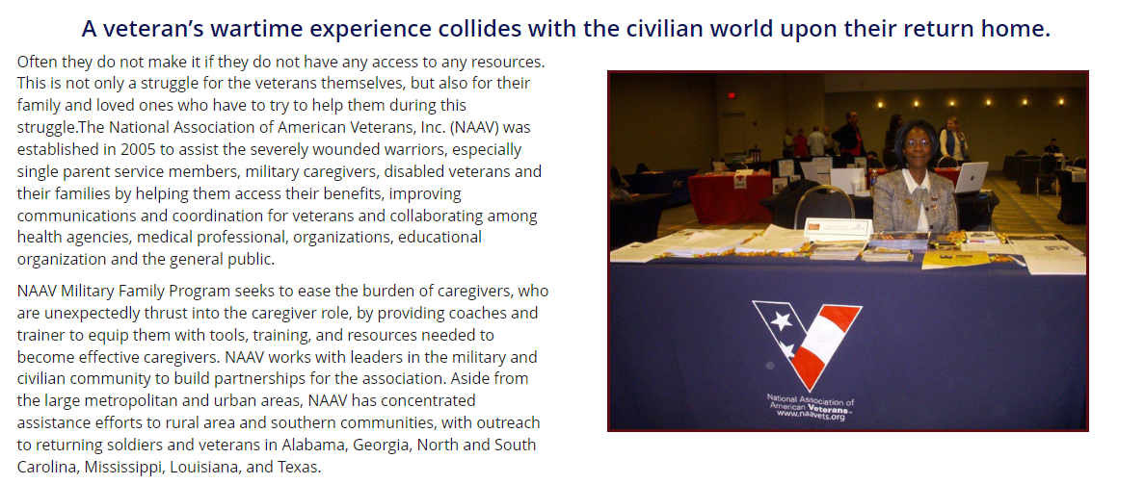
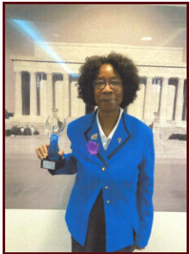 Congratulations: Constance A. Burns, Founder, President, Chief of Operations of the National Association of American Veterans, Inc. (NAAV) is recognized as a Marquis Who’s Who Humanitarian in July 2023. Visit the official Marquis Humanitarians website at Constance A. Burns https://worldwidehumanitarian.com/2023/07/13/constance-burns/

Congratulations to a Force of Nature: At 103 years old, (Retired) Major Nancy Leftenant-Colon celebrated her 3rd centenarian year of favor on Sept. 29, 2023. Nancy Leftenant-Colon, was the first African American nurse to serve in the reserve or active-duty Army/Air Nurse Corps, the precursor of the Air Force. She joined the Army Reserves in 1945, unable to get into the regular Army Nurse Corps because she was an African American. For more about Ret. Maj. Leftenant-Colon, visit www.naavets.org click on Veteran Stories for more information.

*https://www.nami.org/Get-Involved/Awareness-Events/Suicide-Prevention-Month

September was National Suicide Prevention Month. According to reports published by VA Mental Health.gov, Veterans committed suicide at a rate of approx. “16.8 per day”, in other words, over 500 veteran suicide deaths a month. That’s too much, that’s too many. If you know someone who is contemplating suicide, please know that you are not alone in the struggle. There are people and organizations to help and walk along-side you through whatever crisis. Go to https://www.mentalhealth.va.gov/docs/data-sheets/2022/2022-National-Veteran-Suicide-Prevention-Annual-Report-FINAL-508.pdf for more facts on this topic.

- If you or someone you know is experiencing a mental health crisis, call or text 988 immediately.
- If you are uncomfortable talking on the phone, you can chat the Suicide & Crisis Lifeline at 988lifeline.org.
- You can also text NAMI to 741-741 to be connected to a free, trained crisis counselor on the Crisis Text Line.

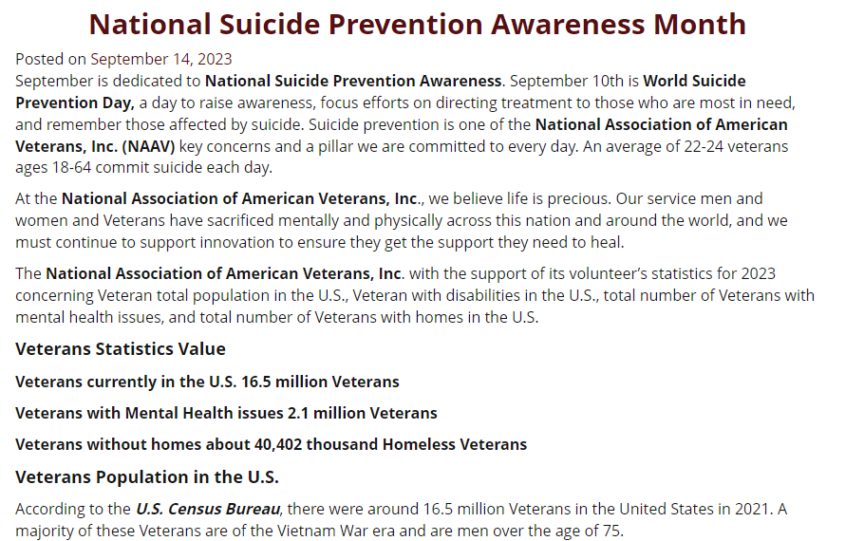
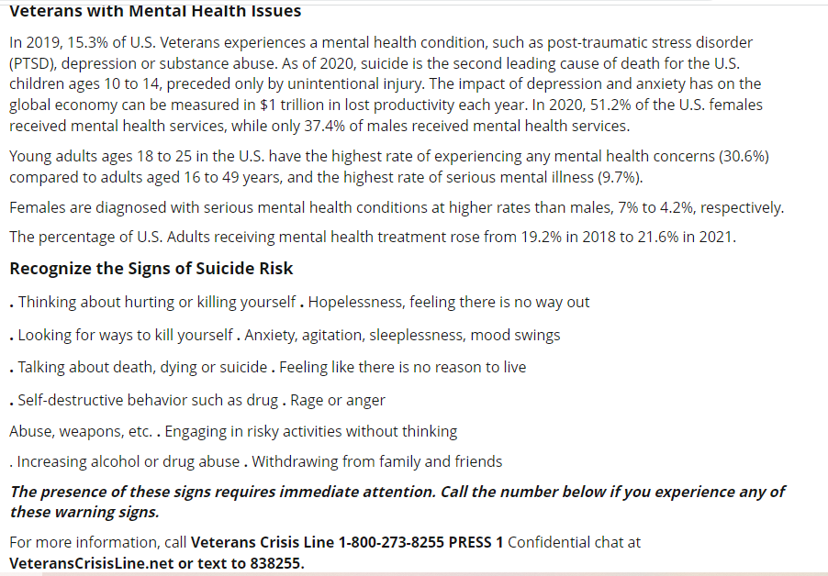

*Please take the first step, if you or someone you know is in a crisis. Text: 988-1.
… And this we know~ Hope is alive. Although the road might not be easy, there is a path leading to the light of life. Proverbs 3:5-6 reads – “Trust in the Lord with all your heart and lean not to your own understanding, in all your ways acknowledge Him, and He will make your path straight” (KJV). If you need more support or understanding in this area please contact NAAV at info@naavets.org, or go to the NAAV website (www.naavets.org) under the “Spiritual Wellness Tab” for more information.

Despite the post Coronavirus crisis of 2021, NAAV’s CEO and President, Constance Burns and her supporting soldiers are on mission and determined to stay on task for our American Veterans and their family members.

The NAAV 3rd Quarter Veteran News Shout Out --
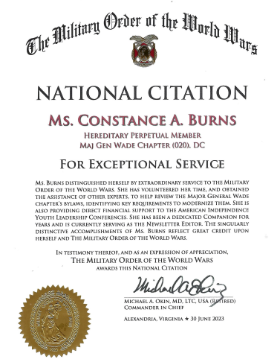 National Citation award to Constance A. Burns, President and CEO of NAAV and Hereditary Perpetual Member of MAJ Gen Wade Chapter (020), DC for Exceptional Service awarded 30 June 2023, by Michael A. Okin, MD, LOTC, USA (Retired) Commander in Chief, Alexandria, Virginia.

- Become a NAAV Sponsor or Partner
- Show your support by using this link to give NAAV your best rating:
https://g.page/r/CT-qGmv5up2WEB0/review
The NAAV Scoop for Veterans: Become a Sponsor
https://www.shutterstock.com/image-vector/cartoon-bee-icon-set-flying-on-1824044459

Become a NAAV Sponsor or Partner in support of our nation’s Service men and women and Veterans and their caregivers and family members most in need of emergency aid with a yearly donation of $10,000 or more. You will get exclusive NAAV communications so you can keep track of the progress we make together. You will also get with a gift of $20,000 or more NAAV Annual Report. Monthly partners can receive free career coaching and not have to navigate life’s challenges on your own, and our Career Coach is in your corner to help with resume building, job search and interviewing techniques. Take ownership of your career! For more information, call (202) 465-3296 or email: info@naavets.org. To donate now visit www.naavets.org click on DONATE TODAY. Thank you.
A few quick important resource facts:
- Between July-Sept. 2023, NAAV has received about 1,290,000 visitors to its website.
- The emails and telephone calls include providing financial, referrals and resources to help with veterans claims and benefits, emergency assistance programs to help veterans such as rental, mortgage, utilities, food, transportation, homelessness, housing, legal assistance, caregiver assistance, and home improvement to name a few.

Update: The National Association of American Veterans, Inc. (NAAV) is now on Goggle First Page and is receiving more new visitors to its website at www.naavets.org. In addition, we also have support from our sponsors at Thrivent Financial, Bob's Discount Furniture Store Foundation, Fort Myer Thrift Store, TechAnax of Virginia, as well as NAAV valued Supporters and Partners represented nationwide over the past twenty years.
NAAV would like to thank all of our supporters, sponsors, and partners who fully appreciate how important it is to help our nation's military families. Your support has allowed us to maintain a rhythm of much-needed help for those who have done so much for all of us.
We know you understand that military families are accustomed to adapting to the unexpected, whether dealing with short-notice deployment's, moving to a new posting, transiting to civilian life, homelessness, or adjusting to a disabling injury yet despite their resiliency, many military families are facing significant financial struggles at home that have the potential of derailing their hopes for a brighter tomorrow.
Just as we trust in the universe to keep us affixed to earth throughout all seasons of change, let us also learn to trust, by faith, in the Lord who created the heavens and earth…

Moments of Meditation & Prayer
Posted on August 1, 2023
“Faith is the substance of things hoped for the evidence of things not seen” (Hebrews 11:1). Faith is needed to accomplish God’s perfect and complete will for your purpose in life. Our Lord Jesus Christ said that a small amount of faith can move mountains: “For truly I tell you, if you have faith the size of a mustard seed, you can say to this mountain (problem), “move from here to there,’ and it will move.’” Trusting in the Lord God is the beginning of faith for He is our faith. Being in the presence of God will guide your way toward moving the mountains in your way. To have faith is to relinquish trust in oneself and to put that trust in another.
To increase your faith, you must pray and trust in the Lord God for a divine answer that may be large or small and that the answer be His perfect and complete will for you. Spent time daily thanking God for His perfect will in your life. “Giving thanks always for all things unto God and the Father in the name of our Lord Jesus Christ” (Ephesians 5:20).
Scriptural Verses:
“Trust in the LORD, and do good, dwell in the land, and feed on His faithfulness. Delight yourself also in the LORD, and He shall give you the desires of your heart.” (Psalm 37:3-4)
“Trust in the LORD with all your heart and lean not on your own understanding; in all your ways acknowledge His, and He shall direct your paths.” (Proverbs 3:5-6)
“Jesus said to them, “My food is to do the will of Him who sent Me, and to finish His work.” (John 4:34)
Prayer:
Heavenly Father, help us to be joyful in hope, patient in affection, and faithful in prayer. Lord, fill us with Your joy, peace, and hope as we trust in You by the power of the Holy Spirit (Romans 12:12,15:13). Lord our God, You are our refuge and strength, and our help in trouble (Psalm 46:2). Lord, please keep us in your acceptable and perfect will now and forever. In Jesus’ name. Amen.
Scripture Verses for Mediation: (NKJV)…
We may be coming to an end of the “bee” season, but not to “BE”ing kind to one another…
Your continued donations during our 2023 End-of-Year NAAV Fundraising Campaign will go a long way to provide military families with the support they have earned and urgently need at the present time. To donate today visit www.naavets.org click on DONATE. If you are a federal
employee or retiree, please visit www.GIVECFC.ORG to donate. NAAV designated CFC number is 85065 "Caring About Those Who Served." Thank
you.
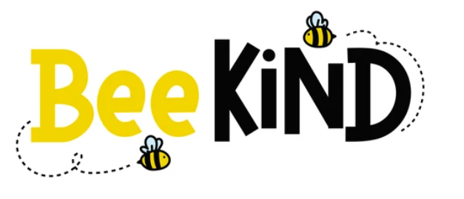
https://www.shutterstock.com/image-vector/bee-kind-funny-inspirational-card-flying-1811623870

NAAV’s theme for this year 2023 – Remember to [Be] Kind
Buzz like a bee into your new season of change

Announcement Reminder: While you’re buzzing like “bee” at the end of this summer, please do not forget the 2023 CFC Campaign, which runs from September 1, 2023, thru January 15, 2024. “GIVE HAPPY”
NAAV’s CFC number is 85065 "Caring About Those Who Served."
NAAV has additional testimonies to share on the website at www.naavets.org, if you would like to read more. We are also open to hearing from you, our fellow followers, readers, contributors. Volunteers, and prayer warriors on any way NAAV has touched your life or the life of someone you know.
If you have a special gift or talent that you believe could be of benefit to NAAV and our efforts to serve Veterans and their family members, please reach out to NAAV, CEO and President Constance A. Burns at info@naavets.org. Your added support, in the smallest of ways, could mean a magnitude of giftedness to the many men and women in need. Thank you in advance for your thoughts, prayers, and wonderful action and acts of kindness… Keep our theme in your heart even as the buzzing of the bees around you begin to fade, and the wide eye of beautiful sunflowers begin to shut– [BE] Kind.
Over this past three quarters, as you continue to follow NAAV, share in our successes, and read our stories, we hope will continue to support our mission or decide to become one of the gracious cheerful givers who allows the kindness of your day guide you to those who have given so much, we welcome and thank you for your generosity.
Testimonial note~ “Just wanted to let Veterans know that the National Association of American Veterans, Inc., is a wonderful, caring and supportive agency. They listen without judgement and treat you as family. Ms. Constance Burns the CEO, President and Founder is a fantastic person, who goes out of her way to help veterans and their family. She helped our family with our situation in a timely and professional manner. Ms. Constance, we thank you and we are so appreciative for your help. I encourage all Veterans, organizations and individuals to donate to this wonderful non-profit organization, they are full of resources to help your family get what they need.” God Bless, --The Urban Family, Birmingham, AL
https://www.shutterstock.com/image-vector/earth-sun-axis-formation-seasons-1475101040.

Fall into this season and embrace the change!
Special thanks to Sherri Jones-Kleiner, NAAV Manager for Quarter Newsletter and Testimonials. Your continued professional assistance is greatly appreciated.

Peaceful autumn of change,

On behalf of NAAV, Inc.
Founder, President and CEO
Constance A. Burns
Washington, D.C.

