“To Be or Not to Bee Kind”
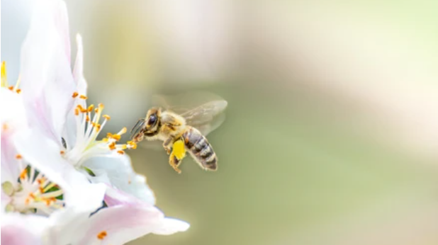
https://www.shutterstock.com/image-photo/flying-honey-bee-collecting-pollen-apple-1763459165, pulled 6.27.2023

Note from the Editor

During the 1st Quarter Newsletter, NAAV spoke about the undercurrent, felt but never seen moving silently below the radar. This 2nd Quarter, we would like to briefly draw your attention to a more visible topic… Kindness and we’d like to compare our goodness to that of a Bee. That’s right, a Bumble Bee. Kindness, if you think about it is an unseen energy that begins within, but shows up as an outward expression. Where does kindness come from, how is it formed and why is it easier for some people to share than others… What is the cost of kindness? Constance Burns, the CEO and President of NAAV has a heart of kindness. She touches lives like a bee pollinating flowers. They are there (people), they are sweet (flowers) and
the need to reach out and touch cannot be ignored. NAAV’s CEO and team of supporters are called to spread their kindness, just as bees are called to pick up and distribute the pollen from flowers and other crops essentially becoming the little engine producing approximately “one-third of human’s food supply.” This literally equates to an effect of survival. In comparison, NAAV’s cadre provides the fuel to support our Veterans and their family members and the small little bee spreads its pollenating abilities as honey so sweet. So, the next time you see a bee, try to be kind and let it be… And, the next time you have an opportunity to support NAAV, try not to hesitate, just do it as an act of kindness. Follow the inward prompt as an outward expression… Spreading the love.
Content: Editor’s Theme: Humble as can Bee

The Scoop of the Day ♦ NAAV Outreach ♦ Moments of Meditation and Scripture
NAAV’s latest updates [BE]come a sponsor Contributor: Constance A. Burns
Veteran news: What Buzzing You’re invited to join “Oh Praise the Lord…” - Pages: 7-8
-Page: 3-5 -Page: 6 *Finally: [Be] Kind… - Page: 9

Called to Be Kind – A shared message
An article by Dr. Tony Evans, Pastor of Urban Alternative church in Dallas, Texas wrote and article, which stated “kindness is love on display.” I’d like to share with you what Dr. Evans shared through his article as it relates to NAAV’s 2nd Quarter Newsletter theme: “We all know that we’re supposed to be kind to others, and we genuinely want to [BE]. But it’s easy to get off track: when we’re stuck in traffic, feel like we were wronged, face loud, contradicting viewpoints, or are even criticized for our own beliefs. How does the Bible tell us to respond to our adversaries? How did Jesus treat those who criticized Him? 1 Peter 2:23, says: “…while Jesus was being reviled, He did not revile in return; while suffering, He uttered no threats, but kept entrusting Himself to Him who judges righteously.” Now, I must confess… I don’t like bees. Why? Because I’m allergic to them, and when I see a bee, I automatically either run away or try to smack it down by any means necessary, not concerned with the result, if you know what I mean. But, since learning more about bees, I realize this behavior of mine is wrong… Unlike the example of Jesus, what I do or did is not an act of humility, it’s not being nice nor kind. Dr. Evans continues:
…”None of us are perfect, but we are called to become more and more like the Perfect One. That means we respond with respect, we respond with love, we respond with peace, and we respond with the hope of unity in mind. If we as Christians started responding with this type of kindness in every situation, to every person, everywhere we go, we would stand out. People wouldn’t be able to ignore the difference we’d be making in our families, our communities and ultimately in our in our world. And when we do that, we become the salt and light”… of the world (Matthew 5:13-16). Kindness, in its basic definition, is described as: “the quality of being friendly, generous, and considerate;” In other words, kinds is not selfish, it’s not rude, it shows mercy; it helps, it reaches, it gives, it shares… What the Word of God says about kindness? Blessed in the one who is kind to the needy and the poor, the orphan and the widow, express kindness to your neighbor, be a lender and expect nothing in return. On behalf of NAAV, it is my hope that as we engage in summer-time play we all seek ways to be tender hearted, show kindness towards one another, and also don’t forget about ourselves! How about this--a quick smile in the mirror could [BE] a simple, effortless yet promising start and reminder…

What’s Buzzing – Veteran Resources 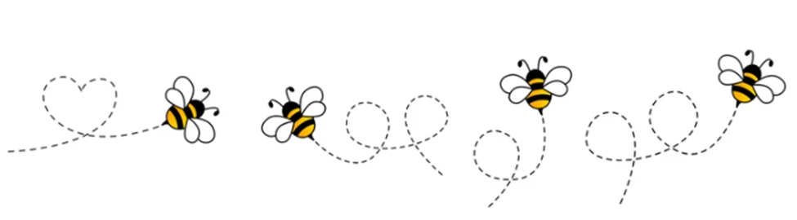https://www.shutterstock.com/image-vector/cartoon-bee-icon-set-flying-on-1824044459

The NAAV Scoop for Veterans
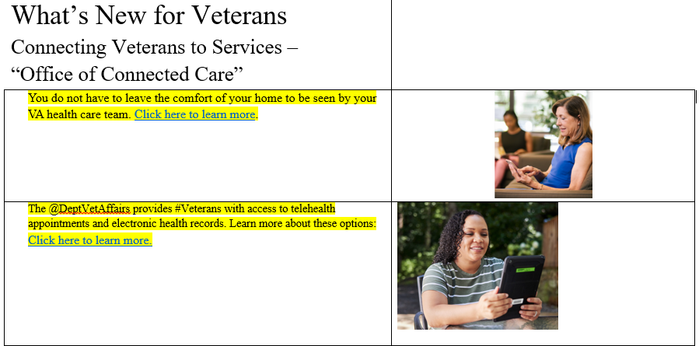

- The Valley Community Services Board, Mental Health America of August and Embrace Community Center will sponsor the “Community Veteran Feed and Connect Event” scheduled for September 27, 2023, from 10 a.m. to 2 p.m. EST. For more information, connect Leah Hale at (540) 280-2252 or email: lhale@vcsb.org. Thank you.
- There are about 18 million veterans living in the United States today. Chances are, there are more than a few in your community. Many veterans could benefit from help from their neighbors with various life circumstances and decisions, no matter the age. And you have the opportunity to contribute to the betterment of their lives! Today, the National Association of American Veterans shares some practical insight into how you can help veterans in your community lead a higher quality of life.

Help Them Earn a Degree
- Veterans have many advantages when it comes to going back to school. But that doesn’t mean some won’t experience challenges connecting with the right university. Research accredited online colleges and help a veteran in your community enroll in a degree program that will provide them with the flexibility they need to study at their own pace, work full-time, and manage all their responsibilities. Today, you can find a degree program in almost any industry. For instance, you could take up a teacher certification to pursue a career in teaching!

Help Them to Secure Housing
- It is common for veterans to experience homelessness, especially if they do not have a family to return to. If you’re familiar with rentals in the area, help them to find something within their budget. Or if they’re interested in something more permanent, guide them towards VA loans that can allow them to purchase a home with lessened fees and no down payment.

Show Them How to Stay in Touch
- Many veterans withdraw from society and fail to keep up with loved ones, not because they want to but because they simply don’t know how to stay connected. Technology has made it easier than ever to interact with friends and family from afar.
- Show a veteran in your community how to use a video chat app (e.g., FaceTime, Google Hangouts, Skype, etc.). That way, they can have meaningful conversations and see the people they talk to.
There are many more ways to help. Visit https://www.naavets.org/meaningful-ways-to-help-your-veteran-neighbors-2/

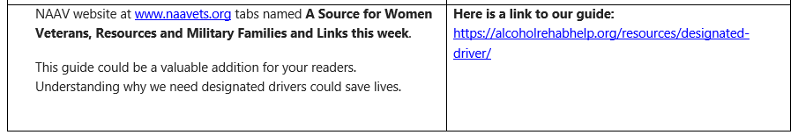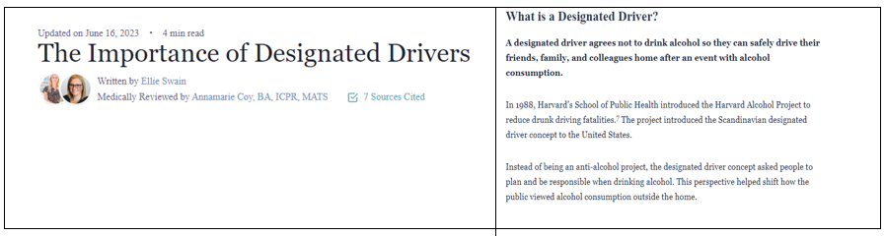
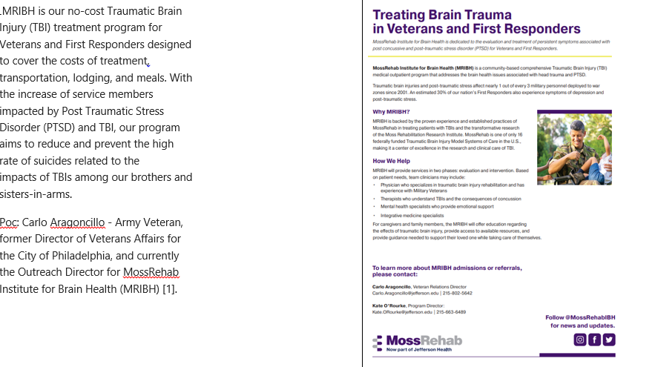
Topic 1 - Click here to learn more
Topic 2 - Click here to learn more.
Topic 3 - https://alcoholrehabhelp.org/resources/designated-driver/

For more information on Veteran Resources, please go to: NAAV website at www.naavets.org for more details and postings.

The NAAV 2nd Quarter Veteran News Shout Out --
Become a NAAV Sponsor or Partner
Become a NAAV Sponsor or Partner in support of our nation’s Service men and women and Veterans and their caregivers and family members most in need of emergency aid with a yearly donation of $10,000 or more. You will get exclusive NAAV communications so you can keep track of the progress we make together. You will also get with a gift of $20,000 or more NAAV Annual Report. Monthly partners can receive free career coaching and not have to navigate life’s challenges on your own, and our Career Coach is in your corner to help with resume building, job search and interviewing techniques. Take ownership of your career! For more information, call (202) 465-3296 or email: info@naavets.org. To donate now visit www.naavets.org click on DONATE TODAY. Thank you.
A few quick important resource facts:
- Between 7/3/2022 to 7/3-2023 NAAV has received about 537,000 visitors to its website

- Over the past month approximately 131,000

- Over the past week approximately 615

- NAAV now have exposure on Goggle’s First Page for three months.

- NAAV received over 100 calls for the 2nd Quarter of 2023 with over
70% being emergency assistance calls and the remainder for VA benefits
and claims assistance.

- Since early January until June 2023, NAAV have received six (6) $500.00
grants from The Bob's Discount Furniture Store Foundation in
Connecticut. They were awarded to recipients residing in the District of
Columbia, Maryland, Kentucky and Indiana. NAAV received Thanks from all
grantees for gifts during the First and Second Quarter of this year.
- Did You Know: Veteran Statistics (Posted April 2023)
Veterans currently in the U.S. 16.6 Million Veterans
Total Veterans with disabilities in the U.S. 11.9 Million Veterans
Total Veterans with Mental Health issues 2.1 Million Veterans
Total Veterans without homes About 40,401 Thousand Homeless Veterans
Moments of Meditation & Prayer
- Posted July 2022

I WILL PRAISE YOU, O LORD with my whole heart; I will tell of all Your marvelous works.
I will be glad and rejoice in You; I will sing praise to Your name, O Most High.
The LORD also will be a refuge for the oppressed, A refuge in times of trouble. And those who know Your name will put their trust in You. For You, LORD, have not forsaken those who seek You. Sing praises to the LORD, who dwells in Zion! Declare His deeds among the people.
When He avenges blood, He remembers them; He does not forget the cry of the humble. Have mercy on me, O LORD! Consider my trouble from those who hate me,
You who lift me up from the gates of death, That I may tell of all Your praise In the Gates of the daughter of Zion. I will rejoice in Your salvation. (Psalm 9: 1-2; 9-14) Scripture Verses for Mediation: (NKJV)…

This summer season is no different from any of the other season’s past. We have faced natural disasters, horrific accidents, plans, trains, and automobile crashes, gun violence, racial injustice, and political turmoil as well as wars and rumors of wars. Yet, through it all we must learn to trust in Jesus; we must learn to trust and lean on God.

Yes, good can be found in most everyone, it’s all a matter of what we choose to do that is good, gracious, and kind… [Be] the change; [Be] the difference maker… “Let your light shine so that men may see your good works and glorify your Father who is in heaven” (Matthew 5:16), as He has called us into [Be]ing…

Here’s an attitude to maintain found in Matthew 5:2-11; it’s better known as the “Sermon on the Mount,” 2) when upon the mountain Jesus opened His mouth and speaking to the crowd and His disciples, He said,
³ “Blessed are the poor in spirit, for theirs is the kingdom of heaven.
⁴ “Blessed are those who mourn, for they shall be comforted.
⁵ “Blessed are the meek, for they shall inherit the earth.
⁶ “Blessed are those who hunger and thirst for righteousness, for they shall be satisfied.
⁷ “Blessed are the merciful, for they shall receive mercy.
⁸ “Blessed are the pure in heart, for they shall see God.
⁹ “Blessed are the peacemakers, for they shall be called sons^{[a]} of God.
¹⁰ “Blessed are those who are persecuted for righteousness' sake, for theirs is the kingdom of heaven.
¹¹ “Blessed are you when others revile you and persecute you and utter all kinds of evil against you falsely on my account. ¹² Rejoice and be glad, for your reward is great in heaven, for so they persecuted the prophets who were before you.” (ESV - Bible Gateway.com)

…The lesson Jesus taught was, in a sense, a representation of the “Be[e]’s Attitude” –

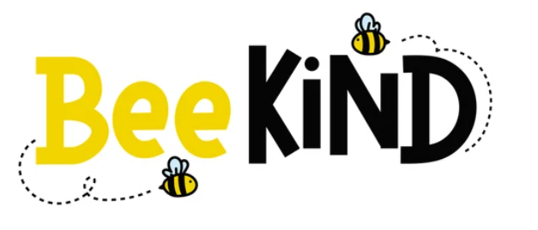
https://www.shutterstock.com/image-vector/bee-kind-funny-inspirational-card-flying-1811623870

[Be] Kind
Buzz like a bee into your new season

Upcoming Announcement:
While you’re busy as a “bee” don’t forget the upcoming 2023 CFC Campaign beginning September – January 2024. This year’s theme is: “GIVE HAPPY.”
NAAV’s CFC number is 85065 "Caring About Those Who Served."

NAAV has additional testimonies to share on the website at www.naavets.org, if you care to read more. We are also open to hearing from you, our fellow followers, readers, contributors. Volunteers, and prayer warriors on any way NAAV has touched your life or the life of someone you know.
If you have special gift or talent that you believe could be of benefit to NAAV and our efforts to serve Veterans and their family members, please reach out to NAAV, Constance A. Burns, President and CEO at info@naavets.org. Your added support, in the smallest of ways, could mean a magnitude of giftedness to the many men and women in need. Thank you in advance for thoughts, prayers, and wonderful action and acts of kindness… Keep our summer theme in your heart as you see the bees buzzing around or as you walk past a sunflower or all the many colorful wildflowers – [BE] Kind.
Over this past 2nd quarter. Here is one we hope all the contributors, prayer warriors, volunteers, and sponsors will smile about. As you continue to follow NAAV, share in our successes, and read our stories, we hope will continue to support our mission or decide to become one of the gracious cheerful givers who allows the kindness of your day guide you to those who have given so much. For more testimonies, please see posting on NAAV’s website www.naavets.org.

Summer’s blessings!
On behalf of NAAV, Inc.
Constance A. Burns
President and CEO
Washington, D.C.

