TALENT MANAGEMENT JOB DESCRIPTION
 |  | 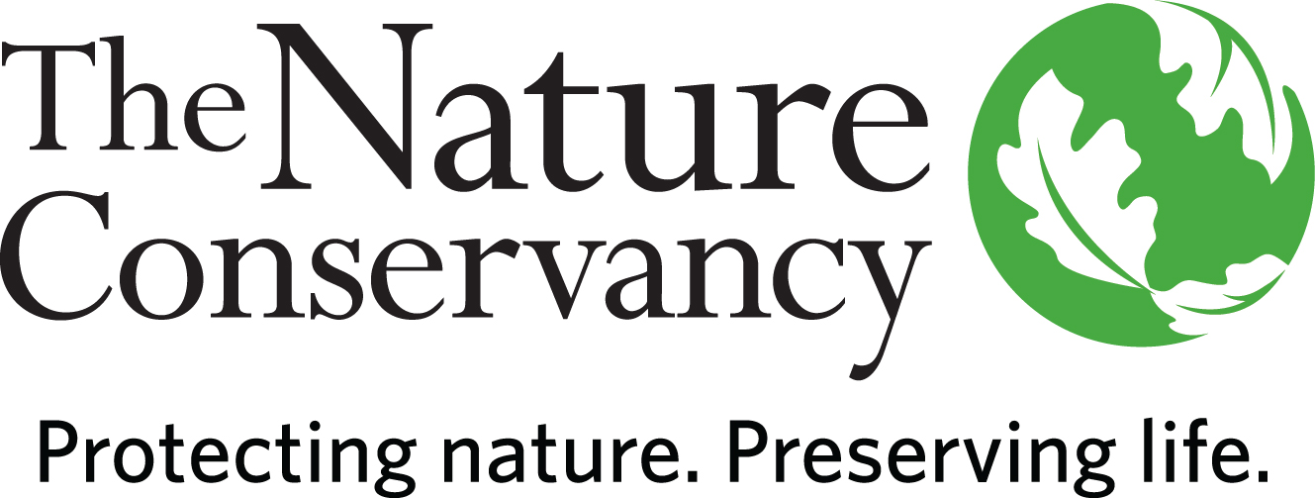
JOB TITLE | Program Director I  Oceans Project Director
JOB FAMILY | Conservation
JOB NUMBER | 250005
SALARY GRADE | 7
STATUS | Salaried
DATE | June 2022

A LITTLE ABOUT US

Founded in 1951, the Nature Conservancy is a global conservation organization dedicated to conserving the lands and waters on which all life depends. Guided by science, we create innovative, on-the-ground solutions to our world's toughest challenges so that nature and people can thrive together. We are tackling climate change, conserving lands, waters and oceans at unprecedented scale, providing food and water sustainably and helping make cities more sustainable. One of our core values is our commitment to diversity. Therefore, we strive for a globally diverse and culturally competent workforce. Working in 72 countries, including all 50 United States, we use a collaborative approach that engages local communities, governments, the private sector, and other partners. To learn more, visit www.nature.org or follow @nature_press on Twitter.
[Add Oceans info here]
YOUR POSITION WITH TNC

Fisheries provide critical resources for billions of people, yet they also present threats to ocean health, causing overfishing, bycatch, and habitat degradation. Improving how fisheries are managed can not only help increase fish populations and ecosystem resilience, but also increase sustainable protein sources and revenues. TNC works at this intersection to improve fisheries sustainability by closing data and capacity gaps that prevent effective management. To ensure fisheries not only provide food and livelihoods but also protect biodiversity, TNC works across California and the Pacific to reduce the time and cost to achieving effective management by leveraging technology to simplify data collection and analysis and engaging communities to boost capacity for active management.
The Oceans Project Director coordinates, manages, and leads projects aimed at scaling improved fisheries management. This position presents an opportunity to work with staff and partners from multiple geographies to advance community-based conservation and small-scale, coastal fisheries management.

ESSENTIAL FUNCTIONS

The Oceans Project Director provides technical and programmatic support to advance the deployment and scaling of FishKit, a set of software tools to advance community-based management of coastal fisheries, and other projects as appropriate. The Oceans Project Director works in close collaboration with TNC colleagues and partners to coordinate, manage, and lead projects across the Pacific. This person will support strategy development to identify new opportunities for deployments and support the development of training programs and partnerships to accelerate new management plans. They will lead tracking and reporting of key metrics across projects and manage project budget(s). This person will support and lead strategic communications, including fundraising and donor stewardship, and coordinate grant management for public and private awards.

RESPONSIBILITIES & SCOPE

- Geographic size and scope is larger than a preserve and smaller than a business unit.
- Programmatic scope may require cross-boundary work and relationships.
- Leads and manages team or project to support and improve conservation efforts.
- Responsible for supporting public and private fundraising, including drafting proposals, reports and other written materials.
- Responsible for supporting financial and budget management for projects
- Solicits, negotiates, and manages contracts or other business transactions
- Develops and delivers communications to widely communicate solutions and best practices
- Builds cooperation from outside parties to accomplish program goals
- May work in variable weather conditions, at remote locations, on difficult and hazardous terrain and under physically demanding circumstances.
- Frequently makes independent decision based on analysis, experience, and context.

MINIMUM QUALIFICATIONS

- BA/BS degree and 5 years’ experience in conservation practice or equivalent combination of education and experience.
- Experience managing complex or multiple projects, including staffing, workloads and finances under deadlines.
- Experience in partnership development with non-profit partners, community groups and/or government agencies
- Experience negotiating.
DESIRED QUALIFICATIONS

- Multi-lingual and multi-cultural or cross-cultural experience appreciated.
- MS/MESM/MBA and equivalent 5-7 years’ experience in conservation practice or related field or equivalent combination of education and experience.
- Demonstrated experience influencing, developing and implementing conservation policy and plans.
- Knowledge of current trends and practices in relevant discipline(s) and regions.
- Knowledge of methods and standards of biodiversity information systems and initiatives or related field.
- Communicating clearly via written, spoken, and graphical means in English and other relevant languages.
- Demonstrated experience in fundraising.
- Politically savvy.

ORGANIZATIONAL COMPETENCIES

Builds Relationships | Builds productive relationships by interacting with others in ways that enhance mutual trust and commitment.
Collaboration & Teamwork | Works collaboratively with stakeholders across levels, geographies, backgrounds, and cultures to improve decisions, strengthen commitment, and be more effective.
Communicates Authentically | Communicates proactively and in a timely manner to share information, persuade, and influence with the appropriate level of detail, tone, and opportunities for feedback.
Develops  Others | Takes ownership to help develop others’ skills, behaviors, and mindsets to help them maximize their workplace contributions.
Drives for  Results | Sets challenging goals and objectives based on a strong sense of purpose and high-performance standards and steadfastly pushes self and others for tangible results, while ensuring work-life balance.
Leverages Difference | Demonstrates commitment to harnessing the power of differences strategically; consistently sees, learns from, and takes strategic action related to difference; and demonstrates the self-awareness and behaviors to work across differences of identity and power respectfully and effectively with all stakeholder. Actively seeks to build and retain a diverse workforce and fosters an equitable inclusive workplace by drawing upon diverse perspectives.
Systems  Leadership | Thinks and acts from a broad perspective with a long-term view and an understanding of 1) the dynamic nature of large-scale challenges and 2) the need for integrating five key practices: skillfully engaging appropriate people; providing a clear process for change; taking a holistic view of situations; focusing on a small number of strategic actions, while learning from and adapting them over time; and being aware of how one’s own thinking or patterns of behavior may be limiting change.

This description is not designed to be a complete list of all duties and responsibilities required for this job.

