Volume 04 22 | Issue 4 | National Association of American Veterans (NAAV), Inc.
October ~ November ~ December 2022
The National Association of American Veterans, Inc. “Fall into Winter”

Issue Date: July, August, September 2022

1) https://as2.ftcdn.net/v2/jpg/02/30/65/15/1000_F_230651505_6xjADRaknv45P69wBcHDS0tRxWUHBU17.jpg

2)https://t4.ftcdn.net/jpg/01/27/06/19/240_F_127061969_8u0CPI98Hc8jCgiNdj4MZJWBV4XehZ3g.jpg
NAAV INC., Newsletter 4th Quarter Year-End |  | In This Issue – Roll with it

NAAV fall into winter
Editor’s notes: We are here in this 4th Quarter issue of 2022, NAAV’s End-of Year closing newsletter to thank you all for sharing with us this year. As we go from fall into our winter season, we ask that you pause and join us in reflecting upon one question: Is this the end or the start of a new beginning?
As always, we have features highlighting care for veterans, fall and winter testimonies, resources, and announcements and more. Your generosity towards year-end giving would be most appreciated and greatly necessary as we move into the winter months. Fall into winter and roll with us as we continue this journey into a new season of comfort, joy, and giving.
Tis the season of Giving

The 2022 Combined Federal Campaign (CFC) at Fort Belvoir, Virginia
On November 10, 2022, the National Association of American Veterans, Inc. (NAAV) teamed up with DAV and Combined Federal Campaign (CFC) at Fort Belvoir to provide multi-services for Military, Veterans, family members, and their caregivers. In attendance was Ira Smallwood, DOD Loan Executive; Cheryl Clark, Campaign Manager; James Woosley, DAV President; Joseph Johnson, Chief of Staff; Dr. Mary Roach, U.S. Army, (Ret) NAAV Board of Directors, Veteran, Health Advocated and her husband, a U.S. Army (Ret) Veteran; and Roy L. Croom, U.S. Army (Ret) NAAV Board of Directors and Veteran.
This year’s CFC Theme is “You Can Be the Face of Change” NAAV designated number is #85065 “Caring About Those Who Served.” To donate today in support of our nation’s Service Members, Veterans and their caregivers and family members, please visit www.GIVECFC.ORG or www.naavets.org click on DONATE TODAY! Thank you.
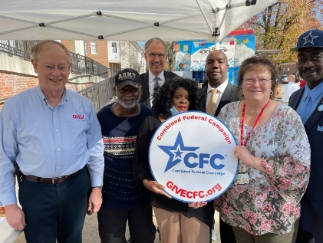

Attention: Historically, the final week of the CFC brings in millions of dollars.
Here are some easy ways you can help us amplify the message during this
critical period:
* Like, comment, and share our Finish Strong Facebook posts [3].
* Publicize Jan. 14, the last day to pledge through the CFC, in your
communications and social media efforts.

Here’s an alternate route to lend a helping hand by: ***Making a generous gift online at www.naavets.org click on DONATE TODAY or Give via the 2022 Annual CFC NAAV’s Number 85065 visit www.GIVECFC.ORG or www.cfcnca.org to donate.

He Came: For unto us a Child is Born

Good tidings we bring to share with you NAAV’s 4th Quarter Winter season Newsletter. He came; He died; He arose, and He will come again. Our great redeeming gift. Isiah 9:6 (NIV) ~

6 For to us a child is born,
to us a son is given,
and the government will be on his shoulders.
And he will be called
Wonderful Counselor, Mighty God,
Everlasting Father, Prince of Peace.
⁷ Of the greatness of his government and peace there will be no end.
He will reign on David’s throne
and over his kingdom,
establishing and upholding it
with justice and righteousness
from that time on and forever.
The zeal of the Lord Almighty
will accomplish this.

A brief commentary on those two verses in Isaiah:
(2001, Richelson). “This is a prophecy of the coming rule of Jesus on earth. These verses gather into one announcement the predictions of the birth, the deity, his earthly government, his just kingdom, and eternity of Christ.
~For unto us a Child is born
The purpose of Christ’s coming was for “us.”
~Unto us a Son is given
Jesus did not happen upon earth. From eternity God planned to “give” Him. Jesus is the Son of God. Jesus existed eternally as the Son. The word “Son” is used to show the relationship between the Father and Son.
~And the government will be upon His shoulder
Jesus will reign as King Jesus King of the world. The government of the entire world is on His shoulders.
~And His name will be called Wonderful
When He came, He was a wonder. He transcends human understanding. He is unique among human beings. He stands supreme above everyone else. His name is wonderful because he is wonderful.
~And His name will be called… Counselor
Jesus reveals the mind of God. He counsels us from God’s perspective. He gives God’s council.
~And His name will be called… Mighty God
He is God almighty. In Him dwells all the fullness of the Deity in bodily form (Colossians 2:9).
~And His name will be called… Everlasting Father
This is better translated “The Father of eternity.” All the ages meet in Him (Hebrews 1:2). The Son is not to be confused with the Father, although the Father and He are one (John 10:30).
~And His name will be called… Prince of Peace.
Peace will characterize His reign upon earth.
Of the increase of His government and peace
There will be no end
Upon the throne of David and over His kingdom,
To order it and establish it with judgment and justice
From that time forward, even forever.
***The zeal of the Lord of hosts will perform this.
God made a covenant with David many years before the writing of Isaiah that His Son would reign forever. This has not yet been fulfilled. Jesus has not yet been seated upon that throne. There is a day coming when He will reign (Revelation 3:21).” (*This information was written by Dr. Grant C. Richelson (2001, Dec 25); https://versebyversecommentary.com/2001/12/25/isaiah-9-67/ )

Q. Is this the end or beginning of a new season?

NAAV recalls all the special graces our contributors, partners, sponsors, volunteers, friends, and prayer warriors have bestowed upon this organization not only throughout this year, but throughout the years. We keep doing and you keep rolling with us. For unto us mercy has been give; unto us grace, and faith, and hope have been restored. Our American veterans and their family members have reaped the benefits of your generosity and continued support.

Resources, Announcements & Media Highlights
National Association of American Veterans, Inc. (NAAV) Presents Clothing Donation to
Homeless Sponsored by Charles Tyrwhitt at Tysons Corner, Virginia

On Thursday, December 1, 2022, the National Association of American Veterans, Inc. (NAAV) received two (3) large boxes of donated over one hundred (160) men business shirts from Edward Arnold, Assistant Store Manager at Charles Tyrwhitt Men’s Store located at Tysons Corner, Virginia. This in-kind contribution was given to Central Union Mission’s Family Ministry Center in Washington, D.C. and Homeless Veterans in Indianapolis, Indiana in December 2022. NAAV sent a letter of appreciation to Charles Tyrwhitt for making a difference in the quality of life to those who served in the U.S. Armed Forces worldwide. Charles Tyrwhitt has forty-five stores worldwide, of which twelve stores are in the United States. In addition, NAAV sent $480.00 for the Mission’s Thanksgiving and Christmas Meals for homeless Veterans residing at the Central Union Mission in November 2022.

The Central Union Mission was established a hundred and thirty-seven years ago. The heart of the Mission “is serving the hidden homeless and hungry in our city-one life at a time.” Testimonies… “Thank you NAAV for your continued financial support on behalf of our homeless in the greater Washington metropolitan area. Your support is greatly appreciated. We are all grateful for the wonderful donation.” Staff, Central Union Mission, Washington, D.C.

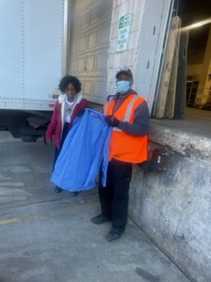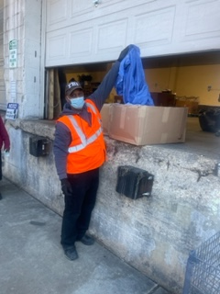

For more information, please contact Constance A. Burns, CEO and Veterans’ Service Officer at info@naavets.org or call (202) 465-3296 for details. Thank you.

ATTENTION MILITARY SPOUSES –

- Can Military Spouses Go to College for Free? We Break Down How It All
Works.
Good news to know. Check this out… What if military spouses could have access to all these benefits and more:

- Eligible benefits and transfer requirements-
- College benefits
- Spousal assistance
- Army Emergency Relief Spouse Education Assistance (AER) Program
- Career advancement account scholarship

Well, in fact they can, and they do…
Click into this site for more information:
https://www.militarysupportivecolleges.com/faq/can-military-spouses-go-to-college-for-free/

Reaping: Recognition of Giving Support

NAAV received an award and certificate of sponsorship in November 2022. NAAV is humbled to be a part of wonderful cause as a veteran’s service organization (VSO) and grateful to not only give but to also receive. Thanks to all our external partners who support our mission and efforts.
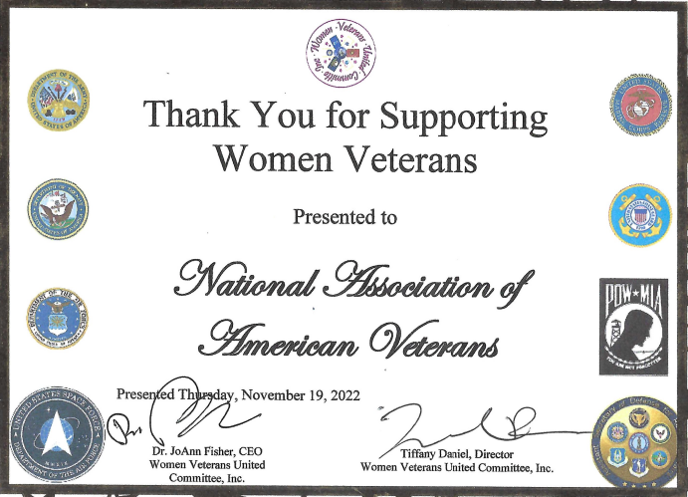
***In addition, NAAV also received a monetary donation in support of women veterans with mental health and suicidal tendency residing in DC, Maryland, Virginia, and nationwide.
Let us not forget to continue to give: C [iF] you can C

ATTENTION: NAAV is in the process of seeking Grant Writers for our organization concerning our mission, goals, and objectives to support our nation’s veterans and their family members. If interested and you have a skill to share, please NAAV at info@naavets.org or call (202) 355-3879, Monday-Friday 9am-5pm ET. Thank you kindly in advance of your volunteer time and service!
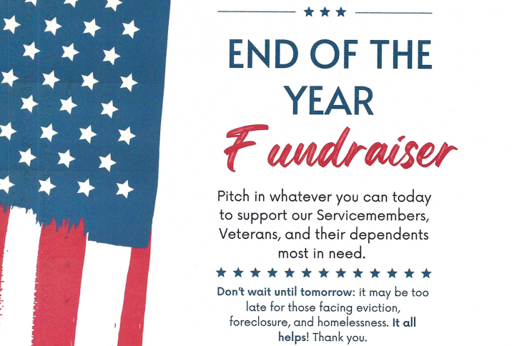
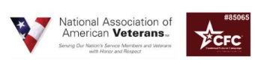

Bells of Hope
Fall/Winter Featured Testimonial:
- Central Union Mission
NAAV helps support the donation of a shelter, food, and hope to the Washington, D.C. homeless community:
"Thank you, and God bless you, for allowing our Christmas Challenge to double your gift received so even more people can receive help and hope at this special time of the year. You will be giving men, women, children, and veteran’s food, shelter, hope and the chance to make a fresh start this Christmas." -- Central Union Mission, Joseph Mettimano, President & CEO, Central Union Mission, Washington, DC

Remember NAAV has a Social Media & Resources Platform:
Hello once again to all social media, Instagram, Facebook, and Twitter enthusiast! Did you know that NAAV’s CEO and President also has a presence in many of those outlets? Constance A. Burns is not only known for her enduring service to our Military servicemembers and veterans through the establishment of NAAV, but she is also highly esteemed amongst other platforms. Here are a few snips of her accomplishments and ways to follow:
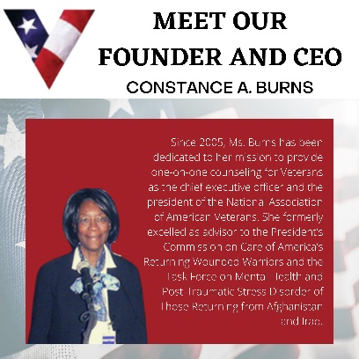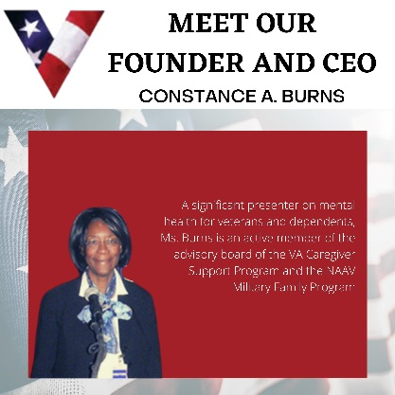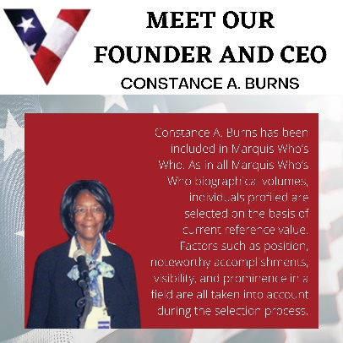
*Images can be enlarged for better view…
- Upcoming news: NAAV is in the process of launching a new fundraising website… Stay tuned…

- NAAVets, a 501(c) (3) nonprofit organization, assists veterans and their dependents accessing benefits.
naavets.org
- Moreover, did you know…
Constance A. Burns was inducted into STRATHMORE'S WHO'S WHO Worldwide "The recipient named above is included in the 2022 Edition of the STRATHMORE'S WHO'S WHO. Acceptance is granted to individuals who have exemplified leadership and achievement in their occupation, industry, or profession. NAAV, Inc. received the wall plate in October 2022.
Meanwhile, Constance A. Burns is also listed on Worldwide Who's Who in since 2015.

An End of Year Message from NAAV CEO
Closing words from President and CEO~ Greetings from the National Association of American Veterans, Inc., (NAAV):

Please accept our sincere appreciation for all you do for the National Association of American Veterans, Inc. (NAAV) throughout the year. I hope you will also take time to call a hospitalized or homebound veteran
or current service member in your community, if possible. Sad as it is,
many older veterans feel lonely and forgotten. It would mean so much to them to know they have a thoughtful, caring person - like you to call.
Meanwhile and more importantly, thousands of veterans who served in Iraq
and Afghanistan have joined the ranks of generations of veterans who served in prior wars needing our help. So many of them have returned home with serious injuries they will have for the rest of their lives
like Post-Traumatic Stress Disorder, Traumatic Brain Injury, severe depression, anxiety, stress, and suicidal tendency to name a few.
With your help today, we can reach out to our nation's heroes in our communities with care and support this holiday season.
Your generous contribution of $50, $75, or even $100 would really help our heroes nationwide. You play an important role in providing continued support for those who served and are serving in the U.S. Armed Forces worldwide. You are making a difference in the lives of our nation's service members, veterans, their caregivers, and family members.
To donate now visit www.naavets.org click on DONATE TODAY! Thank you.
If you are a federal employee and/or federal retiree, please visit
www.GIVECFC.ORG NAAV's designated CFC number is 85065 "Caring About
Those Who Served." Thank you.
***Wishing you and your family a Merry Christmas and a Happy New Year!
Best and warmest regards,
Constance A. Burns
NAAV CONTINUES ITS TESTAMENT OF STEADFAST FAITH AND HOPE. DURING 2022 AND ONWARD INTO 2023, “WE MUST CHOOSE THE SEEDS OF LIFE” TO PLAN, REAPING AN ABUNDANT HARVEST OF HOPE, JOY, AND LOVE… WE WILL, LORD WILLING, CATCH UP WITH YOU ON THE OTHER SIDE OF THE NEW YEAR!
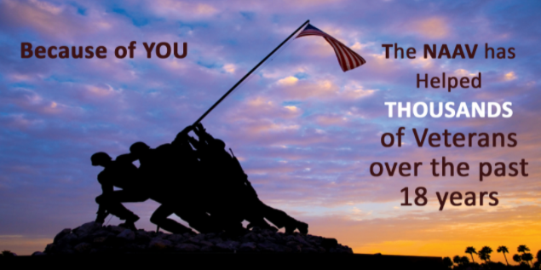
YOUR GIFTS OF SERVICE AND FINANCIAL SUPPORT – DO MATTER!
Constance A. Burns, President & CEO
Veterans Service Officer
National Association of American Veterans, Inc.
1725 I Street, NW Suite 300, Washington, DC 20006-2423
Mobile: (202) 355-3879
Office: (202) 465-3296
Email: info@naavets.org
Website: www.naavets.org click on DONATE TODAY! Thank you.
CFC #85065 "You Can Be the Face of Change"
visit www.GIVECFC.ORG to donate. Thank you.

Please note, NAAV does not endorse all resources provided herein; however, we are sharing as potential interest for your determination and value.
https://thumbs.dreamstime.com/b/christmas-bells-3802324.jpg ii https://media.istockphoto.com/id/174900697/photo/jingle-bells.jpg?s=612x612&w=is&k=20&c=JOiRJNaCY3eYzEUDabm_fscjna6HBzq0xQdiKfcrE6Y= iii https://media.istockphoto.com/id/1277117715/photo/christmas-jingle-bells.jpg?s=612x612&w=0&k=20&c=kxdOsBek_v-Ltxx3MUP2WvsEwZw2OpJa9a3deDiP-vI=

