Women Veterans United Committee, Inc., CTLDOMGroup, Inc.
& DAV Omaha Beach Chapter #7
Saturday, October 1, 2022
American Legion Harry White Wilmer Post #82
6330 N. Crain Highway, La Plata, MD 20646
2 pm – 4 pm

2022 Annual Baby Shower

2:00 pm Opening Remarks Dr. JoAnn Fisher, CEO, WVUCI
2:05 pm Mistress of Ceremony Tiffany Daniel
2:10 pm Invocation TO BE ANNOUNCED
2:15 pm Pledge of Allegiance Audience
2:20 pm National Anthem Audience
2:25 pm Recognition of Distinguished Guest Brenda Jamison

2:30 pm Welcoming Remarks & Words of Encouragement
Delegate Edith Patterson
Commissioner Tomasina Coates
Lt. Col. & Mrs. Magness

2:55 pm Blessing of Food

3:00 pm LET’S HAVE FUN Games & Activities

3:30 pm Presentation of Baby Shower Baskets led
by Dr. Fisher & Tiffany Daniel

3:55 pm Closing Remarks Dr. JoAnn Fisher, CEO, WVUCI
Cdr George Hawley

3:58 pm Benediction TO BE ANNOUNCED
Host Committee Members
Commissioner Tomasina Coates, Charles County, MD
Delegate Edith Patterson, Charles County, MD

Program Committee
Dr. JoAnn Fisher, CEO, Women Veterans United Committee, Inc. (WVUCI)
Tiffany Daniel, Chair, Board of Directors, Director, Health & Wellness (WVUCI)
Brenda Jamison, Director, Communication (WVUCI)
Phyllis Fisher, Director of the South (WVUCI)
Karen Holmes, Director, Safety (WVUCI)
Mary Phelps, (WVUCI)
Lenora Davis
Cdr. George Hawley, AL Harry White Wilmer Post 82, La Plata, MD
Kemia Duncan-Kirby, Bethel Outreach Worship Ministries
Princess Facen, National Association of Black Military Women (NABMW)

Sponsors
American Legion Auxiliary Greenbelt Unit 136, Greenbelt, MD
American Legion Post 66, Bowie
American Legion Harry White Wilmer Post 82, La Plata, MD
Pisgah United Methodist Church
R3 (Recognize, Repair, Repeat) - Civility Management Solutions
American Income
National Association of Black Military Women (NABMW)
Champlain Court Cooperative, Washington, DC
Sisters Empowering Sisters-Bethel Outreach Worship Ministries
National Association of American Veterans, Inc. (NAAVETS)
Public Health Emergency Response Strike Team (PHERST)
Blue Campbell & Associate, LLC
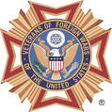 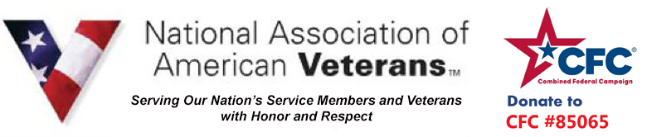 Maryland Travel Plazas, I - 95 JFK Memorial Highway MM 82, Aberdeen, MD 21001

