Volume 03 22 | Issue 3 | National Association of American Veterans (NAAV), Inc.
July ~ August ~ September 2022
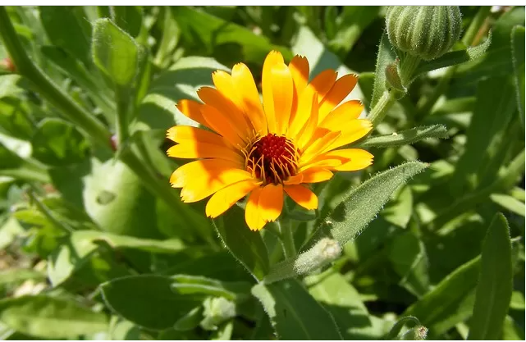 |  | The National Association of American Veterans, “In the Heat of Summer – Spreading Seeds of Joy”  Issue Date: July, August, September 2022

https://garden.lovetoknow.com/annuals/best-seeds-easy-summer-plants;

Header Image: https://clipartix.com/wp-content/uploads/2017/06/Summer-clipart-free-images-3.jpeg
NAAV INC., Newsletter 3rd Quarter Review |  | In This Issue – Sowing

NAAV in the Heat of Summer
Editor’s notes: All the blessings of this summer are being poured out in this 3rd Quarter issue of the National Association of American Veterans (NAAV) newsletter. We have features highlighting care for veterans, summer testimonies, available resources, and announcements for advocating your generous continuation of financial support that will enable us to continue our veteran service mission.
NAAV is proud to spread seeds of joy to our American veterans and their family members. Thank you for joining us this summer as your time, talent, and treasures are most needed and appreciated. Read on to see how NAAV has been able to grow the seeds of love, the flowers of joy, and rich soil to fertilize lives.
Sowing the Seeds of Giving

Greetings from the National Association of American Veterans, Inc. (NAAV) established in 2005 and incorporated in 2006 to provide support for our nation's service men and women, disabled veterans, their caregivers and family members most in need nationwide.

For many veterans and their caregivers and family members in America, Thanksgiving and Christmas is a time to gather and celebrate with family and friends. But for most military families in need, it can be a challenging time of the year. With the rising cost of food, thousands of veterans will find it especially difficult to afford food for their holiday meals. In addition, to holiday meals, most veterans and their family members are seeking emergency assistance from public charity organizations like the National Association of American Veterans, Inc. (NAAV) to assist with food, rental, mortgage, utility, and homelessness nationwide.

With your continued support, we are planning to help many military families have meals over the holidays this year. I know that providing assistance to thousands this year with holiday meals is a lot; however, I believe all things are possible through Jesus Christ our Lord.
Can we count on your donation of $10, $15,$20, $25, $50 or more to give to NAAV in support of NAAV partners who are preparing meals for those who may go without a holiday meal? Every dollar you give help provide at least 10 meals for families most in need. Your generous contribution of $25 helps provide food for 250 meals and your donation of $50 will help provide food for $500 meals for families including the homeless.
Thankfully, our veterans and their families will have thankful holiday meals including other emergency assistance requests because of your continued support. Thousands of veterans and their family members can use a little extra help right now. You can lend a helping hand by:

***Making a generous gift online at www.naavets.org click on DONATE TODAY or Give via the 2022 Annual CFC NAAV’s Number 85065 visit www.GIVECFC.ORG or www.cfcnca.org to donate. Thank you.

Parable: Lesson’s of Sowing and Reaping

Welcome to NAAV’s 3rd Quarter Summer season Newsletter. Have you ever read the parable about sowing and reaping? Do you believe this is a measurable concept? In the book Matthew, chapter 13, Jesus taught His disciples the principle of sowing and reaping. He shares in verses 1-9 (NIV) ~

The Parable of the Sower
13 That same day Jesus went out of the house and sat by the lake. ² Such large crowds gathered around him that he got into a boat and sat in it, while all the people stood on the shore. ³ Then he told them many things in parables, saying: “A farmer went out to sow his seed. ⁴ As he was scattering the seed, some fell along the path, and the birds came and ate it up. ⁵ Some fell on rocky places, where it did not have much soil. It sprang up quickly, because the soil was shallow. ⁶ But when the sun came up, the plants were scorched, and they withered because they had no root. ⁷ Other seed fell among thorns, which grew up and choked the plants. ⁸ Still other seed fell on good soil, where it produced a crop—a hundred, sixty or thirty times what was sown. ⁹ Whoever has ears, let them hear.”
¹⁰ The disciples came to him and asked, “Why do you speak to the people in parables?”
¹¹ He replied, “Because the knowledge of the secrets of the kingdom of heaven has been given to you, but not to them. ¹² Whoever has will be given more, and they will have an abundance. Whoever does not have, even what they have will be taken from them. ¹³ This is why I speak to them in parables: “Though seeing, they do not see;
though hearing, they do not hear or understand. ¹⁴ In them is fulfilled the prophecy of Isaiah: “‘You will be ever hearing but never understanding;
you will be ever seeing but never perceiving. ¹⁵ For this people’s heart has become calloused; they hardly hear with their ears, and they have closed their eyes. Otherwise they might see with their eyes, hear with their ears, understand with their hearts and turn, and I would heal them.’^{[a]}
¹⁶ But blessed are your eyes because they see, and your ears because they hear. ¹⁷ For truly I tell you, many prophets and righteous people longed to see what you see but did not see it, and to hear what you hear but did not hear it.
¹⁸ “Listen then to what the parable of the sower means: ¹⁹ When anyone hears the message about the kingdom and does not understand it, the evil one comes and snatches away what was sown in their heart. This is the seed sown along the path. ²⁰ The seed falling on rocky ground refers to someone who hears the word and at once receives it with joy. ²¹ But since they have no root, they last only a short time. When trouble or persecution comes because of the word, they quickly fall away. ²² The seed falling among the thorns refers to someone who hears the word, but the worries of this life and the deceitfulness of wealth choke the word, making it unfruitful. ²³ But the seed falling on good soil refers to someone who hears the word and understands it. This is the one who produces a crop, yielding a hundred, sixty or thirty times what was sown.”

NAAV calls its readers to hear about the goodness of grace and mercy many of you have shared through your giving and multitude of ways this organization has been blessed by our sponsors, readers, volunteer’s generous gift of time, talent, and resources. Thank you for hearing then doing, for seeing then trusting, by trusting then believing in the organization’s mission to help, heal, and preserve the dignity of our American veterans and their family members.

The parable about sowing found in Matthew is, although spiritual in nature, a way of shining the light on all our hearts and causing us to pause to take thought of minds i.e., how we are listening, understanding, and appreciating blessings we have enough to share with others. Others who don’t ask for much, but who are deserving of more. Thank you for your continued support and consideration of partnering with this organization. Let not your heart only be warmed by the summer heat, but also by the “Son’s” grace and love.

Resources, Announcements & Media Highlights

https://static4.depositphotos.com/1028655/384/i/450/depositphotos_3843124-stock-photo-two-thousand-five-hundred-bills.jpg; *Pulled 9/30/2022.
- Financial Relief Announcement
Financial literacy is an important tool designed to help military members prepare for the day they reintegrate into society. With so many financial problems that plagued military personnel over the years, the programs provided by the government through laws like 10 U.S.C. 992 have given relief to veterans. Learning how to manage your debt, you can take some advice from reputable debt settlement companies, create a budget, and find a job are skills that should help you establish your finances once you leave the military.
Anchor text: reputable debt settlement companies Target page:
https://joywallet.com/article/best-debt-settlement-companies
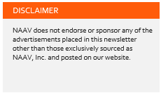
- HEAD’S UP EVENT: Re-Announcement -
We are very excited to announce that the 2022 – Veterans Bonanza will be taking place on Saturday, November 5, 2022, from 10 a.m. to 4 p.m. at the La Crosse Center in La Crosse, WI!
Come join us in ensuring 2022 will be a continued success by registering your spot.
Please visit our website https://veteransbonanzalax.com/ to learn more. You can
register to be a sponsor (Sponsor Registration https://veteransbonanzalax.com/sponsorship/)
or a vendor (Vendor Registration https://veteransbonanzalax.com/vendor-registration/) at our website as well.

Disabled Veterans National Foundation (DVNF)

My name is Meredith Fick and I work with the Disabled Veterans National Foundation (DVNF) located in Lanham, MD.
Every year, DVNF hosts a Veterans Resource Fair. Unfortunately, we hadn’t been able to have our event since 2019. However, this year we are excited to announce its return! Our event, in honor of Veterans Day, recognizes the service and sacrifice of all veterans by collaborating with local government and nonprofit organizations to provide critical resources. DC, Maryland, and Virginia employment and education officials will be in attendance, as well as several nonprofits that offer services to veterans. The resources include job recruiting, information on benefits, recreational therapy, and much more. We’re so excited to relaunch our annual event and are hosting the resource fair on Thursday, November 10th in honor of Veterans Day. It will take place at the Silver Spring Civic Center from 9 am-2:30 pm. Please see the attached flyer for more information!
In addition to these useful resources, veterans who attend can receive:
• Free, Brand-New Suits – Brand new business attire (for men and women), intended for job-seeking veterans, made possible by Joseph A.
Bank, a corporate partner of DVNF.
• Free Meal and Free Groceries
• Comfort Kits – From DVNF’s Health & Comfort program, to provide immediate relief to veterans facing financial and housing insecurity.
• Gift Cards
• Raffle Items
At this event, we are looking to provide as many resources as possible to the at-risk and disabled veterans who attend the event and would love to have you join us! To make this event a success, we’d like organizations like yours to host a vendor table at the event. There is no cost to participate. We just want to provide as many free or low-cost resources to as many Veterans as possible. If you’re interested in being a part of this event, please use the link below to register.
https://dvnfveteransfair.ticketleap.com/dvnf-resource-fair-vendor-registration-2022/
We also ask that you help us spread the word about our event to any Veteran you may encounter. They can also pre-register (though not required) using the link below.
https://dvnfveteransfair.ticketleap.com/dvnf-resource-fair-2022/
Please reach out to me if you have any questions or would like more information.
Sincerely,
Meredith Fick
Office Assistant
T: (202) 737-0522

Winterhaven/Stand Down 2022
Editor speaks: This event is perfect opportunity for anyone who in inclined to give-back by helping to serve our volunteer organizations and contributing to the needs and respect of our American homeless veterans. In my experience, this nothing more humbling and rewarding then to greet with a smile, assist with directions and filling out applications while supporting homeless veterans of all ages, race, creed, and colors and branches of the military who walk through the lines at during the Winterhaven/Stand Down event. Please consider joining NAAV and many other Veteran Service Organizations (VSO) this coming November 2022. If you are unable to be there in person to support this wonderfully worthy cause, please considering donating/dropping off a pair of unblemished shoes or boots for distribution to men or women. See details below:

Greetings all!
A message from W. Elmore:
The purpose of this correspondence is to make you aware that the District of Columbia Veterans Administration Medical Center (VAMC) will resume the (in-person) (2022) Winterhaven/Stand Down, and the ‘Walk In Their Footsteps New Boots/Shoes collection for homeless female and male
veterans, on Saturday, November 5, 2022, (7:30 a.m. – 3:00p.m.) at the VAMC located at: 50 Irving Street, NW, Washington, DC 20422. The Winter Haven/Stand Down will take place on the Patient parking lot, (out of tents) on the rear outdoor parking area of the VAMC. It’s been two (2) years, and now we are back!
The COVID-19/Delta-Variant Pandemic has had a devastating impact on our homeless veterans, as well as those veterans transitioning from homelessness to stable housing, and their families. Subsequently,
the need for assistance to our homeless female and male veterans, and their families, has increased exponentially. This partnership, and your tax deductible ‘in-kind’ donation of new Boots/Shoes, will go a long way
to assist those homeless veterans, veterans at-risk of homelessness, and veterans transitioning from homelessness to stable housing.
New Boots/Shoes donations will be accepted beginning Monday, September 19, 2022 thru Wednesday, November 2, 2022.
***Boot/Shoe sizes needed – Men: (91/2 – 15), Women: (81/2 – 12)
Please note, that we will not accept cash donations. Only ‘In-Kind’ donations will be accepted however, your ‘In-Kind’ donation of new boots and shoes is considered a taxable donation 501 (c) (3) for which a
donation receipt can be provided, if requested.

The drop-off locations, for new boots & shoes, include the following:

1. Access Housing, Inc. (Southeast Veterans Service Center)
820/840 Chesapeake Street, SE, Washington, DC 20032 202) 561-VETS(8387)
POC: Walter Elmore; welmore@accesshousingincdc.com
Monday – Friday (9:00a.m. – 2:00p.m.)
2 Washington DC VA Medical Center (Volunteer Services)
50 Irving Street, NW
Washington, DC 20422
(202) 745- 8320.
Mr. Jeffery Bozeman, Assistant Chief
Jeffery.Bozeman@va.gov

Please coordinate all donation drop offs with Jeffery Bozeman. Please
notify the points of contact if you have a donation that needs to be
picked up. When dropping off new boots & shoes please request a receipt
for the number of new boots/shoes donated, and you may also request a
tax exempt receipt. Thank you in advance for your support.
If you have any questions, please do not hesitate to contact Walter
Elmore at: Welmore@accesshousingincdc.com

- Below are photos from previous year’s Winterhaven/Standdown events:
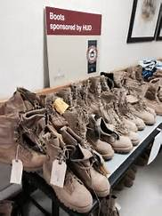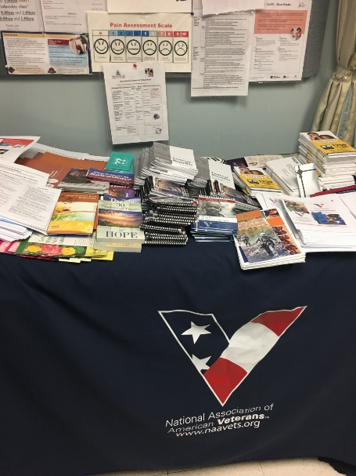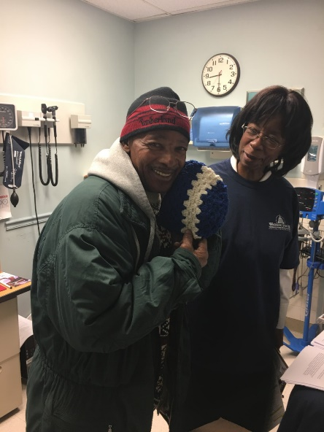
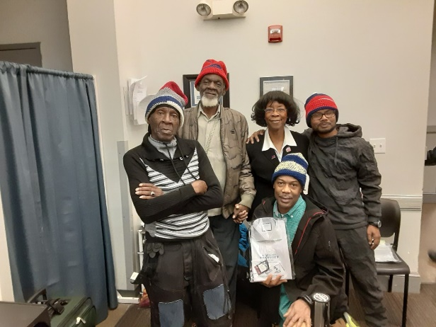 Knitted hats for the homeless… 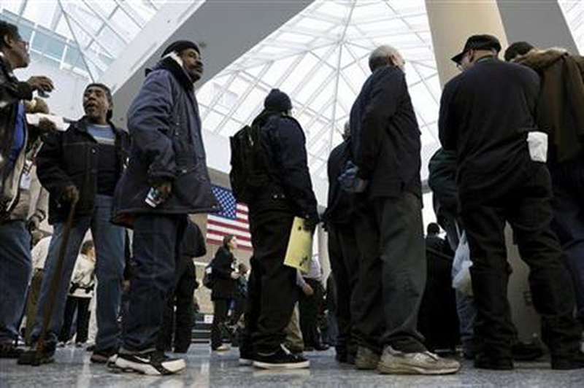
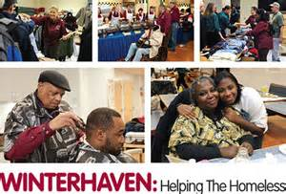 (Photo by Andrew J. Wright)
Will you consider being a part of the mission to serve this year?

Social Media & Resources:
Hello once again to all social media, Instagram, Facebook, and Twitter enthusiast! Did you know that NAAV’s CEO and President also has a presence in many of those outlets? Constance A. Burns is not only known for her enduring service to our Military servicemen and veterans through the establishment of NAAV, but she is also highly esteemed among other platforms. Here are a few snips of her accomplishments and ways to follow:
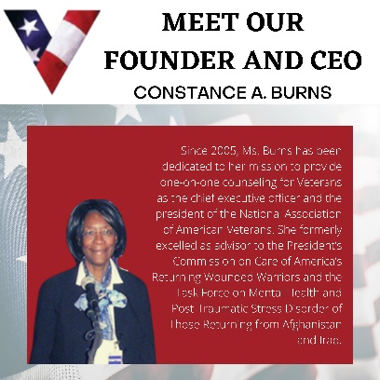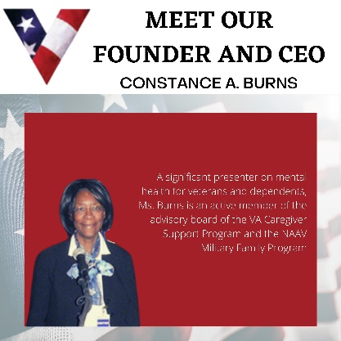
*Images can be enlarged for better view…
NAAVets, a 501(c) 3 nonprofit organization, assists Veterans and their dependents accessing benefits.
naavets.org

Featured Testimonial:
- April & May 2022
NAAV helps support the donation of a new vehicle and wheelchair for disabled Army Veteran:
Mobility Works: “We delivered the vehicle on 4/27 at his home. They were happy to have
a home delivery. Eric and his wife were both very quiet people and did not tell me that much about their personal life. He purchased a 2019 Dodge Grand Caravan. He really liked the one we found because it was sporty. The trim is a GT which is the Dodge with the sport trim package. All black interior and granite exterior. We completed the financing. He plans to use it to take her out here and there. Eric did have a disability himself, but he was able to use the vehicle just fine to transport her.”
…Putting the gift all together for delivery.
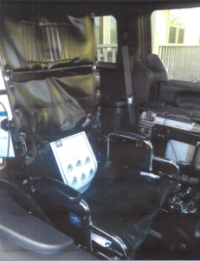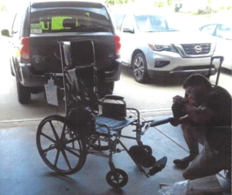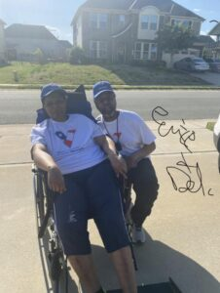
*Above Image: showing Eric A. Arrington, U.S. Army Veteran and his spouse Deborah who is recovery from a severe brain stroke in donated high back wheelchair donated by
NAAV, Inc., in May 2022. They reside in Mebane, NC.
*Eric A. Arrington, U.S. Army Veteran comments regarding NAAV’s donation of a new 22-inch-wide high back wheelchair, and the mobility van secured by Mobility Works with the support of Randy Benson, NAAV Board of Directors Member.

- Mr. Arrington writes:
“We prayed to ease my wife’s pain and make her more comfortable. God answered quickly, in his time. National Association of American Veterans, Inc. generously donated a 22-inch-wide high back manual wheelchair. We are humbled and very thankful to Ms. Burns the President and CEO. She is a servant of the Lord helping us in our time of need.”
— The Arrington’s, Mebane, North Carolina
To end our summer in the spotlight of a warming sunshine, take in these rays: NAAV never tires of saying thank you and to acknowledge that YOUR GIFTS OF SERVICE AND FINANCIAL SUPPORT – DO MATTER!
We hope you find the stories, resources/announcements, and encouraging testimonies in NAAV’s 3rd Quarter Newsletter and that seeds of sowing continue to reap one hundred fold as we enter into the fall and winter seasons of this year 2022!
Stay well and be safe!
Warmest regards,
Constance A. Burns
Founder, President and CEO
Veterans Service Officer
NAAV, Inc.
Washington, DC

NAAV CONTINUES ITS TESTAMENT OF STEADFAST FAITH AND HOPE. In 2022, ONCE AGAIN AS BEFORE “WE MUST CHOOSE THE SEEDS OF LIFE” TO PLANT REAPING AN ABUNDANT HARVEST OF HOPE, JOY, AND LOVE…

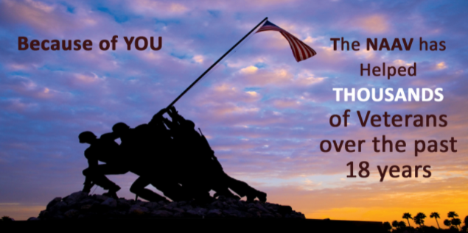

Please note, NAAV does not endorse all resources provided herein; however, we are sharing as potential interest for your determination and value.

