Volume 01 22 | Issue 1 | National Association of American Veterans, Inc.
January ~ February ~ March 2022

GREETING & ANNOUNCEMENT
Welcome all to The National Association of American Veterans, Inc. (NAAV) 1st Quarter 2022 Newsletter. It seems 2021 just closed out, yet here we are one quarter into a new year. Time does not fly, but rather humanity does not stop… That is until God says when.
These past few months have met us with a lot of unexpected twist such as the Russia/Ukraine crisis, devastating fires in the west and tornados throughout the mid-and central U.S. Let us also recognize the past two-year mark of the COVID pandemic outbreak, which is only now slowly withdrawing its ravishing effects.
NAAV CONTINUES ITS TESTAMENT OF STEADFAST FAITH AND HOPE. In 2022, ONCE AGAIN AS BEFORE “WE MUST CHOOSE THE LIGHT” AND PRESS ON TOWARDS A HIGHER CALLING…

Please allow us to repeat portions of our sentiment posted during the 4th Quarter 2021: “We chose the light. That is the light of God in our hearts…” This end of March is the beginning of a season of crisp sunshine and rays of hope. NAAV is here to state we stand firmly on the same sentiment i.e., we choose the light—We choose to see the movement of life in the light of service toward our American Veterans and their family members…
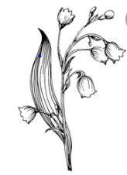
IN MEMORY OF:
Message from NAAV, Inc.: Please accept our heartfelt sympathy to Veterans and their family members who passed away or lost loved ones during this first quarter.
>Evangelist Margaret Walker, U.S. Navy (Ret) and NAAV Spiritual Wellness
>Advisor whose beloved mother passed in January, to the family of
>Patricia Morris, a NAAV supporter who passed on March 22nd, and James
>Wheat, Jr., a NAAV Veteran supporters whose brother a Vietnam War Veteran who passed in March 2022.
Matthew 5:4 “Blessed are those who mourn for they shall be comforted.”

Social Media & Resources:
Hello all you social media, Instagram, Facebook, and Twitter enthusiast! Did you know that NAAV’s CEO and President also has a presence in many of those outlets? Ms. Constance A. Burns is not only known for her enduring service to our Military servicemen and veterans through the establishment of NAAV, but she is also highly esteemed amongst other platforms. Here are a few snips of her accomplishments and ways to follow:
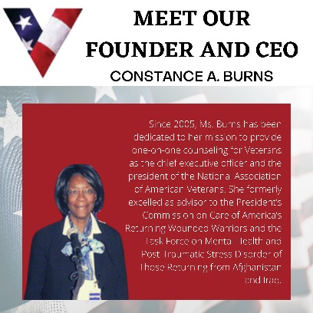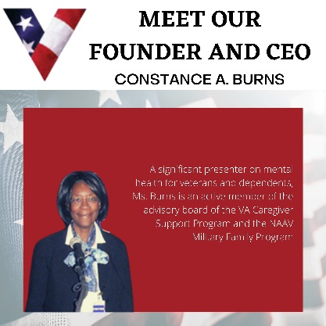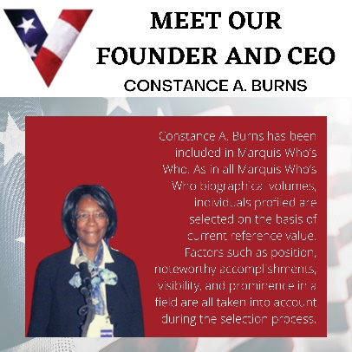
*Images can be enlarged for better view…
NAAVets, a 501(c)3 nonprofit organization, assists Veterans and their dependents accessing benefits.
naavets.org
HEAD’S UP EVENT:

We are very excited to announce that the 2022 – Veterans Bonanza will
be taking place on Saturday, November 5, 2022, from 10 a.m. to 4 p.m. at
the La Crosse Center in La Crosse, WI!
Come join us in ensuring 2022 will be a continued success by registering your spot.
Please visit our website https://veteransbonanzalax.com/ to learn more. You can
register to be a sponsor (Sponsor Registration https://veteransbonanzalax.com/sponsorship/)
or a vendor (Vendor Registration https://veteransbonanzalax.com/vendor-registration/) at our website as well.
TESTIMONIAL HIGHLIGHTS:
On March 24, 2022, NAAV, Inc. paid for a dining table and two chairs, an
office desk and office chair with wheels including a microwave with
pots, dishes, pans and glasses, etc. the kitchen for once homeless
Veteran Julius Berger of Fredericksburg, VA.
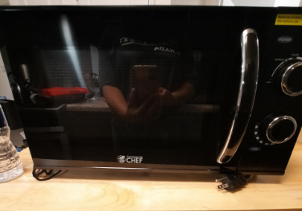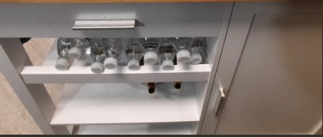
- NAAV, Inc. donated funds in support of Native American Veterans
Assistance in Pine Ridge, South Dakota in March 2022 to help with box of
food, help to get Veteran's electricity turned back on and with the
purchase of cords of wood etc. in March 2022.
NAAV also sent $244.00 to the American Bible Society for Bibles to be
sent to Service men and women serving in the U.S. Armed Forces worldwide
in February 2022.
Funds were also given $309.00 to the Central Union Mission in February
2022 to provide meals for over 100 homeless Veterans and men residing at
the shelter in Washington, DC.

- We received over 100 calls for assistance with financial hardship
nationwide including assistance with VA claims and benefits.

Springtime message to warm your heart:
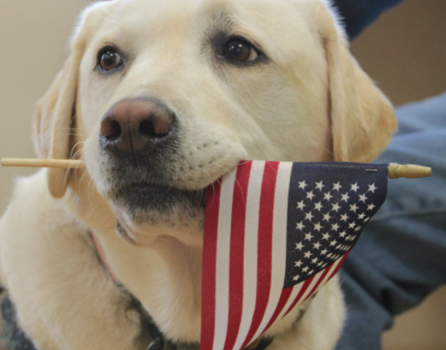
Greetings NAAV,
HMI Sully H.W. Bush, the former service dog and companion to President George H.W. Bush, stopped by the Armed Forces Retirement Home in Washington, D.C yesterday bringing smiles and joy to our military Veterans and staff here at AFRH.
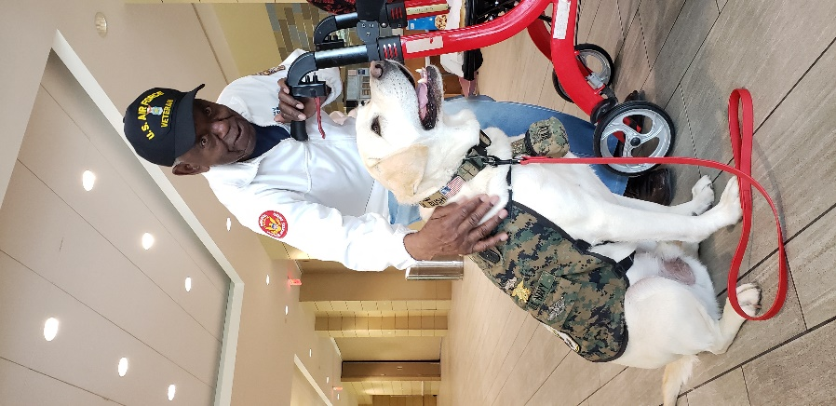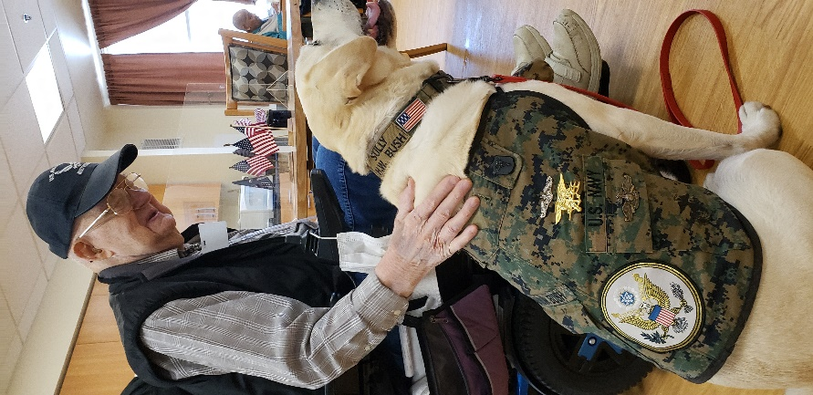
Representatives from Walter Reed National Military Medical Center's Facility Dog Program brought Sully to our facility giving our Veterans and staff a rare opportunity to meet
and greet the devoted Lab, famous for faithfully standing by his owner's side until the end.
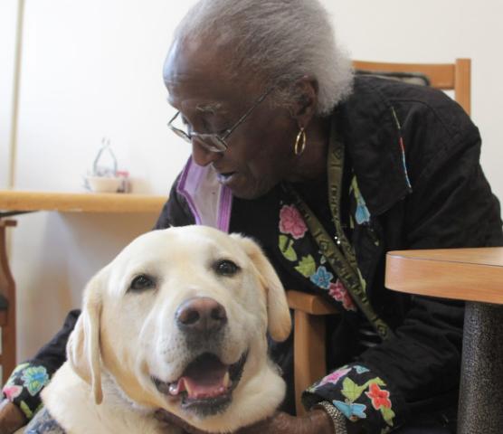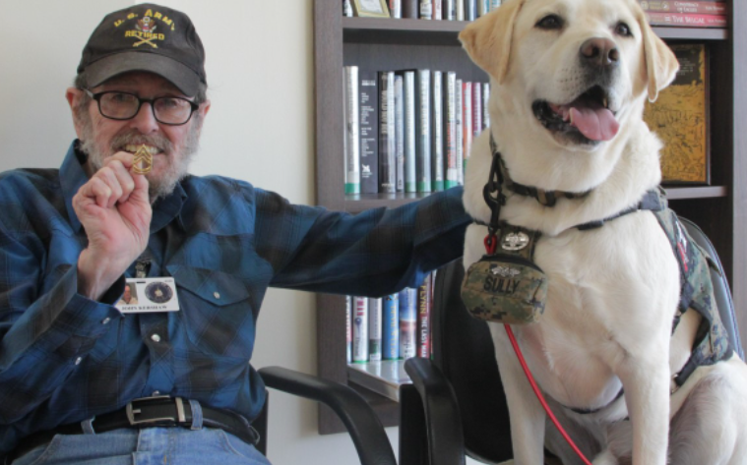

-Below: Insert from main article shared with NAAV:
Today, Sully is a member of the Walter Reed National Military Medical Center’s (WRNMMC) Facility Dog Program in Bethesda, Maryland, a role he assumed in accordance with the wishes of the 41st president. “It’s an honor to have Sully visit with our veterans here at AFRH,” said Susan Bryhan, administrator of the campus here in Washington, D.C. “Dogs always boost the morale of our Veteran residents. We thank the Walter Reed Team for sharing him with us today.” Amy O’Connor and Angela Kinart, both command project managers at WRNMMC, escorted Sully throughout the campus as he engaged with military Veteran residents and staff.
“Sully H.W. Bush is one Walter Reed’s facility dogs, and was formerly owned by President George H.W. Bush,” Kinart explained. “Before he passed, he decided he wanted Sully to continue working to help improve the experience and provided care for our members in uniform.” (Article released on Apr. 11, 2022, for more information regarding this story and more go to: http://www.afrh.gov/.
Happening in April:
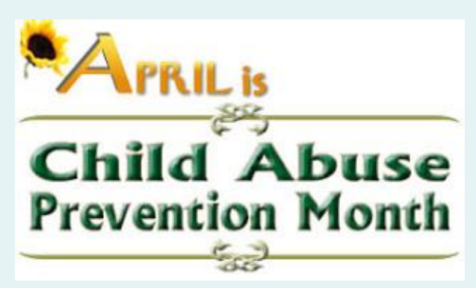

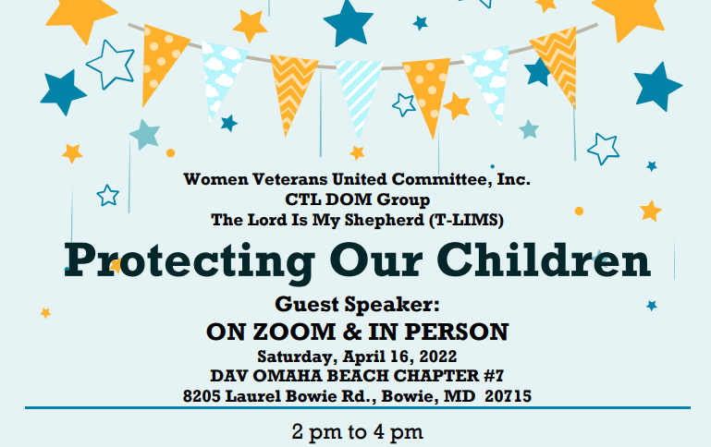
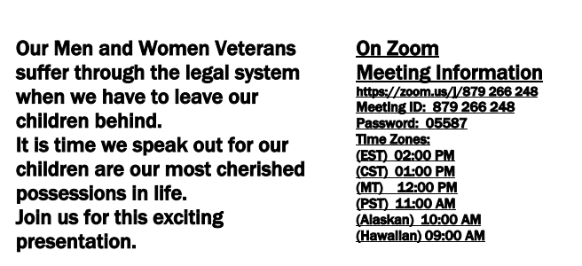
… More to come for women… You don’t want to miss:

In case you missed the recent event, please see below:

*Recently held - FREE LEGAL CLINIC FOR WOMEN VETERANS
TVC held a FREE legal clinic for Women Veterans in DC, VA &
MD on APRIL 12, 2022.
This clinic was virtual and by appointment only.
For future reference and or more information on other upcoming events be sure to share with any women who have served in the U.S. Military.
The Veterans Consortium | 2101 L Street NW, Suite 840, Washington,
DC 20037

Cont…
NEED HELP FIGHTING SUBSTANCE ABUSE:
Substance abuse is one of the most difficult issues anyone can face.
It’s also a growing problem nationwide. Yet many people are afraid to
seek treatment, in part because they don’t know what to expect.
That’s where this helpful guide comes in.
It contains valuable information such as:
How to prepare to enter treatment — what you need to pack, tying up
loose ends, etc. This sort of advice can help make the process of
getting help a bit less intimidating.
https://www.naavets.org/medicare-guide-for-veterans
ADVANCED CARE PLANNING: A CONVERSATION ABOUT BURIAL BENEFIT
Calling all Caregivers, Veterans, and Community Members! Join the
Washington DC VA CSP team, American Association of Retired Persons
(AARP), and the VA National Cemetery Administration (NCA) for the second
event in their Advanced Care Planning Series. Participants will learn
more about the services and benefits offered through VA NCA. The event
will be held on: April 20, 2022, at 10:00 a.m. – 11:30 a.m. ET (9:00
a.m. CT; 8:00 a.m. MT; 7:00 a.m. Pacific). There will be an opportunity
to ask questions to the presenters! Please RSVP at least 72 hours in
advance using the following link: https://aarp.cventevents.com/d/m8qbzv/
[8].
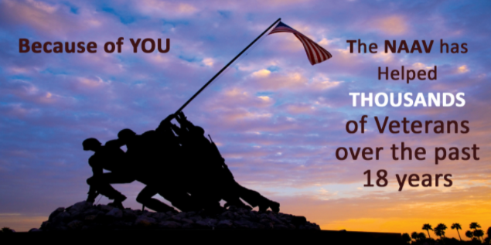

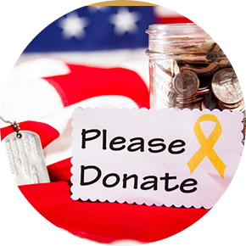

We wish you an exciting springtime adventure!
Sincerely,
o/b/o CEO/President
NAAV, Inc.
Washington, DC

Images taken from:
https://www.shutterstock.com/image-vector/hello-spring-floral-card-holidays-decoration-1050188078.

https://www.shutterstock.com/image-vector/lily-valley-by-hand-drawing-maylily-1940091814.

Please note, NAAV does not endorse all resources provided herein; however, we are sharing as potential interest for your determination and value.

