The National Association of American Veterans, Inc. (NAAV)
1st Quarterly 2022
Winter/Spring Testimonies

Slip off the melt of a frozen winter’s season into the drops of spring time’s dew. Welcome to the NAAV’s 1st Quarterly testimonials. This past winter was cold, but not cold enough move warm hearts. NAAV has been treading through the calls, emails, and request for assistance for the past three months without skipping a beat:
- 1st Quarterly Figures
January to April 2022 - 89,400,000
- Visitors to NAAV Website:
Past week - 492,000
Past month - 729,000
*Past year - 2,070,000 4/7/2021 - 4/7-2022
Here to share with you a few of the highlighted response corresponding with NAAV’s support and enduring service to our American Veterans and their family members.
NAAV is a 365 day season of love, gifting, and building resource of hope. Our Veterans and their family members deserve a listening ear, generous heart, and open hand no matter the weather as their dedication and sacrifice set the record for weathering the storms.
NAAV and other CHARITABLE CONTRIBUTIONS
On Saturday, April 9, 2022, the National Association of American Veterans, Inc. (NAAV) received three (3) large boxes of over two hundred men shirts with one male suit donated by Jeff Albert, Senior Sales Manager at Charles Tyrwhitt Men’s Store located at Tysons Corner, Virginia. Two boxes of men shirts were given to Central Union Mission’s Family Ministry Center in Washington, D.C. on April 11, 2022.
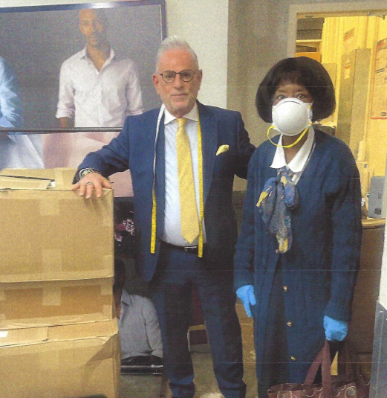
Meanwhile, NAAV sent one box with twenty-four men shirts and one male suit to a Homeless Veterans Mission in Indianapolis, Indiana for an event this summer.
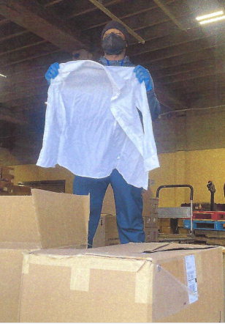
NAAV provides mortgage and financial assistance to a Sandersville, Georgia Veteran. His testimonial is meant to encourage other Veterans and their family members facing many challenges during the COVID-19 pandemic outbreak and global crisis.
- Encouragement from one Veteran to another in times of struggle:
There are many lessons in life that we encounter. We should appreciate
these lessons and learn from them. My biggest lesson or struggle is in
part the Christian struggle. The Great Apostle Paul taught us about this
struggle in the book of Romans chapter 7:7-25. This whole struggle
I've learned is really a matter of getting or bringing your flesh under
control. The carnal mind will have you doing the things that you know
you shouldn't do. With me it's been mismanaging my money. Putting my
priorities aside and in the wrong place. My wife talked to me about this
time and time again but I continue. I prayed to my Heavenly Father about
this but still let my flesh lead me. This struggle was taking its toll
on me and my wife. My wife was preparing to leave me and let me keep
struggling on my own. Thank God for his Grace and Mercy to allow me to get
in touch with Ms. Constance Burns. She talked to me and my wife and
inspired us to continue trusting and believing in God. She also helped us
with our mortgage payments. I thought that I had got past having to
still deal with my flesh. No, not yet there was one more encounter that
almost made the progress that I had made be in vain. Getting another
loan and letting my priorities go the wrong way again. Once again I
called upon Ms. Burns and she reminded me of doing the right thing. I
told her that I know, but I was still struggling and was about to have
my house foreclosed. She is like my guardian angel, my ram in the bush,
but most importantly one of God's true servants. She got my mortgage
payments up to date and prayed for me and my wife to endure. I am
working harder to get and keep my flesh under control now by fasting and
praying. This too will past because I know I am a child of God who is
love by God, bless by God, and have the victory with God.
Thank you and
appreciate you, Johnnie and Hattie Miller, Sandersville, GA
TESTIMONIES:
Pieces of a dream: I wish to thank Ms. Burns, Ms. Ward and Bobs Discount Furniture for helping me in my time of need. I never thought that a few pieces of furniture would turn my house into a home.
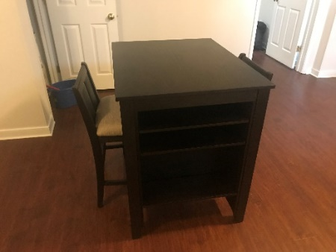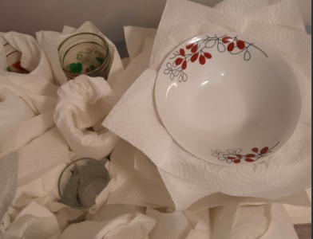
Thank you guys so much! Julius Berger
Mr. Berger now resides in a one-bedroom house on the lower-level in Fredericksburg, VA. The VA Social Worker in Fredericksburg, VA was instrumental in getting permanent housing for him in early March. NAAV provided additional items earlier last month along with other items donated:
-Large office desk and office chair with wheels; small dining table with
two chairs, clothes rack, small microwave with a small microwave table,
kitchen items such glasses, plates, pots, pans, dishes, bowls, etc.
Special thanks to Lola Johnson, NAAV Advisor for Caregivers and Homeless
Veterans and Bob's Discount Furniture Store in Woodbridge, Virginia for
their support and professional assistance.
- "Thank you NAAV, Inc. for providing emergency assistance for my
utility bill in March and ensuring a new payment plan via my utility company
in Illinois. I am very grateful for your financial support and
professional assistance." - Kim Dillard, Veteran in Swansea, IL
NAAV provided donated items to a grateful wife of a U.S. Veteran. Pictures below portray images of her sorting through some of those generous items:
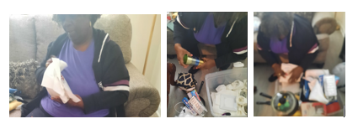
- Blessings Ms. Burns, (above) here are some of the pictures of Mrs. Shirley Robinson, (Caregiver of Veteran) looking thru the donated items.

- "Thank you NAAV, Inc. for paying three months of overdue mortgage for me
and my family on March 10 and 11 of 2022. My retirement benefits were
cut in half in 2021 causing be to get three months behind. I am very
grateful and thankful to God and NAAV, Inc. for your financial support.
I will tell others to donate to your nonprofit organization because of
your years of emergency assistance and support to disabled Veterans and
their family members most in need. Thank you!" - Johnnie and Hattie
Miller, - Sandersville, GA

- "Thanks, NAAV, Inc. for your gift of fruit to me and Lola and words of
encouragement to me and my family. It was a pleasant surprise this
week." - C.& L. Johnson, Glenn Dale, MD

- "Thank you NAAV for emergency assistance and most need microwave
provided in March 2022, your continued support is greatly appreciated."
- P. Morris, Glenn Dale, MD

- "I love the chair it's what I needed. I thank you for thinking about me
and taking the time as well. Stay bless and hope to see you soon.” 💜 – Janice Wimbush

NAAV received over fifty calls for emergency assistance in March. Your
continued monthly financial support is most needed to continue NAAV
Community Outreach to those who served and are serving in the U.S. Armed
Forces with emergency assistance and words of encouragement 24/7. To
donate visit www.naavets.org.
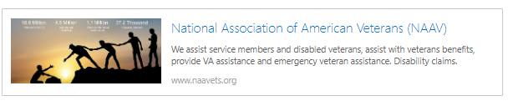

Kindest regards,
Constance A. Burns
CEO/President
Veterans Service Officer
NAAV, Inc.
Washington, DC

