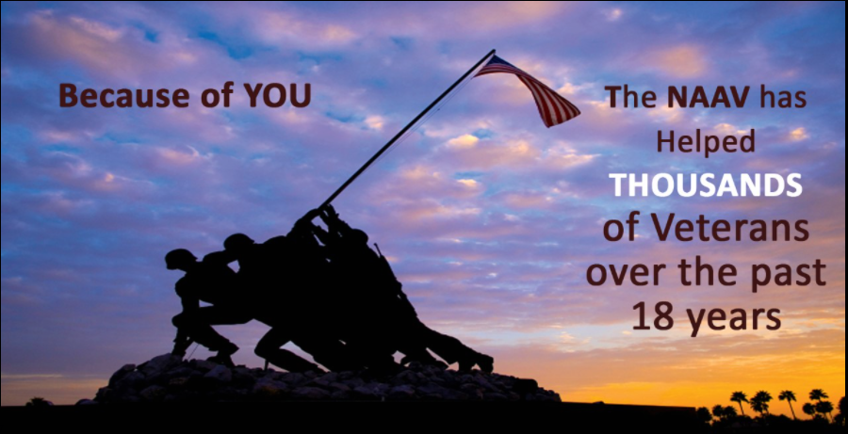  - National Association of American Veterans  (NAAV) Inc.  Tis the Season to fall in Line and Give Thanks with a Merry Heart  The National Association of American Veterans is pleased to share end of fall happens and warm December updates. NAAV has always been serving American Veterans and their family members. We gave thanks this Thanksgiving 2021 for your gifts, thoughts and prayers. Contributions and service provided towards our Veterans and their family members has not gone un-noticed. Let’s end this year as bright shining lights with gifts to bare. NAAV maintains a constant eye on, ears opened, and heart bent towards the mission of abundant giving to our Veterans throughout the nation and fulfilling their needs.  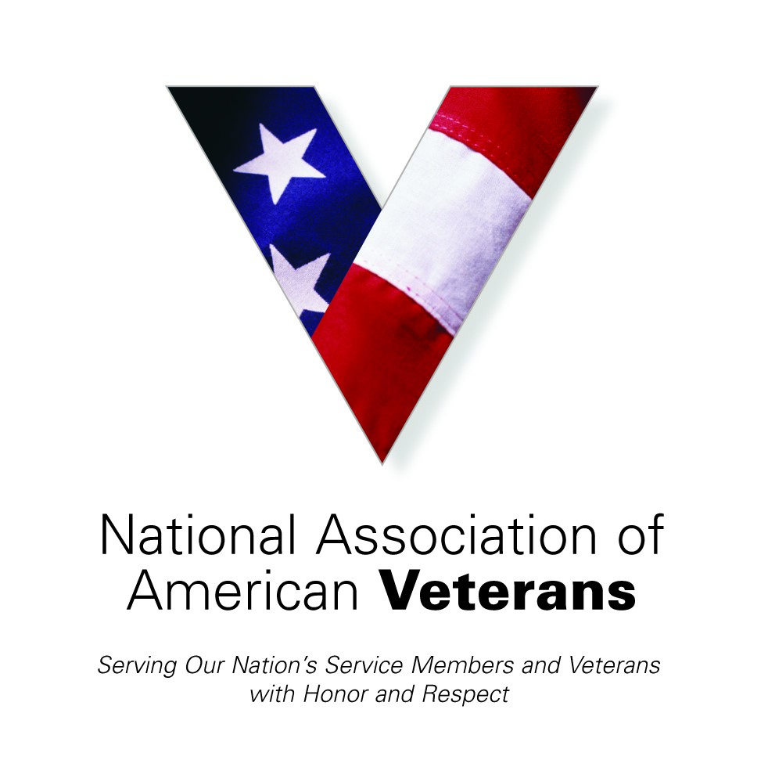 | Testimonials  ____  Oct, Nov, Dec 2021  ____  Fall/Winter Reviews Making a Difference  ____  Serving Those Who Gave So Much: American Veterans  ____  https://lh3.googleusercontent.com/proxy/bE1yJJCxYhDzyy5IckH3hyf_ligUU5Z5Fju0-FlhgCMVywZetJjk_zNnVJQcIc_Djo3G3rrhXNb7FrTWwGhdVCHkPeLFpcS3jtQAURMffuW57pOceUs41LQ83ux5AfPWorddExaeerRpt6nQ0IPoxTeOMWHwddVNNlStb5vnjFs  NAAV, Inc  1725 I Street NW Suite 300  Washington, DC 20006-2423  (202) 465-3296  Info@Naavets.Org

Fall Happens with Thanksgiving & Warm December Cheer… NAAV October, November, December ~Testimonies
NAAV is always pleased to share actions, activities, and resources spread out over this past year in response to the needs of our Veterans and their family members. With your continued support and the sponsorship of others, we once again have positive testimonies to report despite the continued ups and downs of our economy and the health, welfare and security of our nation. NAAV closes out this year with a measure of service to our American Veterans and their family members, which you helped us to ensure that their needs were met and for that, we are truly grateful and joyfully share:
October Knocks ~
On October 23, 2021, NAAV, Inc. donated two (2) new pair of female boots
and two (2) new pair of male boots to Access Housing, Inc. for the
Homeless Veteran Winter Haven Stand sponsored yearly by DC VA Medical
Center, Washington, DC.
- “Thanks, NAAV, Inc. for being one of our sponsors in support of Homeless
Veterans in the greater Washington, DC metropolitan area." Your support
and professional assistance is greatly appreciated! - Dwayne Jones,
Property Manager, Access Housing, Inc., Washington, D.C.

- Andre Bell, U.S. Army received emergency assistance funds for his power
and transportation in October 2021. "Thanks NAAV, Inc. for your
financial support and words of encouragement during my time of great
need. Your professional assistance is greatly appreciated." - Andre
Bell, U.S. Army Veteran, Georgia
- "Thanks NAAV, Inc. for providing emergency assistance for my mortgage in
October in the amount of $1,050.00. Thanks for your housing resources
and referrals to provide further guidance and direction on behalf of this
disabled Veteran spouse." - Kim Dillard, Illinois
- "Thank you NAAV, Inc. for support with my request for emergency food
assistance including providing your resources and referrals. I was able
to raise $800.00. Thank you again for adding $300.00 to this amount.
God bless your organization for helping those most in need with food." -
Leon Thomas, U.S. Army Retired Disabled Veteran, Georgia

November Falls for Giving ~
November 1, 2021, NAAV provided emergency food assistance to Robert Neville, U.S. Army Veteran, and his spouse as well as assistance with his VA claims and benefits including legal assistance with his
service-connected VA disability.

- "Thank you Ms. Burns and NAAV, Inc. your kindness made a difference and your thoughtfulness touched my heart. Thank you for the CD and emergency food assistance for me and my
spouse. Thanks again for everything you have done regarding receiving my VA Pension and current work to receive my VA service-connected disability.” – R.D. Neville, U.S. Army Veteran, Temple Hills,
MD
- November 12, 2021, NAAV, Inc. Donated Thanksgiving Turkeys with full
meal food items for 6 families at Access Housing, Inc. in Southeast
Washington, D.C. Access Housing Inc. DC is a non-for-profit corporation
providing housing and supportive services to homeless Veterans. Access
Housing, Inc. (Southeast Veterans Center) will be distributing frozen
Turkeys and Fix-Ins distribution to low-income and formerly homeless
Veterans, and their families, until supplies last.

- On November 15, 2021, NAAV, Inc. provided emergency support for Veteran
Thomas William Mills, of East Flat Rock, North Carolina. "Thank you
NAAV, Inc. for paying my emergency expenses this month. Your support
is greatly appreciated! - William W. Mills, U.S. Army Veteran, North
Carolina
- November 19, 2021, NAAV donated funds to purchase two (2) Christmas
trees from The Home Depot for Access Housing, Inc. in Southeast
Washington, DC. "Thank you.”

- “NAAV, Inc. for your continued support of our
nation's homeless Veterans and their family members. Thank you for your
support and professional assistance." - Dwayne Jones,
Property Manager, Access Housing, Inc., Southeast Washington, D.C.

- “Thank you NAAV, Inc., CEO and Staff for providing immediate emergency
assistance in support of my request for help with food and
transportation for me and my family. Your financial support of
$1,050.00 is gratefully and most needed due to the effects of COVID-19
pandemic." Wilbert B. Orr, U.S. Air Force, Veteran and Family,
Salisbury, NC

- Thanks, NAAV Inc., for providing emergency assistance for food,
storage, and shelter totaling over $600.00 at the In Town Suites due to
our homelessness since October 5, 2021. We thank you for helping us
locate housing with voucher that is due to expire in early January 2022.
We are thankful to our Lord God for His help through NAAV." - Craig and
Cynthia Gardner, Gulf War and OIF/OEF Veterans and Family, Hattiesburg,
MS
NAAV donates Christmas Trees: “I wanted to let you know that the trees have arrived
and the Access Housing veterans will be decorating very soon.” Joyous times…
December Remembers ~
The National Association of American Veterans, Inc. (NAAV) sent of 70
Christmas gifts to Service Members, Veterans, and their caregivers and
family members nationwide. Here are just a few of the thank you received
during the month of December.
- "Ms. Burns and NAAV, Inc. thank you for your kindness and difference you
make. Your thoughtfulness touched my heart. Thank you for the
emergency food assistance for me and my spouse for the holidays." - R.D.
Neville, Maryland

- Thank you NAAV, Inc. and staff. God is at home in a loving heart; He
lives in yours. I received your spiritual wellness books and CD for the
Thanksgiving and Christmas holidays. Thank you for your kindness." -
Princess Clemons, Raleigh, North Carolina
- Thank you NAAV, Inc. for your spiritual wellness books and CD." I am
very thankful for the difference you make in the lives of our nation's
Veterans and their family members." God bless you." - Pastor Phillip
Gaillard, U.S. Veteran, South Carolina
- "Thank you NAAV, Inc., CEO and staff for your gifts, emergency
assistance funds, and words of encouragement to me and my spouse who is
recovering from a brain stroke. Your continued support made a difference in our life.
- We thank our Lord God for sending NAAV, Inc. to us." God bless you and your staff." -
Eric A. Arrington, LTC U.S. Army (Ret), North Carolina
- "Thank you for your gifts (books and CD) it came to us as a pleasant
surprise for Christmas. Thank you again for your thoughtfulness!" -
Charlie and Lola Johnson, Maryland

Greetings and Happy Holidays,
Finally, “tis the season of giving.” As we close out this year, please know that you are appreciated.
On behalf of all our Servicemembers, Veterans and their caregivers and
family members, thank you so much for your generosity to the National
Association of American Veterans, Inc. (NAAV) and joining us in
providing emergency assistance, resources, and support to hundreds of
thousands of Servicemembers and disabled Veterans and their caregivers
and family members most in need nationwide.
Your donations to our 2021 CFC Charity Giving Events and NAAV
End-of-Year Campaign will help us provide the highest quality of life
and support to Servicemembers, disabled Veterans and their families who
face overwhelming medical and mental health challenges. Because you
care, your donation will:
* Help Servicemembers and Veterans suffering from post-traumatic
stress disorder, traumatic brain injury, depression, and suicidal
tendency.
*Assistance with VA claims and benefits including legal
assistance, if claim is denied.
. Caregiver Respite Care assistance and support.
. Emergency assistance resources and referrals.
. Housing and financial aid referrals and assistance.
. Career Coaching and medical transportation.
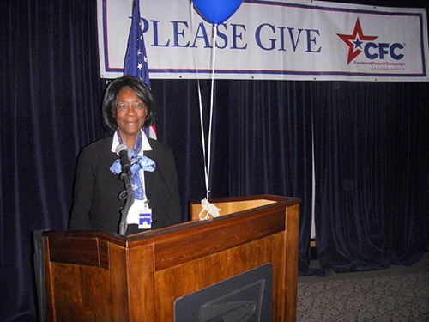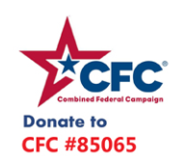
NAAV wants to thank you for making a difference in the quality of life for those who served and are serving in the United States Armed Forces. Remember it all helps and your donations truly can and do make a difference!
The fact is, we could not have provided these amazing services for the
last 18 years without your help, which is why your continued support is
so vital. Once again, thank you for sending your donation to NAAV, Inc.
via our website at www.naavets.org click on DONATE TODAY and via CFC
#85065 "Caring About Those Who Served" visit www.GIVECFC.ORG to donate.
Can we count on your donation of $25; $50; $100; $500;
$1,000, or whatever your heart encourages? It all helps! We look
forward to hearing from you no later than December 31, 2021.
Connect with the campaign on social media:
https://www.facebook.com/cfcnca (https://www.facebook.com/cfcnca)
https://twitter.com/CFCNCA (https://twitter.com/CFCNCA)
Thank you!
Kind regards,
Constance A. Burns
President and CEO
National Association of American Veterans, Inc.
1725 I Street NW Suite 300
Washington, DC 20006-2423
Office: (202) 465-3296
Mobile: (202) 355-3879
Email: info@naavets.org
Website: www.naavets.org click on DONATE TODAY!

https://www.google.com/url?sa=i&url=https%3A%2F%2Fwww.kindpng.com%2Fimgv%2FwwbiJT_graphic-transparent-stock-free-christmas-bell-clipart-christmas%2F&psig=AOvVaw15KDodSTNKSjDK_Lp8yEll&ust=1638774732285000&source=images&cd=vfe&ved=0CAsQjRxqFwoTCNCUzOCNzPQCFQAAAAAdAAAAABAJ

