- National Association of American Veterans  (NAAV) Inc.  Closing In  The National Association of American Veterans is bringing you the end of summer, 3rd Quarter Newsletter amidst the fall. This is not the season for the “fall of man,” but instead, the season we are falling into a new day. During the months of July, August, and September, NAAV was preparing its chest for a harvest of charity. During this 3rd volume, NAAV is highlighting the efforts and need to “close in” on giving towards the Combined Federal Campaign (CFC).  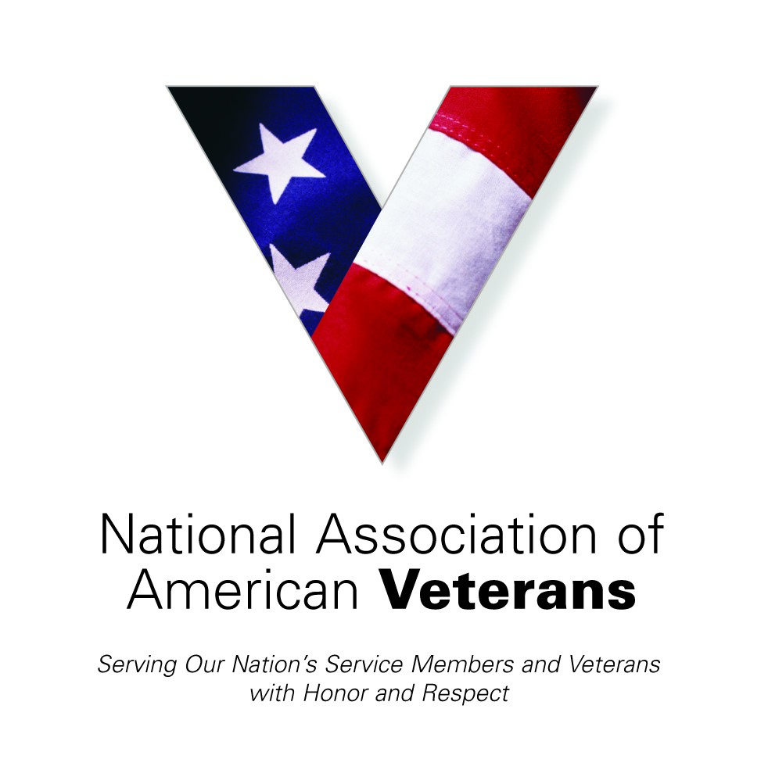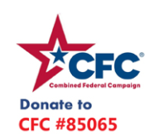 | 3rd Quarter Newsletter  ____  July, August, September 2021  ____  National Association of American Veterans, Inc.  ____  Serving Those Who Gave So Much  Featured: A Veteran’s Story R.M.K.  ____  Image source link:  https://wallpaperaccess.com/full/1172094.jpg  NAAV, Inc  1725 I Street NW Suite 300  Washington, DC 20006-2423  (202) 465-3296  Info@Naavets.Org

The Rise of Charity: Generosity in Action
NAAV is a proud support and participant of the CFC. Why? Because the CFC recognizes those in need and moves to give back. The concept of giving back without receiving is biblical in its principle root. To reference, “it is better to give than to receive,” consider the phrase “you reap what you sow; more than you sow, later than you sow—Quoted by Ministry Leader Dr. Charles F. Stanley taken from Galatians 6:7-8. This simply means, what you give or what you do, will be returned to you 10, 20 or 30 fold, be it good or bad; positive or negative, pleasure or pain.
“… Acts 20:35 states that “In everything I did, I showed you that by this kind of hard work we must help the weak, remembering the words the Lord Jesus himself said: 'It is more blessed to give than to receive” which teaches that there is joy in the act of giving when it is done with pure motives.” (https://www.tlc.qld.edu.au/news/gratitude-it-is-more-blessed-to-give-than-to-receive#:~:text=The%20Bible%20in%20Acts%2020,is%20done%20with%20pure%20motives.)
Charity in and of itself constitutes an effort to give and or to serve in and out of season. We’re closing in the time to give to the CFC as the announcements are rising and the doors are opening for us to give cheerfully and for others to humbly receive.
Charity Receives Thanks -Testimonies from July:
-NAAV, Inc. provided mortgage emergency assistance to Johnnie (US Army Veteran) and Hattie Miller of Sandersville, GA in July 2021 -
“Thanks, NAAV for your continued support and assistance. We are very thankful and appreciate your services.” – Johnnie & Hattie, Sandersville, GA
-Disabled Veteran is helped with receiving his Social Security Benefits in a timely manner and other health related concerns –
“Thank you, NAAV, Inc. for providing your resources, referrals, and guidance for receiving dental care in a timely manner. Again, thanks for your financial support during my stay at the Motel in Spotsylvania, VA. Your assistance is greatly appreciated!” -- Dennis Washington, Spotsylvania, VA
-Female Veteran Affected by COVID-19 Pandemic Outbreak receives Support from NAAV, Inc. -
“Thanks, NAAV, Inc. for providing your resources and referrals which enabled me to get my gas/power turned on and three months paid on my rent due to my unemployment due to COVID-19 pandemic outbreak in 2020. I am very thankful to the Lord God and your organization for your assistance! Praise the LORD!” -- Asia Taylor, Veteran, Leavenworth, KS

NAAV and the CFC:
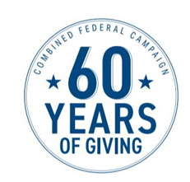

2021 Combined Federal Campaign Fundraiser Underway “You Can Be the Face of Change”
The National Association of American Veterans, Inc. (NAAV), motto “Caring About Those Who Served” will participate in the 2021 Combined Federal Campaign (CFC). NAAV’s work empowers and inspires the generosity of the federal employee community and working together with the CFC can have a positive impact. The 2021 Combined Federal Campaign Charity Fair Kickoff events will be conducted virtually due to COVID-19 worldwide pandemic.
NAAV and other nonprofit organizations have been asked to participate in the CFC Virtual Charity Fair by sending their stories, photos, and videos that will be accessible at www.GiveCFC.org and all local zone websites.
The CFC, the largest workforce charitable giving drive in the world, will began on September 1, 2021 to January 15, 2022. The campaign theme, “You Can Be the Face of Change,” focuses on the impacts and causes, donors care about. It is complemented by Show You Care messaging, which expresses and “shines the light” on the volunteer component of the campaign.
The National Association of American Veterans we fill a very important role and that is by helping on a day-to-day basis our severely injured Service men and women, disabled Veterans, their families and caregivers nationwide. Here in the National Capital Region, which includes DC, Maryland, and Virginia, the Combined Federal Campaign of the National Capital Area will host its 2021 Combined Federal Campaign Virtual Charity Fair on September 1, 2021.
The CFCNCA is the charitable giving program for federal employees and retirees within this region.
NAAV is one of the estimated 7,000 participating charities in this year’s fundraising campaign. The campaign gives donors many options to support the causes they care about. Whether one is passionate about Veterans, homelessness, education, mental health, disaster relief or any other cause, the campaign has a charity you can support.
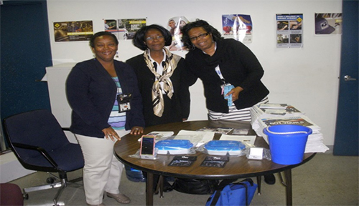
CFC is the only authorized charitable organization for solicitation of federal employees at their workplace. Federal employees who want to donate to Veterans or learn more about the campaign should speak with their organization’s key CFC leader. Federal employees and retirees can also visit www.cfcnca.org (https://cfcnca.org) or www.givecfc.org.
Consider making a donation to the National Association of American Veterans, Inc. by visiting www.givecfc.org or www.cfcnca.org (https://www.cfcnca.org). NAAV is a nonprofit organization classified under section 501 (c) (3) of the U.S. Internal Revenue Code. NAAV CFC number is 85065. Contributions to the NAAV in support of severely injured Service Members and disabled Veterans, their families, and caregivers are tax deductible to the extent allowed by U.S. Federal and local laws. Every dollar counts!
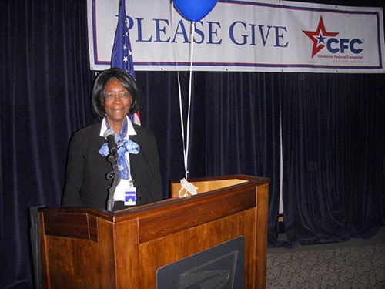
Thank you for making a difference in the quality of life for those who served and are serving in the United States Armed Forces. Remember it all helps and your donations truly can and do make a difference!
Connect with the campaign on social media:
https://www.facebook.com/cfcnca (https://www.facebook.com/cfcnca)
https://twitter.com/CFCNCA (https://twitter.com/CFCNCA)
https://www.Instagram.com/thecfcnca (https://www.instagram.com/thecfcnca)
https://www.linkedin.com/company/cfcnca (https://www.linkedin.com/company/cfcnca)
This information was posted in 2021 CFC/NAAV Fundraising News
NAAV is continuing to shine the “spotlight” on charity giving, and this season of announcing the CFC is here and seeking your presence on stage. So, step up and please considering giving.
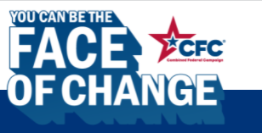 (givecfc.org)
American Veterans are our tangible and real-to-life heroes. Please consider even the smallest level of support… Give the gift. Be a gift. Support the CFC!

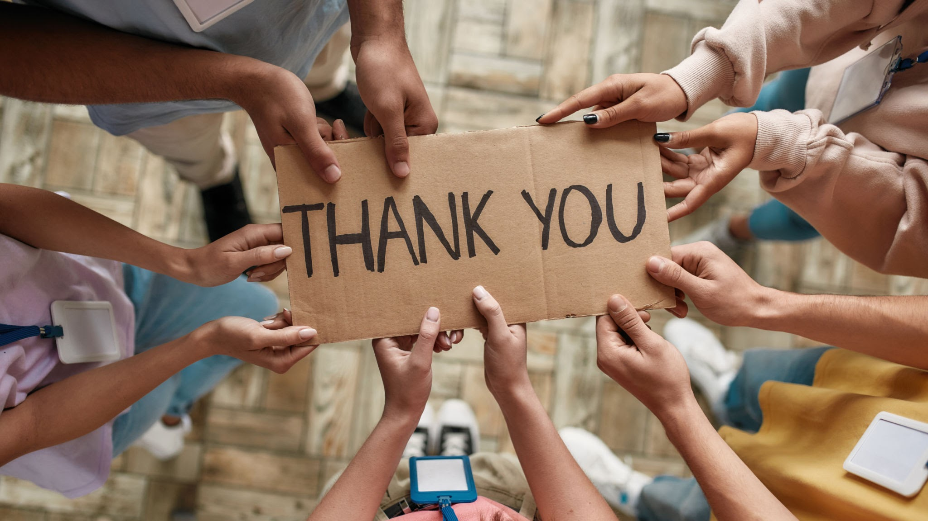 http://t1.gstatic.com/licensed-image?q=tbn:ANd9GcQA3DwOTEd69qmoI2zIvbmGVHTWlDEhSeFdsyBOXBra8f1wIsKI91QeXBhFeHCBuwHxCWV074JIIV4vr-jABl4

NAAV’s Featured Story:
A Veteran’s Story
by Kevin Kraft in Honor of His Father Robert Michael Kraft

~Robert Michael Kraft
Jan 14, 1936 - Aug 17 2020
My father’s soul took flight on Monday Aug 17. A least, that’s how I
prefer to think about it. He was a career naval pilot and always talked
about flying like it was a transcendent, mystical experience, full of
beauty and awe and peace. Perhaps it was the closest he felt to his
understanding of God. If he is having any kind of experience now, I
hope it is something akin to the joy flying brought him when he was with
us.
It has taken me some time to process my feelings and formulate what to
share about his passing and his life. I found it hard to be brief.
Although he was 84, his transition was somewhat surprising since earlier
in the year he had been hospitalized with COVID-19. For 78 days he was
not allowed any visits from family, or to go outside, or to even leave
his hospital room. After surviving that, we thought he was a tank and
he’d be with us for a good long time. But just a few months later, he
suddenly could not be woken from sleep. Dad had had some kind of minor
stroke due to lack of oxygen to the brain. He had some pre-existing
vascular issues which had likely been exacerbated by the COVID-19.
Although he did eventually wake up, he was just not the same and needed
24 home care. His fight was gone and he was declining fairly steadily.
With his situation not looking great, I took my son Leo for a visit with
him at what had been my childhood home, where he had a hospital bed set
up in the first floor family room. Dad had been Covid-19 negative for many
months by this time, so a visit was possible, but it was hard to connect
with Dad because he was asleep most of time. I helped feed and change
him, massaged his hands and arms, and talked to him whenever he was
alert.
I looked around...although he had recently lost clear vision, books
still adorned his bedside table, as did his still active Washington Post
subscription. Dad was always a voracious reader and was very
knowledgeable (and opinionated)! He was a particularly ravenous
consumer of history, biographies and political commentary. So I asked
him if I could read to him. Through closed eyes, he said yes…
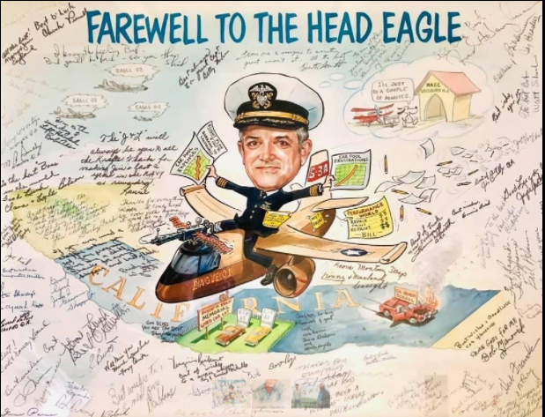
(*For the full story, please visit the NAAV website at NAAV.Org. under “Veteran Stories”)
NAAV is closing in on a new season as we close out on another. Thank you to every individual, organization, and/or service who has been a part of unyielding journey. It has and will continue to be an honor to serve those who have given so much. As we post this 3rd Quarter Newsletter during the month of November, we would like to pay respects in recognition of “Veteran’s Day” to all those who dedicated their lives to the service and protection of others, and to their families who supported them through humble sacrifice. We salute and thank you!
Kind regards,
Constance A. Burns
CEO & President
NAAV, Inc.
Washington, DC

https://media.istockphoto.com/vectors/stage-spot-light-shining-down-with-particles-in-the-air-vector-id468505302?k=6&m=468505302&s=170667a&w=0&h=SUTqviladeKNudb_XQH-Hcww8zXPmPaIoS9Uj6Y5uEs=
https://thumbs.dreamstime.com/b/white-spotlight-shining-colorful-background-vector-illustration-65305666.jpg

