- National Association of American Veterans  (NAAV) Inc.  Summer Happens  The National Association of American Veterans is pleased to share bits of summer happens. Our organization is all about serving American Veterans and their family members. Although seasons come and go with changing wind, rain, sun, clouds, budding flowers and falling leaves, our Veterans and their family members remain a steady root for which to cultivate. NAAV maintains a constant eye on, ears opened, and heart’s mission towards fulfilling the needs of our Veterans throughout the nation.  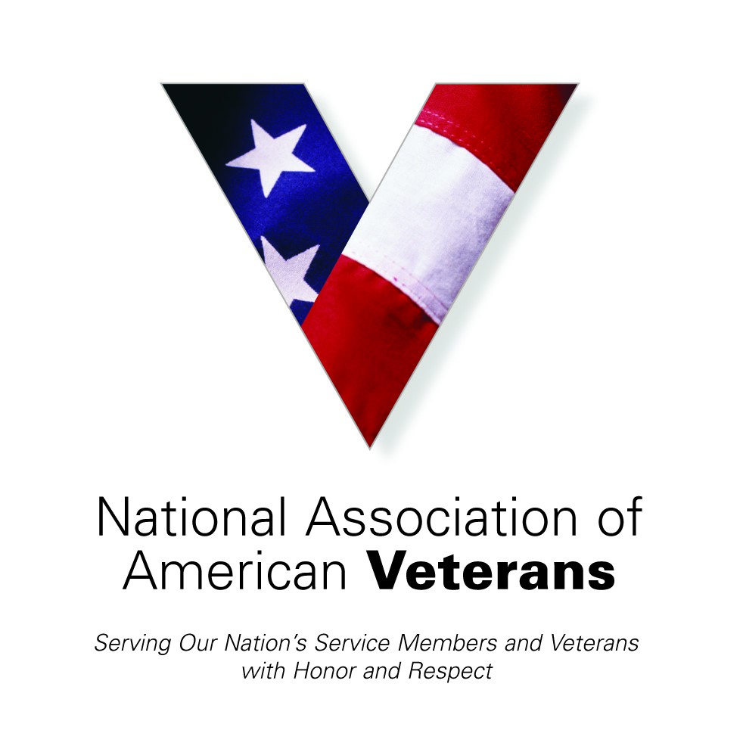 | Testimonials  ____  July, August, September 2021  ____  Mid-Summer Reviews “SPOTLIGHT ON AUGUST”  ____  Serving Those Who Gave So Much: American Veterans  ____  Image source link https://www.google.com/url?sa=i&url=http%3A%2F%2Fwww.villagetherapy.org%2Fblog%2F2018%2F6%2F3%2Fthe-summer-slow-down&psig=AOvVaw1ymsA7CfeHq3uBMmvqt7rI&ust=1633265343271000&source=images&cd=vfe&ved=0CAsQjRxqFwoTCNjHnePhq_MCFQAAAAAdAAAAABAD  NAAV, Inc  1725 I Street NW Suite 300  Washington, DC 20006  (202) 465-3296  Info@Naavets.Org

Summertime Happens… NAAV July, August, September Testimonies
NAAV is pleased to share actions, activities, and resources spread out over the summer months in response to the needs of our Veterans and their family members. With your support and the sponsorship of other, we have positive testimonies to report despite the continued devastation of COVID-19 pandemic, national disaster, and heightened crime wave, among other notable national and international (including economic and military) situations. NAAV does not measure in quantity, rather it’s the quality of service and beneficial results that drive our measure of dedication and success.
July Tells the Story: Meeting Needs
-NAAV, Inc. provided mortgage emergency assistance to Johnnie (US Army Veteran) and Hattie Miller of Sandersville, GA in July 2021 -
“Thanks, NAAV for your continued support and assistance. We are very thankful and appreciate your services.” – Johnnie & Hattie, Sandersville, GA
-Disabled Veteran help with receiving his Social Security Benefits in a timely manner and other health related concerns –
“Thank you, NAAV, Inc. for providing your resources, referrals, and guidance for receiving dental care in a timely manner. Again, thanks for your financial support during my stay at the Motel in Spotsylvania, VA. Your assistance is greatly appreciated!” -- Dennis Washington, Spotsylvania, VA
-Female Veteran Affected by COVID-19 Pandemic Outbreak receives Support from NAAV, Inc. -
“Thanks, NAAV, Inc. for providing your resources and referrals which enabled me to get my gas/power turned on and three months paid on my rent due to my unemployment due to COVID-19 pandemic outbreak in 2020. In addition, thank you for paying to have my water turn back on the same day! I am very thankful to the Lord God and your organization for your assistance! Praise the LORD!” -- Asia Taylor, Veteran, Leavenworth, KS
-Veteran and his Spouse in receive emergency assistance from NAAV, Inc., with support from the Home Depot in Sacramento, CA-
“Thank you NAAV, Inc. and the Home Depot for providing emergency assistance for our home, e.g., most needed washer/dryer, dishwasher, and indoor fan and help with submission of a home grant for a new roof and home air conditioner that were both beyond repair. Thanks again for the indoor fan to help keep us cool in Sacramento, CA during these hot summer months!” - Donald (Navy Veteran) and Spouse Deborah Ramsey, Sacramento, CA

Spotlight on August Redemption and Featured Revelations:
- NAAV provided emergency mortgage assistance and financial counseling via our NAAV Advisor Mary Sprague on August 24-26, 2021.
Johnnie (Veteran) and Hattie Miller of Sandersville, GA
“First thing I will say is, oh how I love Jesus and all His many wonderful blessings. He reach way down and pick me up out of the miry clay. I thank Him for beginning a good work in me and my wife. I know He's going to see to it that we finish it in Jesus’ name.
Now I thank my Heavenly Father for Ms. Constance Burns and for letting me get to know her. Ms. Burns is truly a faithful servant of the Great High Priest. She is gifted with great wisdom, love, and patience. Those are the qualities that was needed for her to help me find my way and get back on the right path. The path that I know my Heavenly Father intended for me to be on.

Being a born again child of God I know I am supposed to be a lender and not a borrower. But I did things like a lot of my fellow Christians brothers & sisters do. I was doing things my way and thinking it was about me. So I ended up getting myself into a bad place financially. I mean I would pay-off one loan and get another soon after. I was splurging my money on unnecessary things instead of using my money on the important things. My wife have threatened to leave me numerous times during our 25 years of marriage. She keeps on forgiving me through it all and is still by my side. I thank my Heavenly Father for bringing me & my wife Hattie Pearl together because He is the One who is keeping us together. I thank God we're equally yoked together as Christians. To that I will say: What God has put together let no man put asunder.
Finally my journey is a blessed one, it just the wrong decisions I've made by not letting the Holy Spirit lead & guide me. My priorities was way out of place. Almost lost my home, my marriage, and my peace of
mind. But thanks be to God, my wife, my church family, and Ms. Constance Burns, I am back on track. I am redeemed thank God. Kinda feel like the situation with the prodigal son being welcome back home by his
father.” Sincerely Thanks, Johnnie & Hattie Pearl
- SSG Andre Bell, U.S. Army OIF Columbus, GA
"I am writing this to inform I'm everyone who is a Veteran, Disabled Veteran or a retired Veteran. I understand there are a lot of organizations out here who say they can and will help you, but unfortunately if you are like me in one way or another it is not easy.
You don't need help with school because you're not in school there's a united school and the healthcare you have is paying for most of your health care, which in turn is a good thing to get help with and people do need help.
Meanwhile, when you need help with bills whether it's rent, car payment insurance, or power bill and I want to say I am grateful for the National Association of American Veterans, Inc. (NAAV) based out of Washington DC. They helped me through a lot of emergency situations and problems that disabled Veterans are going through. NAAV wants to help more vets and do more. Unfortunately, donations have been low due to the COVID-19 pandemic outbreak so if you want to donate to them this is the organization I will highly recommend. NAAV help more people and they're doing more for vets of all kinds than a lot of big name organizations who claim they're doing more than they are.
I'm not one just to accept what someone tells me so look them up yourself, even give them a call and you will see exactly what I'm talking about please donate today to them so they can help other vets like myself and others so we can try to build each other up and know we're not alone. THANK YOU!"

- Spouse of a Disabled American Veteran: Why I support the Non-profit Organization, The National Association of American Veterans, Inc. (NAAV)
“The NAAV plays a vital role in building healthy military and Veteran families who are most in need, across the nation and worldwide. They provide critical services and information that contribute to the economic stability and mobility. The NAAV strengthens military and Veterans families most in need in other ways.” Non-profit leaders are the voice of the people they serve!
Mrs. Johnson
August 2021 spotlight continues…
- Female Veteran Receives Emergency Assistance from NAAV, Inc.
"Thank you NAAV, Inc. for paying my water bill on Friday, August 20,
2021. I am a female Veteran affected by COVID-19 with loss of job and
returning only two weeks ago to learn that the agency that promised to
help me said they could not until mid-September 2021. I called NAAV,
Inc. and my water was turned on in less than 4 hours! Praise the LORD!
Praise the LORD! I am very grateful to NAAV, Inc. and its CEO for
providing immediate emergency assistance." -- A. Taylor, Leavenworth,
Kansas
"Thanks NAAV for providing VA claims/benefits assistance for my
service-connected claims currently pending a decision from the VA Rating
Committee and my attorney referred to me by NAAV, Inc. I am 89 years
old and sincerely appreciated your support in obtaining my VA pension in
2017. I am very grateful to have your support and professional
assistance." -- R. Neville, Temple Hills, Maryland
For it is good to give thanks in all things great and small ~
“Blessings to you Ms. Burns, and good morning. You know, my mother has
always told me that God is an on time God. Thanks to his servant you, and the NAAV, my prayers were answered. I know it was God because I didn't tell you what was needed. But God knew, and he's an on time God!
So I want to thank Him, you, and the NAAV for helping me in my time of need. Now I can relax and have my surgeries and not worry about food.” Lola, Caregiver of Gulf War Veteran, Upper Marlboro, Maryland
- NAAV Provides Emergency to Veteran Most in Need –
“Thank you NAAV, Inc. and your CEO for ensuring that my water and gas were not turned off on the 5th of August 2021. Thanks for your emergency assistance and financial support to those who served and most in need of your services.” -- Clifford D. Gunkel, Burgin, KY

- NAAV provides VA Claims/Benefits and Legal Assistance to Disabled Veteran and his Spouse –
“Thank you NAAV, Inc. and your Veterans’ Service Officer for providing VA Claims/Benefits and legal assistance referrals as well as your guidance and direction on behalf of my service-connected disability claim. Thanks for successfully completing my VA Pension Application in 2017. I am very grateful and appreciate your services in support of those who served.” - Robert Neville, Temple Hills, MD
August 2, 2021
- NAAV, Inc. Caregiver Support and Assistance to Veterans and Their Family Members –
“Thank you NAAV, Inc. for your letter of encouragement and for the emergency assistance support! Thanks again and God bless you for your legal referrals and resources to help provide guidance and direction to caregivers. Your support and assistance are greatly appreciated!” - LTC Eric A. Arrington, U.S. Army (Ret) and Spouse Deborah Arrington, Mebane, NC
August 5, 2021
- Patricia Morris – Senior Housing Assistance and Housing Grant Funding via NAAV, Inc. for family member of a disabled Veteran
“Thanks, NAAV, Inc. for providing your assistance with senior housing and medical transportation for me in the District of Columbia, Washington, D.C. and in the Metro Area to include Maryland. Your professional assistance is welcomed… God bless you!” - P. Morris, D.C.
September the last month of summer to remember:
NAAV would like to thank you all for journeying with us this summer. As the book of Romans, chapter 8 verses 38-29 says: “For I am persuaded, that neither death, nor life, nor angels, nor principalities, nor powers, nor things present, nor things to come, ³⁹Nor height, nor depth, nor any other creature, shall be able to separate us from the love of God, which is in Christ Jesus our Lord.” (KJV)
That testimony, as stated by the Apostle Paul, also holds true for NAAV and our commitment to caring for the needs of our American Veterans and their family. We trust your summer months have touched you with warm pleasures and we look forward to autumn leaves blanketing your path with a cool breeze of joy.
Kind regards,
Constance A. Burns
CEO & President
Veterans’ Service Officer
NAAV, Inc.
Washington, DC

https://media.istockphoto.com/vectors/stage-spot-light-shining-down-with-particles-in-the-air-vector-id468505302?k=6&m=468505302&s=170667a&w=0&h=SUTqviladeKNudb_XQH-Hcww8zXPmPaIoS9Uj6Y5uEs=
https://thumbs.dreamstime.com/b/white-spotlight-shining-colorful-background-vector-illustration-65305666.jpg

