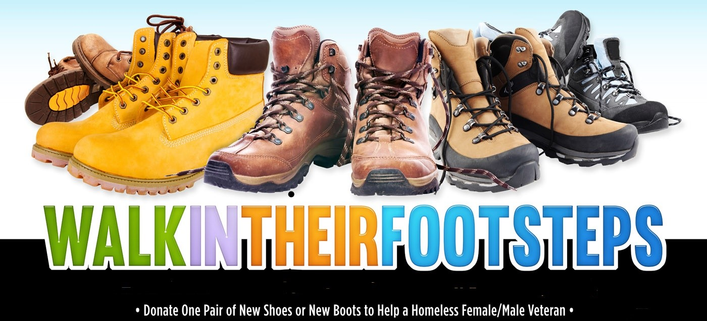

Collection Dates: September 20, 2021 – November 12, 2021 Contact Person: Walter Elmore, Volunteer Coordinator
Southeast Veterans Service Center (SEVSC)
820 Chesapeake Street, SE
Washington, DC 20032
202-561-8389
Welmore@accesshousingincdc.com

