National Association of American Veterans, Inc.
First Quarter 2021 ~ Testimonials
January-March
I am guessing that you like me are shaking our heads thinking, it’s the end of March 2021 already? When, where, how this happened so quickly, it seems we just stepped out of 2020. Well, for me I thought to answer my own question with: perhaps because we brought many of the same situations and circumstance into 2021, forgetting or unable to drop them at the end of the 2020 curb.
There is a familiar cliché that goes “out with the old, in with the new,” upon the onset of a new year. However, we must keep in mind that, “Jesus Christ is the same, yesterday, today, and forever” (Hebrews 13:8 KJV), when we are in the center of His will and because of that, something might not change, instead we endure, by His grace and mercy.
NAAV recognizes the continued devastation the COVID-19 Coronavirus has had on many lives and particularly the lives of our American Veterans and their families. NAAV is still acknowledging, processing, and serving the needs of those affected by this worldwide pandemic and those efforts have carried over from 2020 into 2021 to the point that, while three months have passed into the new year, NAAV’s torch is still burning and wagon wheels still turning.
During this first quarter of 2021, NAAV has responded to several requests for assistance and responded in a number of ways to address those petitions. Please join us as we proudly report positive strides during January, February, and March as the ensuing testimonies attest.
In memory of:
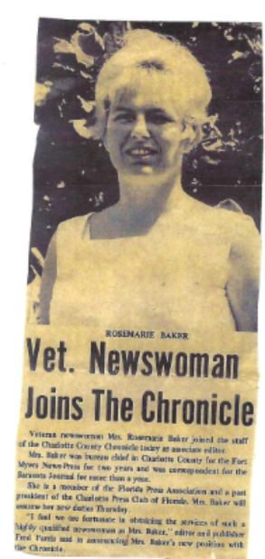
NAAV forwarded a letter of condolences to the family of Mrs. RoseMarie Mikolajczyk-Baker
Good morning, Christopher and Deborah Dooley and Family.
You should be receiving a gift in memory of RoseMarie Mikolajczyk-Baker from the National Association of American Veterans, Inc. (NAAV) on Saturday, March 20, 2021 via the U.S. Postal Service. NAAV received a reply from the Lonnie G. Bunch III, the 14th Secretary of Smithsonian Institution and served as Smithsonian’s founding director of the National Museum of African American History and Culture (NMAAH) regarding an appraiser for RoseMarie's original donated (90) paintings and artwork to NAAV, Inc. NAAV has been in contact with the appraisers’ association in Virginia recommended by Smithsonian Institution and waiting a reply.

Image/painting by Rose Marie: In My Garden
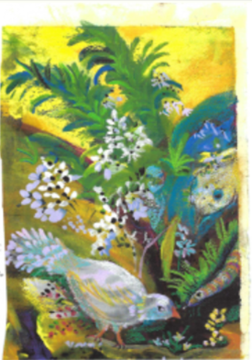

- NAAV contributes to the shelter of a grateful disabled U.S. Navy Veteran and family members for two nights at Super 8:
“I and my kids love you. You have done so much for us and others you made a big difference in our life and Veterans all over. I want to meet you in person some time I will get my car ready for a long-distance trip. I have roadside assistance and I hope to see you soon. I will find out how far it is I would love ❤ to meet you. My kids and I think you are a God sent from heaven. One more day up north would have been a nightmare for me. God always gets me out of a jam right when I need it most all thru my life you got me back on track. Thank you!” -- Mr. Dennis Breault, Sr., U.S. Navy (Ret), White River Junction, VT
- NAAV provide emergency assistance and money for food and gas during his period of homelessness. He was given assistance with car repairs, housing and food this week.
“Hi Ms. Burns,
Here is a brief summary for your website. I am sending out an email to
several other Veterans organizations to see if they can help in your
endeavors. I will copy you in the email. Hope all is well and the birds
still chirping:)
I am a U.S. Marine Veteran who for the first time am experiencing
Homelessness. I reached out to (877) 4aid-vet, as many do. I was given
numerous numbers approximately 10. 8 said they didn’t offer temporary
assistance, one helped with the SSVF process and the last was a small
organization “National Association of American Veterans” that went
above and beyond. I was given 6 days stay at a nice hotel and a $150.00
per diem. A week later I received a new job in Texas and NAAV purchased a new car starter at the Auto Zone for over $249.00 for my car. Many Veterans such as I am too proud to reach out until it is too late and end up on the streets. The Government programs are a
help, but immediate assistance is non-existent.
We need programs like NAAVETS to be there when vets need help, not after
jumping through hoops for assistance. It was a game changer for me to
have someone eager to help and it was more about me, as a Veteran, than
someone collecting a paycheck to talk to me. I’m thankful for this
great organization.” SGT Simms, USMC”
- Black History Month Award Presented to NAAV CEO/President on February 14, 2021
“On behalf of the MG Leigh Wade Chapter, MOWW, a donation of $300.00
was mailed to you today” Doug Roderick Col USAF (Ret)
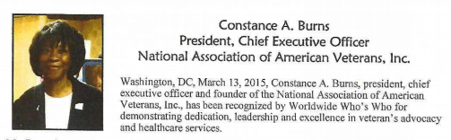
A note from the CEO and President of NAAV upon receipt of this special award:
“I received the Joint Base Myer-Henderson Hall Gospel Service Black
History Month Award and Program. It was an outstanding program. Thanks
again for representing NAAV and me at this historic event. My sincere
thanks and appreciation to all involved with this program.”
- NAAV receives monetary award for continued support to Veterans from Thrivent Choice
“We are excited to share that a deposit of $120.00 is coming in the next
few days to your account. We hope this gift on behalf of Thrivent
Choice® helps to further support your important work.”
- NAAV Advocates for Homeless Veterans and Their Family Members in Vermont… People Reaching People:
“Hello Ms. Constance,
Thank you for taking my call so late. Forgive me for interrupting your Bible study.
If you need to speak with me or a veteran experiencing homelessness is in need of some advocacy support in Vermont, don't hesitate to contact me.” All the best,
Michelle Caver
- Search for Family Members After DNA Testing, Ends in Success with the Help of NAAV in December 2019:
“Thank you very much for your assistance which enabled me to find my
family living in Texas, following a DNA test which proved we are
indeed my family I have two brothers and two sisters, we have now been
corresponding with other on a daily basis to find out about each
other.
Thank you very much you have my eternal gratitude.”
Solon Neal Reynolds
“Ask and it shall be given to you; Seek and ye shall find; Knock and the door shall be opened…” (Matthew 7:7-8 KJV)…Good things to come!
As a glimpse into how often the NAAV website is viewed and others in need of assistance is real, we want to share with you the magnitude of what your continue support and assistance covers… There is a sincere need:
- Total number of visitors to our website as of January/February 2021
  - Over 187million
  - Past 24 hours over: 1million
  - Past week over: 436k
  - Past month: 1,4million
  - Past year 2020 over: 2,6million from 2/2/2020 - 2/1/2021

January 2021 Testimonies:

- "Thank you NAAV, Inc. for keeping my family from becoming homeless in
January 2021 by paying our current rent and talking to our landlord to
remove all of our late fees and allowing my family more time to get the
necessary funds to stay in good standing in January and February 2021.
Praise the LORD!" S. Smiley, Laurens, SC

- “Thank you NAAV, Inc. for assistance with our electric bill and three men shirts
for by husband Henry a disabled Vietnam War Veteran. We greatly appreciate
your financial support.” – M. Purdie, Caregiver, Chickasaw, AL
- "Thank you NAAV, Inc. for providing financial assistance toward the
total balance owed on our electric bill on February 1, 2021 a very cold
day in our nation's history. I am a Veteran of the war in Iraq from
2004-2005 and I served this nation for 12 years with honor. My daughter
and I are very thankful and grateful for your emergency assistance ...
HOOAH! HOOAH!" -- M. Voss, Murfreesboro, TN
- NAAV also received several calls nationwide for VA claims and benefits
and legal assistance.
- In January 2021, NAAV sent a food certificate in the amount of $200.00
to Janice Wimbish, a widow of a deceased in Washington, DC as well as
emergency funds in the amount of $625.00 including referrals for legal assistance. "Thank you NAAV, Inc. for your emergency assistance with food,
household support. Your support is greatly appreciated.
Thank you!" -- J. Wimbish, Washington, DC
- NAAV sent caregivers and those disabled Veterans most in need of
encouragement over twenty-five (25) free copies of "The Promise Is Still
Valid" by Dr. Pastor Byron J. Williams, U.S. Air Force (Ret) and a NAAV
Spiritual Wellness Counselor in January of 2021. NAAV received many
outstanding testimonials regarding Dr. Byron J. Williams book sent to
them by NAAV, Inc.
- "Thank you NAAV, Inc. for the letter of appreciation sent to my dad
Burton W. Jones a World War II Veteran of the U.S. Army Air Corps in
1942. He will be celebrating his 100th Birthday on February 1, 2021 at
the Masonic Care Community Queen's Household in Utica, NY. We greatly
appreciate NAAV's story about my dad place on your website in January
2021. Again, thanks for all the birthday cards received from members of
your staff and board of directors. Your support is greatly
appreciated!" -- Priscilla Jones Heburn, Utica, NY

- “Thank you NAAV, Inc. for paying $395.95 toward my electric bill and ensuring that your partner Operation First Response paid $397.65 toward my Alabama Power Company bill now I am able to pay the remaining balance of $167.00 for keep my power on in February 2021. God bless you and your staff for your financial support. Thank you!” -- Larry T. Jackson, U.S. Army Veteran (Ret), Adamsville, AL

- “Thank you NAAV, Inc. for ensuring that assistance was provided through your
resources from Priority Veterans to pay my electric bill in the amount of $2,161.59
owed to the Alabama Power Company in February 2021. My power has been

off since 2020 due to the loss of income and the effects of the COVID-19 pandemic in 2020. I am very pleased to have heat and electricity on again! Thank you!”
--L. Armstrong, Birmingham, AL
- "Thanks, NAAV, Inc. for the complimentary DVD for chair exercises for me
and husband a U.S. Navy Veteran of the Gulf War. We appreciate your
continued support and professional assistance!" -- Charlie and Lola
Johnson, Upper Marlboro, MD

- “Thanks, NAAV, Inc. for your assistance in getting our plumbing repairs paid in
our home of seventy years. Our first bill was over $4,150.00 and you were able to get
lowered to $2,000.00. And now you are working with The Home Depot get the
balance paid via their Servicing Veterans Program. My husband and I are truly
gratefully for your tireless effort in support of those who served. Thank you for a job
well done!” -- J. and T. Baker, U.S. Navy Veterans, Round Lake Beach, IL

In addition, NAAV would like to thank the BKM Strategies on behalf of TracFone Wireless, Inc., for their contribution of $5,000.00; Harvey R. & Susan S. Durham for their donation of $100.00; and COSTCO Wholesale #200 contribution for $100.00 received in March 2021 in support of those who served and are serving in the U.S. Armed Forces nationwide.
Thank you all for your continued support, prayers, resources, and financial giving to NAAV, Inc., this great work could not be extended without your kind and generous offerings of time, talent, and support. We are truly grateful! Happy Springtime.
Warmly,
NAAV, Inc.
CEO/President
Constance A. Burns
Washington, DC

