Volume 01 21 | Issue 1 | National Association of American Veterans
January ~ February ~ March 2021

From the Editor: A note to our dear NAAV family, supporters, volunteers, sponsors, and friends, we unfortunately were not able to produce the 2021 1st Quarter Newsletter as anticipated due to unexpected circumstance. Nevertheless a few of the highlighted sources and resources are being shared with as NAAV is always committed to caring about those who have served and given so much. We hope you can pardon some of this excluded information; however, if you visit the NAAV website at naavets.org you will find a collection of information and helpful resources.
But first a short prelude to what would have been our 1st Quarter Newsletter Insight:
Yes, I can imagine what you might be thinking… 1st Quarter Newsletter 2021? Well assuredly, it is that time of the New Year. In 2020’s 4th Quarter Newsletter 2020, we committed this statement:

tHIS 4TH QUARTER IS COMING YOU AS A TESTAMENT OF STEADFAST FAITH AND HOPE. 2020 BEGAN WITH UNEXPECTED CHALLENGES AND AS WE COME TO THE END OF A YEAR NO ONE COULD HAVE PREDICTED, WE MUST CHOOSE THE LIGHT.

We chose the light. That is the light of God in our hearts and the light of Christmas colors and expression of glad tidings and good cheer. Now, this New Year 2021, the National Association of American Veterans (NAAV) is here to state we stand on the same sentiment i.e., we choose the light. Even more so as the day light becomes longer and the sun shines a little brighter, we choose to see the movement of life in the light of service toward our American Veterans and their family members… To serve to the best of our ability. Our best ability is not quantitative, but instead qualitative as we can measure based on observations not the numbers there of… Generally speaking, if we can only at this point assist one veteran or family over the past three months with any fulfillment of hope and support, this is a good measurable report.
The CEO and President of NAAV, has always does tirelessly work for the benefit of others. During her move from the office on 18th NW, D.C. to the confines of her home, she transferred fax, phone, and computer to her countertop at arms-reach through a gaze that never lost sight of its target—our American Veterans and their family members.
In 2020, the COVID-19 pandemic outbreak kept NAAV staff and volunteers closer to home. NAAV’s program partners and sponsors are staying close by as well. Because of our early preparations, we have had no cases of infection with any of NAAV’s locations at the VA, DoD and non-VA facilities and we are praying that will continue. Because of our supporters, caring friends and business partners, NAAV, Inc. has been able to provide emergency assistance and resources, food gift certificates and other household items to those most in need including words of encouragement.
Although the coronavirus (COVID-19) pandemic continues to spread throughout Metro Washington, DC Area, and our nation, due to NAAV’s early and effective efforts, we have had no confirmed COVID-19 infections among our staff, volunteers, partners and sponsors. Our health checks, sanitizing, protocols, and social distancing programs, telework are working to keep our programs and services open via the Internet, Zoom, Webinars, and Conference Calls. Your continued financial support help to make this possible, but we still need your financial support to ensure we continue to serve those most in need during what is sure to be a financially challenging period ahead of us. You can donate to our COVID-19 pandemic effort at www.naavets.org click on DONATE TODAY! In addition, we have included a tab for our 2020 NAAV’s Combined Federal Campaign (CFC) number 85065 to enhance our federal employees and federal retirees’ contributions in 2021 and beyond.

This 1st Quarter 2021 Newsletters commits to provide updates, events, and information to serve and support the lives of Veterans and Veteran family members.
Resources:
Resources for Student Veterans During COVID-19
https://studentveterans.org/news/covid-19-resources-for-student-veterans/
SNAP Benefits
https://militarybenefits.info/snap-benefits/
VA Housing Grants for Disabled Veterans
https://www.benefits.com/veterans-disability/housing-for-disabled-veterans
Current VA Loan Rates Available Locally
https://www.mortgagecalculator.org/mortgage-rates/va.php
Top 60 Veteran & Military-Friendly Employers
https://info.recruitics.com/blog/top-veteran-military-friendly-employers-for-2020
Identity Theft- IDstrong.com.
I have an interesting resource that would be helpful for our veterans
and warn them about the dangers of identity theft while they are serving
our country and how not to become victims. 15% of identity theft victims
are VETERANS! To find out more, visit website:
https://www.idstrong.com/sentinel/how-veterans-are-becoming-victims-of-identity-and-credit-file-information-theft/
VA OFFICIALS SEE ‘DIGITAL DIVIDE’ AS BIGGEST REMAINING TELEHEALTH
OBSTACLE - Telehealth
https://www.meritalk.com/articles/va-officials-see-digital-divide-as-biggest-remaining-telehealth-obstacle/
After a year of moving IT heaven and earth to enable a huge jump in
telehealth services for Veterans during the coronavirus pandemic,
officials from the Department of Veterans Affairs (VA) said March 23
that one of the biggest remaining obstacles to delivering telehealth is
a lack of sufficient and/or affordable broadband service in areas where
some Veterans live.
VA’s success in ramping up telehealth services during the pandemic has
been well documented [1], with daily service capacity rising ten-fold by
mid-2020, to 35,000 appointments per day and the ability to hold 17,000
concurrent sessions. By February of this year, VA was averaging 45,000
telehealth visits per day, up from just 2,500 per day in March 2020.
With firm plans to keep moving forward with telehealth into the
post-pandemic era, VA officials said at an event organized by AFCEA
Bethesda that a lack of robust broadband infrastructure – along with
affordability and service uptake issues among some Veterans –
represents a big hurdle to further progress.

NAAV CEO/President was given the Keeper of the Community Award for Black History Month at Fort Myer, Virginia on February 14, 2021 for her unwavering and demonstrated dedication, leadership and excellence in Veteran’s advocacy and healthcare services. Your invaluable and consistent support for our Service Members, Veterans and Military Families reflects highly on your professionalism and selfless service. A true leader of the highest order. We salute you. NAAV Board of Directors Member, Roy L. Croom, U.S. Army (Ret) was present to receive the award for NAAV, Inc.
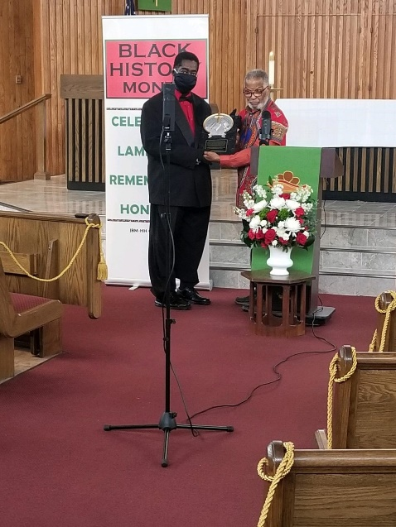
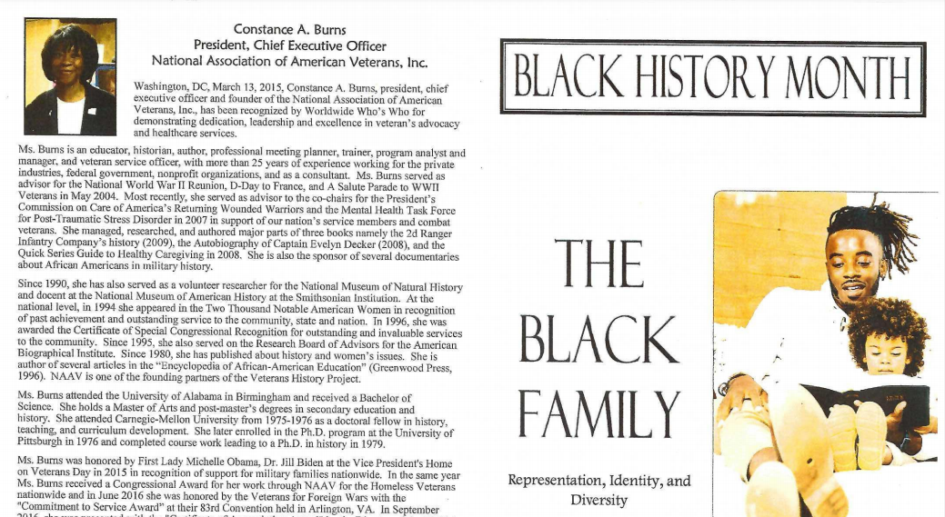
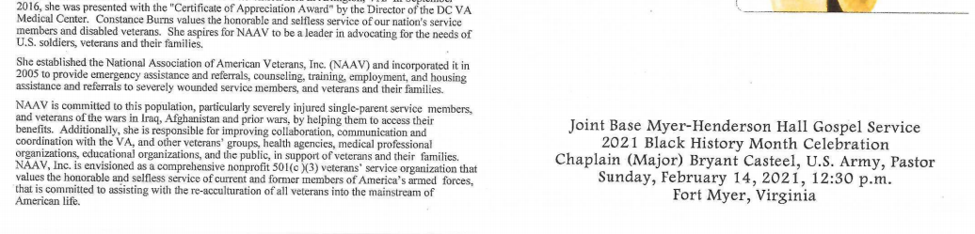

SOLDIER’S HEART: NONCOMBAT WOUNDS OF PTSD by Phemia Gabriel
“Over the weekend there was an article published about your installation.
It is all over the internet about 18th Airborne Corp in Fort Bragg, NC
and how former General now Secretary Defense Lloyd Austin and how he is
looking for ideas from survivors about “US ARMY crowdsourced ideas to
combat sexual assault crisis”.
As a prior 7 year Army veteran from 2011 to 2018 with Military Sexual
Assault issues; Here is the book I published last year as a resource guide to help
current services member and veterans transitioning back to civilian life
after sexual assault in the military. I combine my law enforcement
training and military experiences on how my cases were handled to help
others.
Point of Contact. I can be reached here or (253) 266-0017.
This book is also free on Amazon.”
Very respectfully,
US ARMY RETIRED
PHEMIA GABRIEL, SPC

International Day of Prayer -
- A poem presented during the National Day of Prayer, February 2021, submitted by a Robert Longley, who write/re-writes poems for Gold Star families. To review more, please visit website: https://www.sacredpoems.com
Time to come home dear brother
Your tour of duty through
You’ve given as much as anyone
Could be expected to do-
Just a few steps further
The smoke will start to clear
Others here will guide you
You have no need of fear-
You have not failed your brothers
You clearly gave it all
And through your selfless actions
Others will hear the call-
So, take your place of honor
Among those who have gone before
And know you will be remembered
For now and evermore.

ABOUT (the previous) INSPIRATIONAL POEM
A Hero’s Welcome was originally written for a Hartford Firefighter who perished in a home fire. I’ve created numerous version of this for police, fire and military. It is readily available in different formats for sympathy cards or memorial prints. I currently have versions for all services and most combinations of officer and enlisted. Unfortunately, I do not have a full compliment of female military, fire or police figures. (If you have some good examples please contact me. They are difficult to find and I have avoided having people pose for this poem. I prefer not to know who they are, and I think that’s important for the message of the poem.)
For poetry products or artwork based on the poem A Hero’s Welcome or other poems- check here . For signed poetry prints contact us directly.

On behalf of NAAV, please help NAAV by sending electronic donation message to your friends and business associations including corporations and foundations to give to NAAV, Inc. on behalf of those who served and are serving in the U.S. Armed Forces worldwide. To Give visit www.naavets.org click on DONATE TODAY! Thank you!
Have a wonderful Spring-time experience!
Sincerely,
o/b/o CEO/President
NAAV, Inc.
Washington, DC

Please note, NAAV does not endorse all resources provided herein; however, we are sharing as potential interest for your determination and value.

