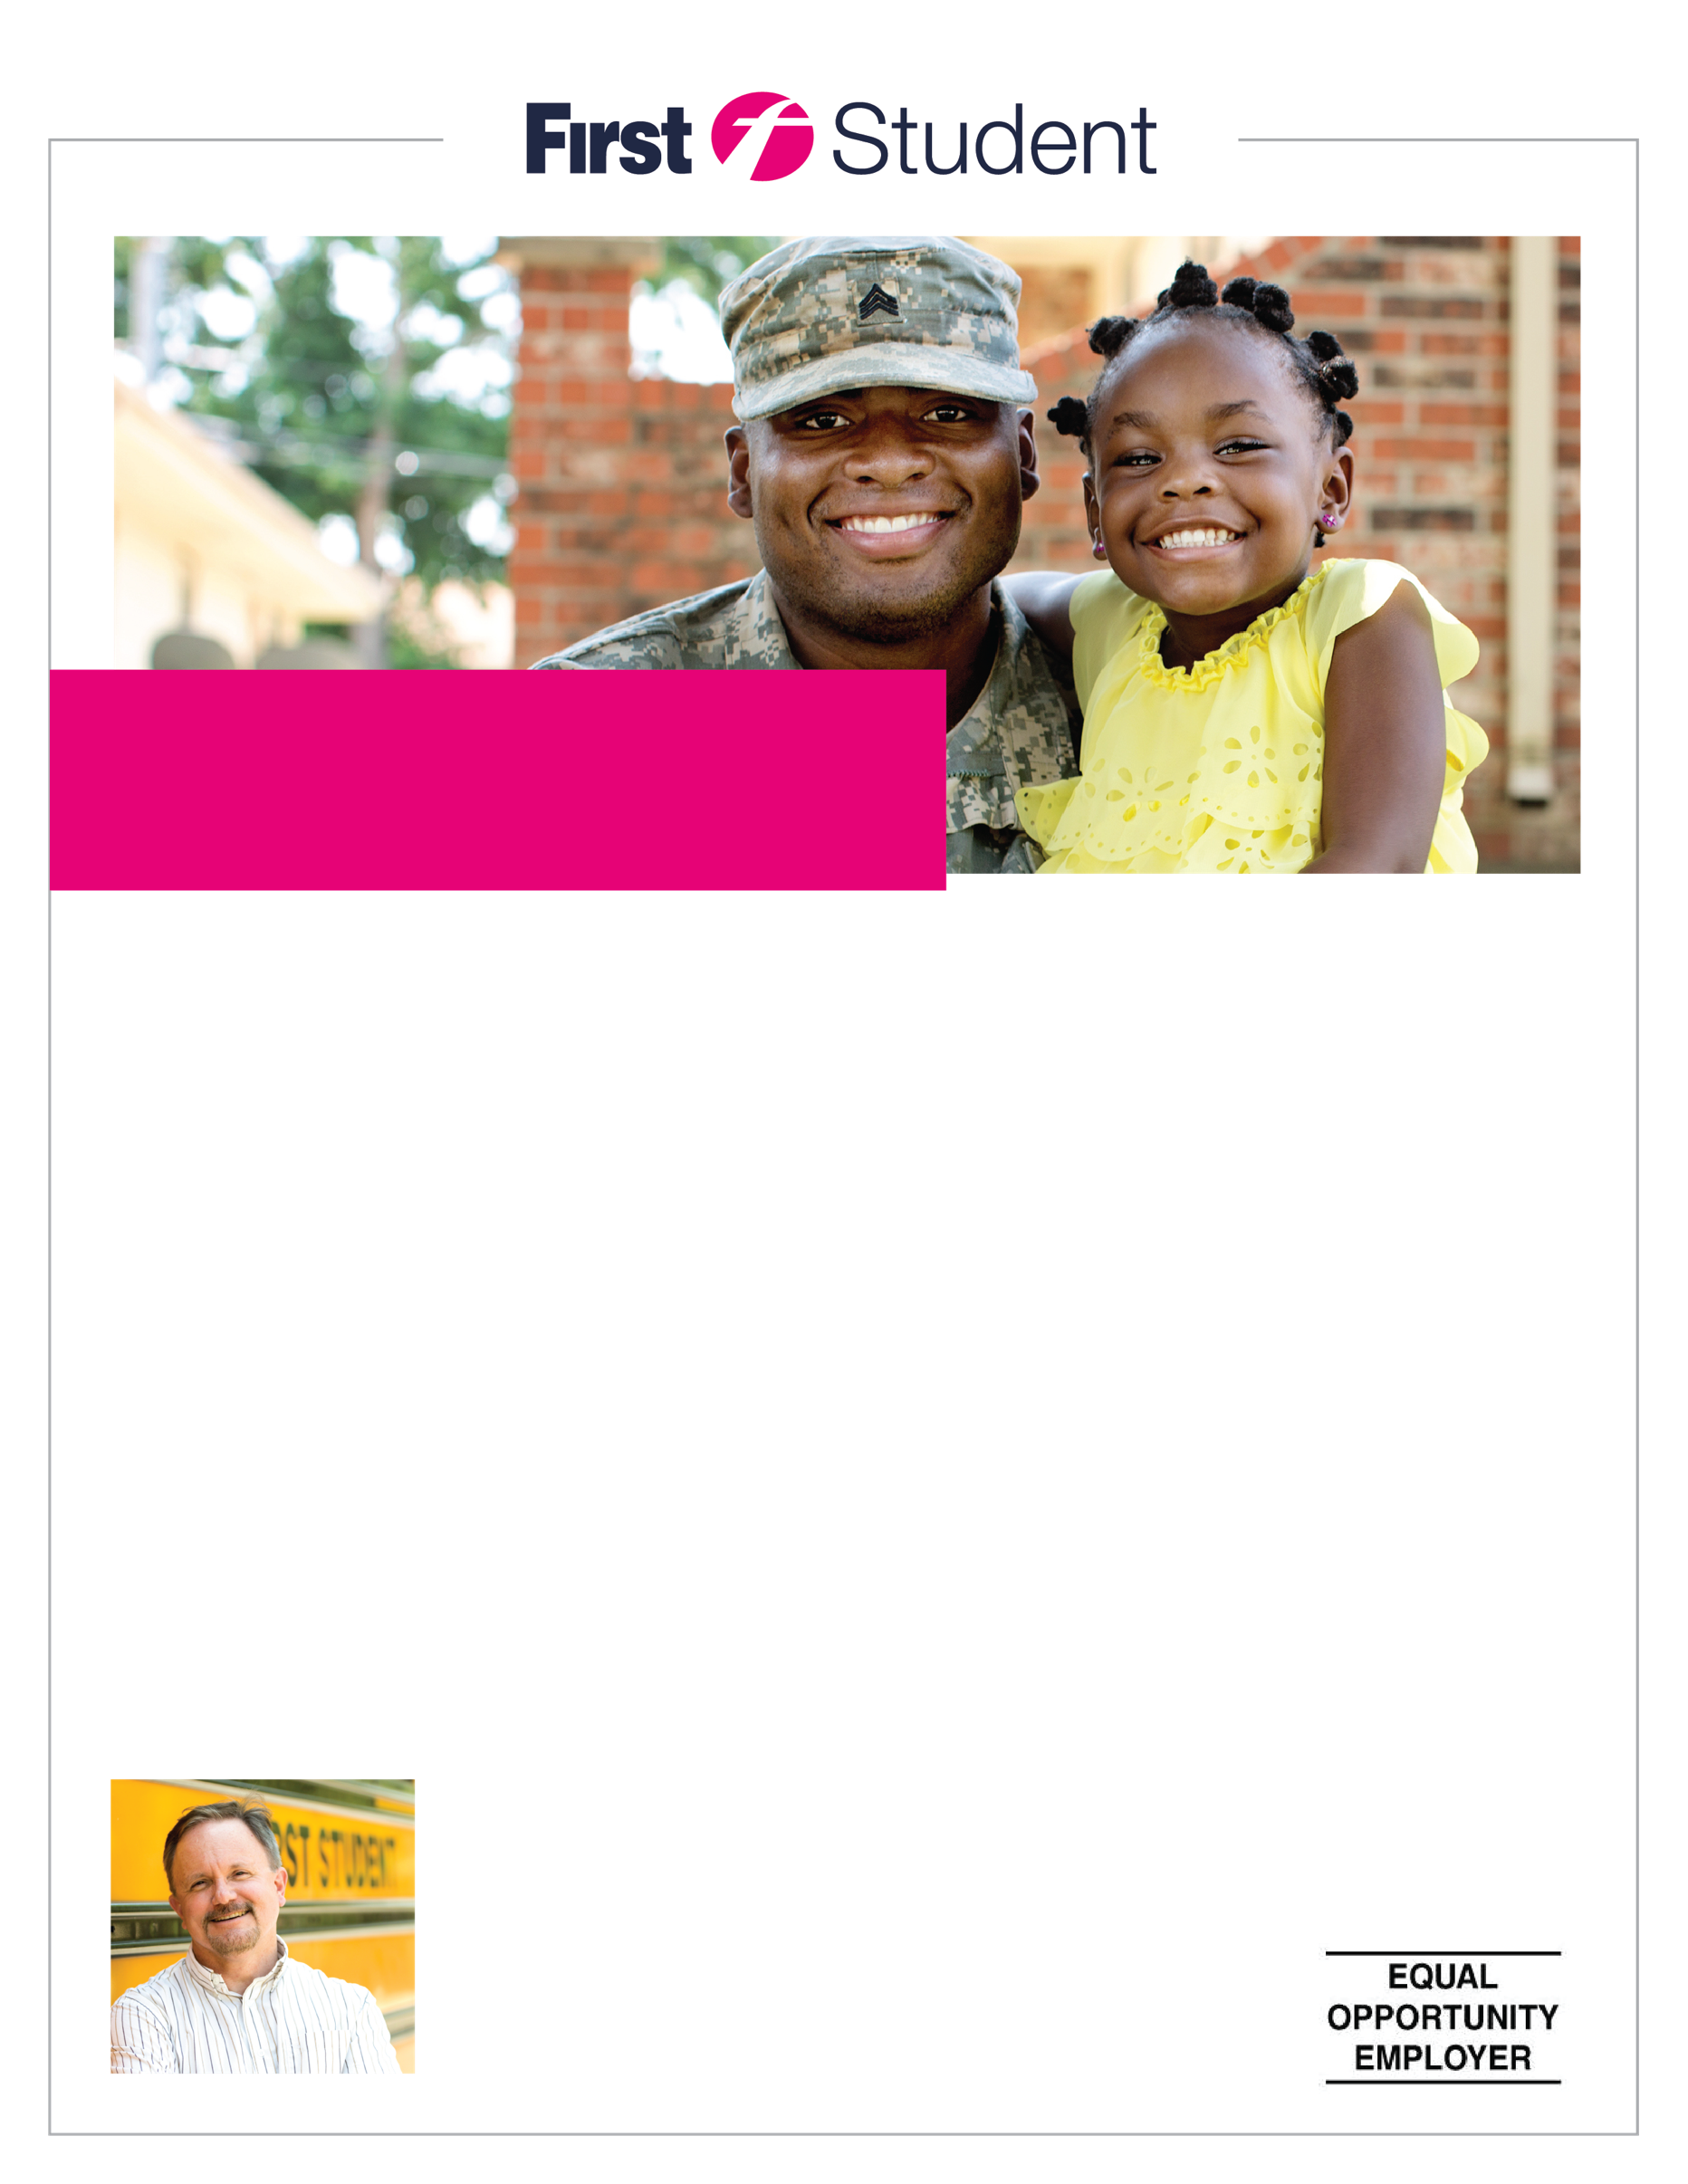

*Bonus expires 5/2021

**APPLY ONLINE:**

[**FirstGroupCareers.com**](http://apply.firstgroupcareers.com/)

(410) 760-5968

762 Queenstown Rd,

Severn, MD 21144

FIRSTGROUPCAREERS.COM

**We are proud to offer:**

At First Student, our Bus Drivers are an integral part of the communities they serve.

They are committed to safety, customer service and have genuine, caring attitudes

for children. We are your friends, family, and neighbors!

To qualify, you must be at least 21 years of age, have a valid driver’s license, a safe driving record and be subject to a background check and drug test.

**We’re looking for you!**

**NOW HIRING PART-TIME**

**SCHOOL BUS DRIVERS**

• $2,000 Sign On Bonus for Fully Licensed CDL Drivers!*

• $20.60/HR Starting Wage

• Child Ride Along Program

• Competitive Pay and Benefits