October, November, December
Quarterly Newsletter ~2020~
Fall into Winter… We go. All for you!  …The sign of seasons to come.  ~ ~ ~ | 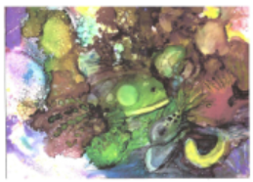 | This Quarter  We’ve passed through summer, poised, and isolated at home. We’ve lost many of our common freedoms or at least have come to live within limits… calculating and judging our every move.  The Autum months are ending as we fall involuntarily into a new season that nature has waiting...Winter. It can be cold and unpredictable. It can be beautiful, and playful with white snow and Christmas lights.  Winter. It can also be dark and dangerous with bitter cold winds and ice. But, nothing can stop what is already set in motion to come. We except it, because that’s what seasons do—they come and they go showing forth their cast of characters that we’ve grown accustomed to.  COVID-19 or the Corona Virus has unfortunately been a part of all four of our 2020 seasons. And who knew… But, God.  This pandemic has captured the world’s attention. Adults and children alike have been made aware. NAAV has been steadfast, adjusting to every season, as advocates for our Nation’s Veterans.
tHIS 4TH QUARTER IS COMING YOU AS A TESTAMENT OF STEADFAST FAITH AND HOPE. 2020 BEGAN WITH UNEXPECTED CHALLENGES AND AS WE COME TO THE END OF A YEAR NO ONE COULD HAVE PREDICTED, WE MUST CHOOSE THE LIGHT. | *Photo from Featured Story by Rose Marie Mikolajczyk-Baker
4rd Quarter

 |  | 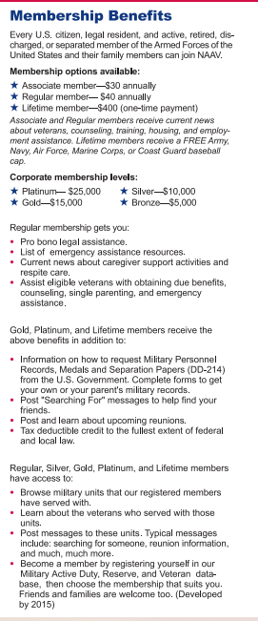

Tips on managing  the Covid-19 and the holidays by Mary Sprague, NAAV Volunteer  The holiday season is splendid! It is a time to celebrate with family and friends and participate in joyous events. But 2020 has disrupted all of our lives. The COVID-19 pandemic has caused financial problems and health scares. While we can’t shake off the year just yet, that shouldn’t stop us from celebrating. That said, what can you do to ensure you won’t break the bank this holiday? Check out some ideas  *Discuss Holiday Plans  This year especially, many have experienced financial insecurities. One approach is to have discussions with your close friends and family to share holiday plans and ways the family can support each other during these difficult times.  *Create a Holiday Budget  Most people shy away from setting budgets. I know. It seems constricting and the need for a lot of math! But don’t despair. It’s easier than you think. Start by identifying how much you can spend  *Remember There Will Always Be Another  Impulse buying is the killer of budgeting and financial stability. And it is so easy to fall into that trap! When you see something that is shiny and new, remind yourself you will always be able to find another thing you find tempting. Is it part of your holiday budget? No? Then drag yourself away.  .  Time to enjoy a story about an American Veteran and the created beauty behind the story:  Rose Marie Mikolajczyk-Baker, Photojournalist, Freelance Writer, and Artist  Rose Marie Mikolajczyk-Baker, an award-winning artist invited twice to the Winner’s Circle Show in Fort Myers, Florida, has donated over forty of her paintings in support of our nation’s Veterans and their family members most in need due to the COVID-19 pandemic outbreak in 2020 worldwide. Born in Cuyahoga Heights, Ohio, in May 1934, she moved to Somerset, Kentucky, in 2000. Twenty years later, she now resides at the City Center Senior Facility in Decatur, Alabama.  Rose Marie began her career as a photojournalist in 1969, covering all phases of news, social events, and feature stories in Charlotte County, Florida, and northern Ohio. She was woman’s editor for the Charlotte Herold News, assistant editor of the Charlotte Chronicle and bureau chief of the Fort Myers News Press.  Her work experience included public community relations at the St. Charles Borromeo Catholic Church and School. She volunteered at the St. Alexis Hospital as a public relations assistant and the West Side Community Mental Health Center, where she was responsible for the Clearinghouse and  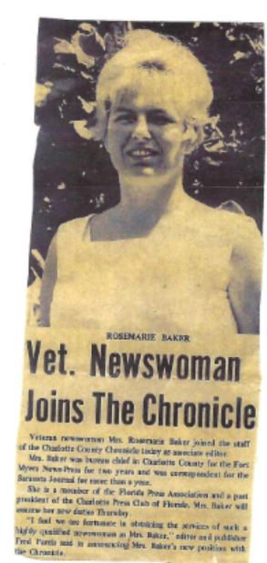  Rose Marie Mikolajczyk has had a lifelong interest in the visual arts and has explored many different mediums. Her subject matter runs from traditional to imaginary to the visionary. Her painting styles are many, depending on the subject matter, and can be realistic or a combination of expressionism and abstraction. She was a She was a three-year member of the Sea Grape Artists co-op in Punta Gorda.  She taught watercolor and pen-ink at adult education. She was past member of Sea Grape Artists, the Help DAN, a drug abuse program for county school kids, and Big Brothers of Charlotte County.  Paintings by this award-winning artist are shown here. Her work is in many private collections in Ohio, Kentucky, Virginia, and Florida.  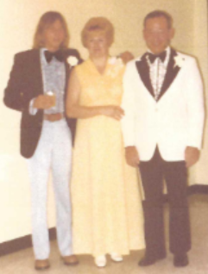  On March 17, 1972, Rose Marie Mikolajczyk married Lieutenant Colonel Richard D. Baker of the U.S. Air Force.  About Lt. Colonel Richard D. Baker  Lt. Colonel Richard D. Baker was born on February 24, 1920. He enlisted in the U.S. Army in 1941, and transferred to the Army Air Corps after recovering from a head injury. He became a Pathfinder and later flew supplies to Germany during the Berlin air lift. He served in Japan under General Douglas MacArthur, and later in Vietnam.  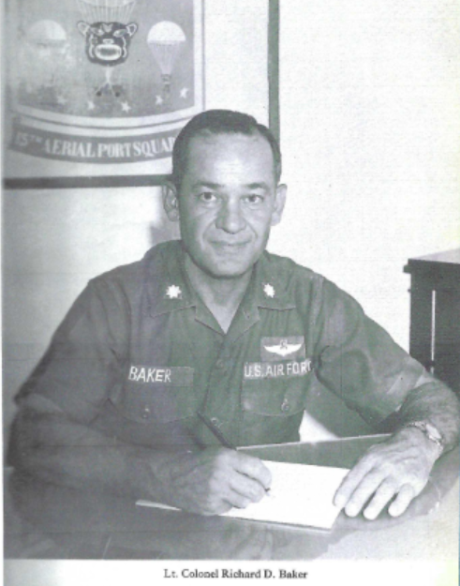  His long list of foreign assignments starts in Bermuda in 1946, with his next assignment in Germany, where he participated in the Berlin airlift. After six years in Germany, he was sent to Azores, where he held the position of  Rose Marie is pleased that her lifetime collection of paintings, drawings, computer designs, and prints such as woodcut, intaglio, and copper etchings will benefit American Veterans. Although she studied art in college and at art workshops, she is mostly self-taught, quite an accomplishment for someone who had two major single artist shows. She was a member of the Charlotte County Art Guild, the Kiwanians, and several other community organizations. She claims that art sooths her soul and she gives thanks to God for this blessing.  While at the newspaper in Punta Gordo, Florida, Rose Marie and the publisher hosted weekly wine tastings and art shows. It is suggested by the family that those who acquire one of her art treasures should attach a copy of this disclosure to it so that your heirs understand its significance. Heirlooms and family treasures are often disposed of because the receiver is unaware of its history and family significance.  Mrs. Mikolajczyk-Baker became aware of the National Association of American Veterans, Inc. in a discussion with Mr. Aaron N. Spencer, a NAAV Senior Advisor, both of whom live at City Center Village, an independent living community in Decatur, Alabama. Also assisting with Rose Marie’s story was Al Kuchinka at the City Center Village in Decatur, Alabama.  Submitted by  Aaron N. Spencer  Senior Advisor, NAAV, Inc.  NAAV is proud to serve all Veterans and their family members during 2020 and throughout the next New Year 2021!  NAAV’s 2020 Closeout Testimony….  What can be said about this year other than “Be still and know...” (Psalm 46:10)  In 2005, Constance A. Burns established a 501(c)3 organization dedicated to assisting Veterans and their dependents find and secure vital support.  Now 2020, Constance is the CEO and President. She is tireless in her effort to network, negotiate, collaborate, and secure funding on behalf of US Veterans everywhere.  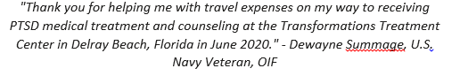  This past year brought the Covid-19 pandemic. Fundraising for 2020 and beyond have been especially difficult, and yet Constance has been busy paving avenues for Veterans battling PTSD, Traumatic Brain Injury, Depression, and Anxiety by taking steps to work in partnership with a VA/FR Specialist, Mr. Fatigante.  Constance Burns secured emergency assistance for Dwayne Summage, a Navy Veteran to ensure his safe arrival to the facility in Delray, FL in June. Mr. Summage is now receiving the necessary treatment for PTSD, and NAAV is looking forward to assisting even more Veterans as this partnership comes to fruition.  This past June, Mr. Fatigante, posted a note of encouragement and forward progress to Ms. Burns, which read:  “Dwayne (a client in the program) is doing well. I am going to make a point to go and visit him this week. Also, I will be telling my testimony at the center this weekend. I still thank God that you and I were brought together for a bigger purpose.”  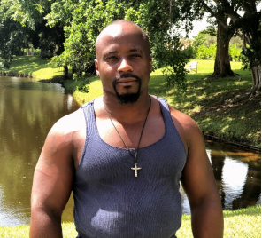*U.S. Navy Veteran, Dwayne Summage  NAAV has a history or stepping in at the vulnerable times for veterans… See 2014 testimonial clip ~  *For the full article, pleae refer to COMMUNITY magazine JULY & AUGUST 2014 | for the holidays. Determine how much you hav e to spend by going through  your earning statements, bank statements, and other banking information. Set a spending limit so you know exactly what your available cash and savings are. This way, you won’t have to worry about potential debt.  *Start a New Tradition  This is a new year – a situation that none of us have faced before. Take advantage of the change and look to do things differently going forward. Maybe start a tradition to set aside a percentage of your holiday budget to donate as a family to a local charity. This gives the family the opportunity to talk about important community values, sharing those values with the children and getting them involved with the conversation. And it is always a wonderful feeling when giving to others. Bonus – all money donated to approved charities is tax deductible!  *Do Your Research and Buy Early  Before you buy, browse the web and look at other retail stores to do a price comparison. Read reviews before purchasing product. Consider purchasing items of higher quality. Cheap products can break easily and just waste your money.  Finding ways to make it through the holiday season is important now more than ever. With careful planning, smart budgeting, and open communication, you might find yourself stressing less and enjoying the holidays more. (For read the full article, visit the NAAV website at www.naavnets.org under "What's New"; "Organization News"; "Veteran News" tabs.)  When Charity Begins… It Never Ends….  NAAV was one of several organizations that participated in a “virtual CFC Charity Fair on December 16, 2020  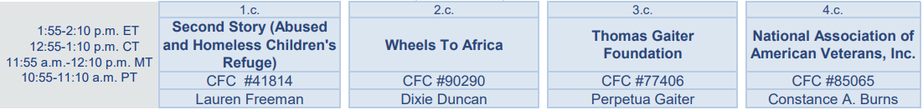  NAAV’s CEO and President Constance A. Burns presented at this event on Wednesday. NAAV is a participant in the CFC registered under CFC #85065. Feel free to “show some love” in your new year of giving.  ***As a reminder: The CFC, the largest workforce charitable giving drive in the world, will began on September 21, 2020 through January 15, 2021. The campaign theme, Show Some Love: Be the Face of Change, focuses on the impacts and causes, donors care about. It is complemented by Show You Care messaging, which expresses the volunteer component of the campaign.  Inside West Side (two newsletters), news releases, and public service announcements.  three-year member of the Sea Grape Artists co-op in Punta Gorda.  She taught watercolor and pen-ink at adult education. She was past member of Sea Grape Artists, the Help DAN, a drug abuse program for county school kids, and Big Brothers of Charlotte County.  Paintings by this award-winning artist are shown below. Her work is in many private collections in Ohio, Kentucky, Virginia, and Florida  She was active in the Aids Ministry in Charlotte County in Florida.  In 1965 and 1966, Rose Marie attended the Cleveland Institute of Art in Ohio, with an emphasis on drawing. She also attended the Cuyahoga Community College in Parma, Ohio, receiving instruction from Professor Sharlene Pearl Green in 1989. Then, in 1992, she attended Manatee Community College in Venice, Florida, receiving instruction from Professor Kate Korp in graphic arts, design, woodcut, and monoprints. She also studied with such noted artists as Gale Bennett in acrylic abstract; Max Muller, watercolor; Marcia Stewart of Fort Myers, Cooper Etching, printmaking; and Skip Lawrence, watercolor.  1.Blackeyed Susans  2.In My Garden  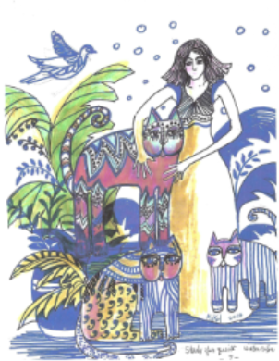  3. Kate Cats  Traffic Manager, 1605th Transportation Squadron. In 1965 he went to Southeast Asia, taking command of the 441st Transportation Squadron, Yokota Air Base, Japan. Also, in the same year, he spent ninety-five days TDY in the SEA area. On November 29, 1966, Lt. Colonel Baker departed for an assignment as 15th Aerial Port Squadron Commander, Da Nang Air Base, Republic of Vietnam. Lt. Colonel Baker’s decorations and medals includes Army Commendation Medal; World War II Victory Medal; Berlin Airlift Device; Distinguished Unit Citation; Vietnam Service Medal (with one bronze service star); and Medal for Humane Action.  He retired from the US Air Force in 1971 and later worked at the Pentagon. He moved to Port Charlotte, Florida where he accepted a position as Development Authority Director. There he met news reporter Rose Marie Mikolajczyk. Together they were active in Big Brothers of Charlotte County, the Knights of Columbus, and the Help D.A.N. Program and the Kiwanis Club. They were married on St. Patrick’s Day on March 17, 1972. He passed on July 27, 1975, at the Walter Reed Army Hospital in Washington, D.C. on the 200 Year Anniversary of the Hospital. Mrs. Rose Marie Mikolajczyk-Baker donated selected drawings of her art collection to the National Association of American Veterans, Inc. (NAAV) for sale in honor of her husband Lt. Colonel Richard D. Baker for his years of military service to our nation and local communities.

The Holly
The holly or holly berry bush has been symonomous with Christmas throughout history. Why? According to some reports, the holly bush is a symbolic of the “crown” of Jesus that was placed on His head at the time of crucifition. The pricky needles are said to represent the “thorns” of the crown, while the [red] berries are said to represent Jesus’ “blood.” But have you ever noticed how beautiful the holly is—whether standing along in all of its green slendor or artfully distinguished carrying its red berries— So ironic that it’s a significant reminder during the Christimas season… The season when Christian celebrate the brith of the world’s long awaited Messiah… Our King.

“O’come let us adore Him… Christ our Lord.”

The year 2020 will ever be etched in our mind almost as a reminder of the story “when time stood still.” We hurt, we lost, we questioned and yes, were drawn to days of doubt and fear as our lives turned uncontrollably upside down. The Bible says that, “the day of the Lord will come like a thef in the night… no one will know that date or time… except only the Son.” As we move towards the end of year no-one-saw coming, we also enter in to a season of hope… of love, joy and peace. May your following days be met with the presence of God and His blessed assurance that He will not leave us as orphans, but instead will send us a comforter, who will be with us and who will guide us into all truth. (Ref. Bible verses: Matthew 24:36; John 14:18; John 14:16; John 16:13;)

NAAV will like to be a reminder to all Veterans and their family members of the comfort in knowing that some one cares and is there to support and assist your needs. We still face uncertain times stepping into 2021, but we will do this together. Let not forget to serve one another.
On behalf of NAAV, thank you for your love, support, and prayers this year. We look forward to bind with you all in the good fight of faith!
May God bless and keep you… may the Lord shine His face upon you and give you peace ~ (Numbers 6:24-26)
MERRY CHRISTMAS ~ HAPPY SAFE AND BLESSED NEW YEAR!!!
Warmest wishes,

Constance A. Burns
CEO and President
NAAV, Inc.
Washington, DC
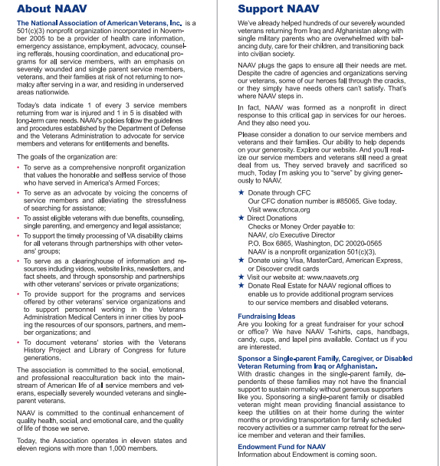  “Caring for those who gave so much” 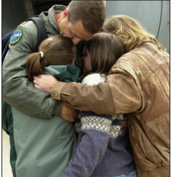 | *If you would like to join us in our 2021 support endeavors, please visit our NAAV website for more information about this Veteran Service Organization (VSO).  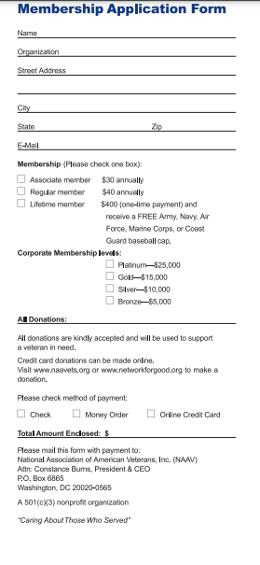

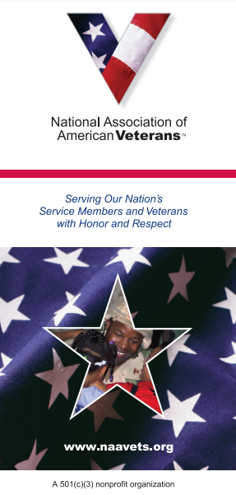
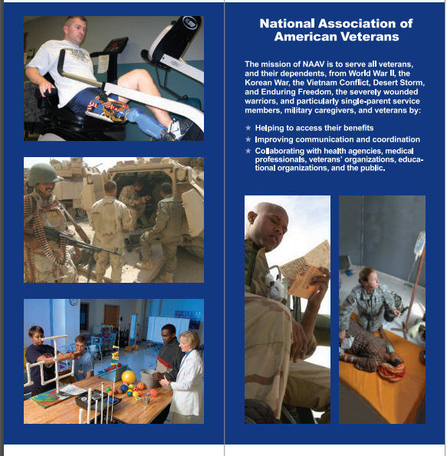

Design Explored.

