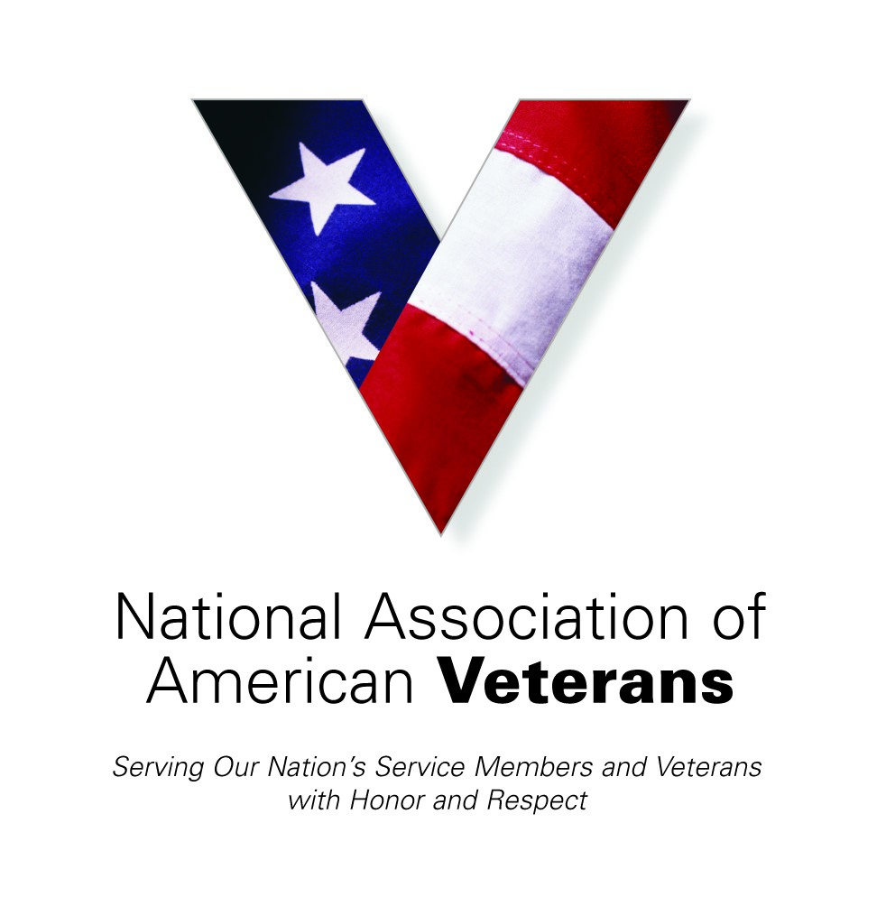
July, August, September Quarterly Newsletter
~2020~
 | 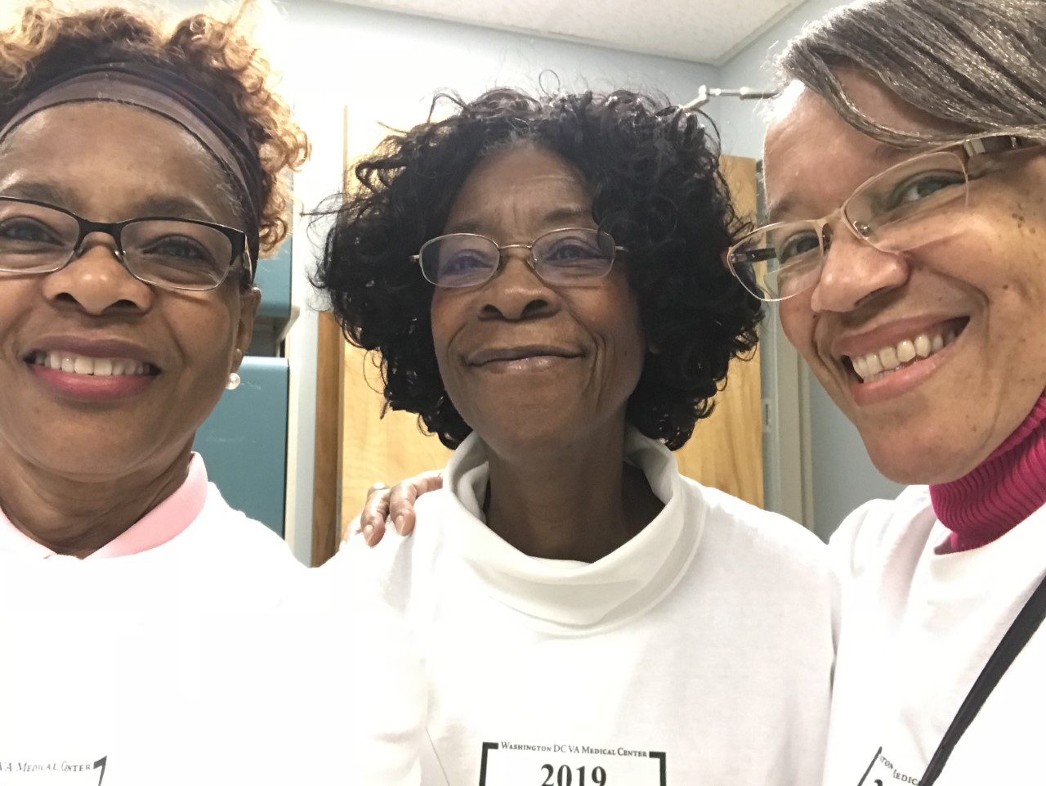 | Summer in full bloom  Thank you for joining us for yet another occasion to share with you the many blessings furnished this summer despite the heighteningmanifestation of COVID-19. Many times new life becomes from a fallen leaf. You have them, I have them, you have them… The seeds of generosity. Without you our fertile ground would be left empty and dry and our Veterans would have nothing to pick from to fill up their lives once again with comfort and joy.  The past summer months during this pandemic were status quo for NAAV and maybe more so as Veterans and their family members  suffered pain, hardship, and loss. Thankfully, NAAV was there to support yet in a new and more dynamic way. I have heard that when a person stresses, his or her eye sight narrows and becomes like a single focus. This pandemic has the attention of not only the world, but also NAAV.  We see, we hear, and we care about our Veterans.

The summer months have been trying to say the least. But warmhearts create kind smiles

3rd Quarter

 |  | 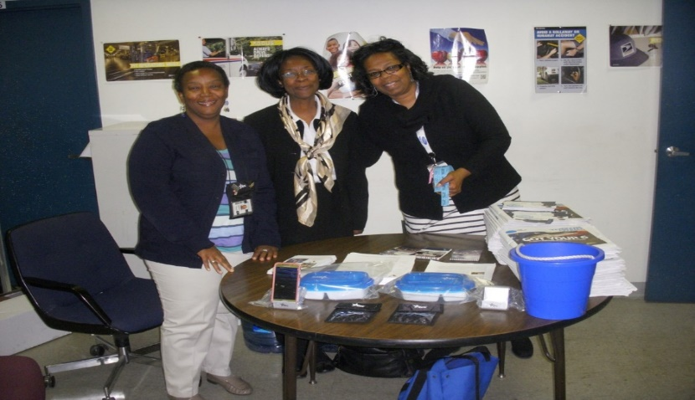
NAAV Partners  NAAV Major Partners and Sponsors  TracFone Wireless, Inc.  TechAnax LLC, Virginia  Burns & Levinson LLP  SafeLink Wireless  Special Kids Fund, Inc.  Thrivent Financial Foundation  Amazon, Inc.  GEICO Direct  TD Bank  The Veterans Law Firm  Salamander Resort and Spa  Cabel Foundation, Inc.  Sheppard's Hands, Lexington, KY  Figures for Visitors to NAAV's website  January 1, 2019 to September 4, 2020 --47,000.000  Past month... 551,000  September 4, 2019 to September 4, 2020 -- 1,700,000From the number of viewers NAAV receives on any given day, you contritutions go a long way in helping ups to serve. Please remember to give. Any mount from $1.00-$1,000 supports our Veterans and their family members.  This year, more than ever the CFC or the Combined Federal Campaign was a spark egnited by NAAV’s drive and commission to participate…  The National Association of American Veterans, Inc. (NAAV), motto “Caring About Those Who Served” will participate in the 2020 Combined Federal Campaign (CFC). NAAV’s work empowers and inspires the generosity of the federal employee community and working together with the CFC can have a positive impact. The 2020 Combined Federal Campaign Charity Fair Kickoff events will be conducted virtually due to COVID-19 worldwide pandemic.  NAAV and other nonprofit organizations have been asked to participate in the CFC Virtual Charity Fair by sending their stories, photos, and videos that will be accessible at GiveCFC.org and all local zone websites.  The CFC, the largest workforce charitable giving drive in the world, will began on September 21, 2020 through January 15, 2021. The campaign theme, Show Some Love: Be the Face of Change, focuses on the impacts and causes, donors care about. It is complemented by Show You Care messaging, which expresses the volunteer component of the campaign. | 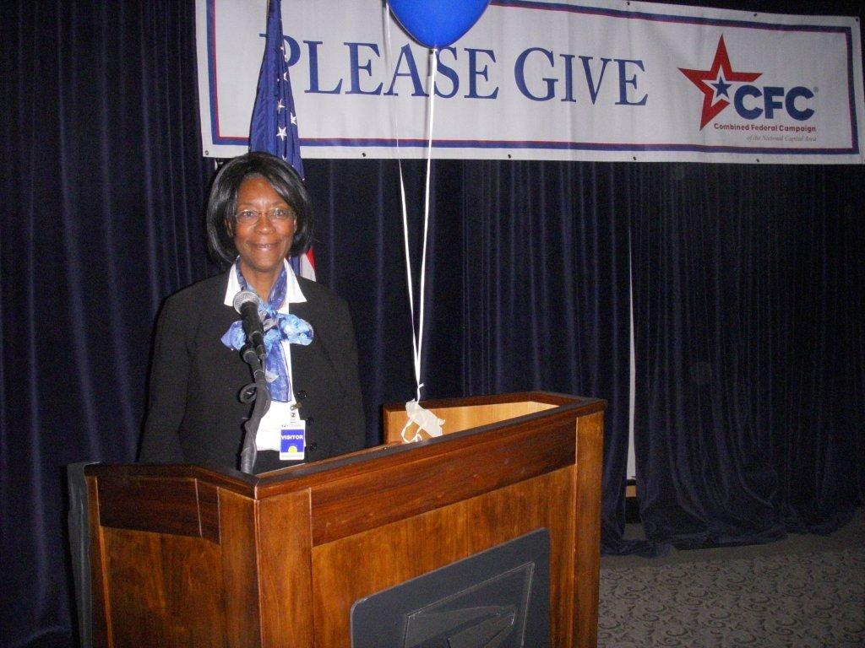

Sharing vital information during the COVID-19 pandemic crisis:
EXTENSION CORNER: RESOURCE LIST FOR THOSE AFFECTED BY THE CORONAVIRUS
>
> Are you in any distress because of the coronavirus? Are you wondering
> what to do next?
>
> If you are, this may be the resource list for you to help ease your
> burdens. Below are 30 resources that are available to help those
> affected by the coronavirus. Please feel free to explore them.
>
> About the Free COVID-19 Student Loan Aid Tool:
> https://crisishelp.bysavi.com
>
> Banks Offering Relief To Customers Affected By Coronavirus:
> https://bit.ly/2Q4d7Rd
>
> COBRA: If you lose your job and it provided your health insurance, you
> can keep your coverage for up to 18 months if you pay for it yourself
> (which typically makes the cost significantly higher).
> https://bit.ly/3iQEnPw
>
> Community Supported Agriculture: https://bit.ly/3gb192X
>
> Coronavirus Emergency Loans Small Business Guide and Checklist:
> https://bit.ly/2YfabFP
>The National Housing Law Project state-by-state list of eviction
> moratoriums: https://bit.ly/32iFYan
>
> The National Restaurant Association Educational Foundation relief fund
> provides $500 grants to restaurant industry employees who have been
> impacted by COVID-19: https://rerf.us
>
> How to Spot Student Loan Scams: https://bit.ly/3iQWOUg
> What the CARES Act Means for Repayment of Federal Student Loans:
> https://bit.ly/3aB16w5
Is this something you are interested in… Check out the services provided:
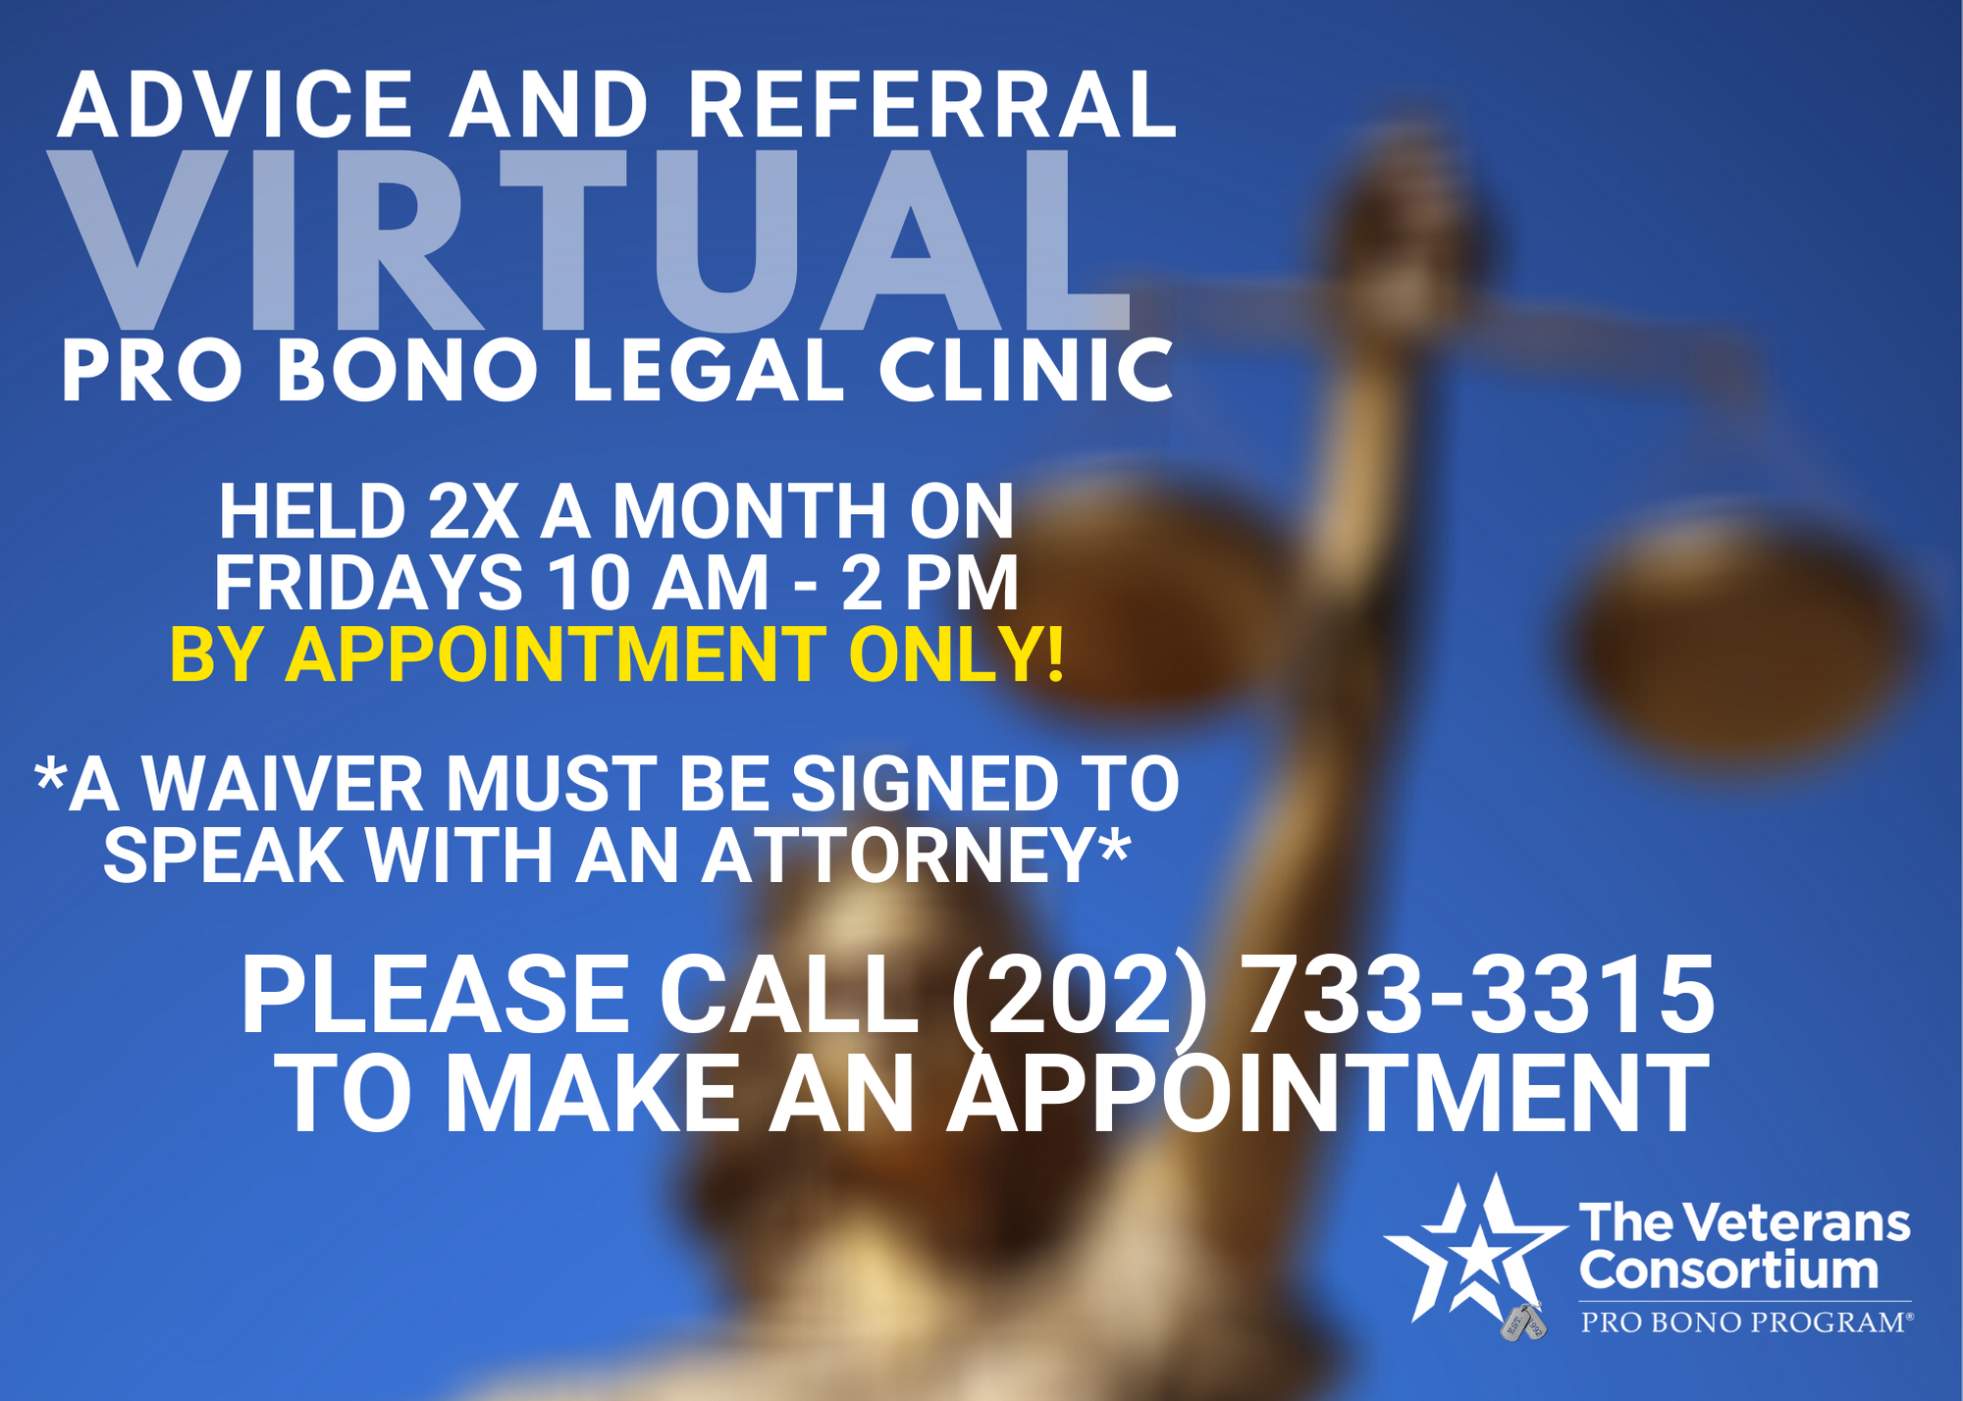

HHelp is available…
The Veterans Consortium & the Washington DC VA Medical Center has partnered with local law firms and DC area law schools to staff The Veterans Pro Bono Legal Clinic. Due to COVID-19, this clinic will be held virtually, via phone or video chat, two Fridays a month
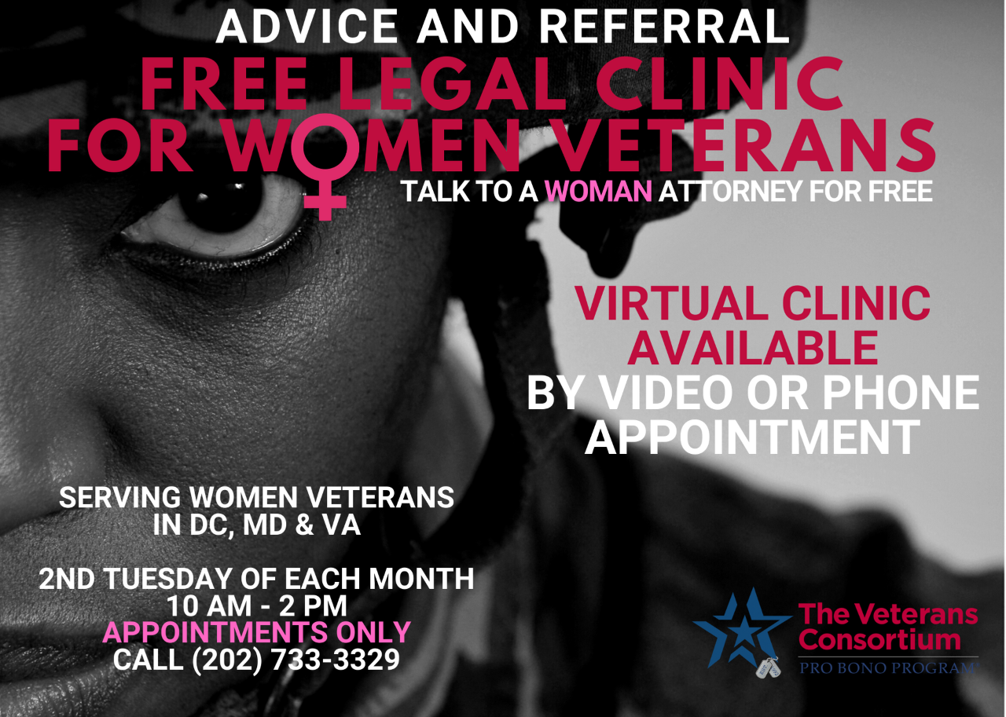
NAAV supporters come to the aid of a veteran in need of assistance… Simple acts of kindness in the mist of storms. Rainbow really do—still—appear.  … A testimonial note to NAAV….Hi,I just wanted to thank you so much for having Corine calland answer myquestions so promptly. Besides being extremely pleasant, she was very helpful and informative. I'm going through a difficult time and she made this process easier than I thought. She truly is a sweetheart and a real asset to your group.  Thank you again  Joe Donati | NAAV, Provided assistance to another veteran in need this summer… Thanks to your support and donations to back up this organization as we reach out to those in need:  Mrs. Amina Higgs is an OIF 100 percent disable Veteran residing in PalmBay, Florida. NAAV paid for the estimate and its Partners at the Home  Depot ensured that the AC Unit was restored. Her spouse is also disabled  and not able to work.  “I would just like to thank NAAV for all their help with my situation. I  am a disabled veteran who lost her niece two weeks ago and who is caring  for her children because my sister who would have been caring for them  is caring for our mother who is on hospice care at home. My AC went out  on Christmas Day 2019 and I have been unable to get it fixed but because  of NAAV we are not burning up all day everyday. May God Bless this  organization and the CEO.”
 | NAAV is proud to serve all Veterans and their family members!

A Moment of Meditation

Putting on the Whole Armor of God
Ephesians 6:11-13 says, “Put on the whole armor of God, that you may be able to stand against the wiles of the devil. For we do not wrestle against flesh and blood, but against principalities, against powers, against the rulers of darkness in this age, against spiritual hosts of wickedness in the heavenly places. Therefore, take up the whole armor of God, that you may be able to withstand in the evil day, and having done all, to stand.”
During this unprecedented time of quarantine due to the coronavirus (COVID-19) pandemic outbreak and as our normal schedules have drastically changed, we can either fill our days with anxiety and fear, watching the daily news headlines, or we can open our Holy Bible and read God’s comforting Scripture verses of hope to guide you through these perilous times.
The Armor of God
Ephesians 6:10-18 says, “… Be strong in the Lord and in His mighty power. Put on the full armor of God so that you can take your stand against the devil’s schemes.”
The whole armor includes the
. The Helmet of Salvation
. The Shield of Faith
. The Breastplate of Righteousness
. The Belt of Truth
. The Sword of the Spirit
. The Gospel of Peace

Prayer—“For I Will Not Leave You Comfortless,” Declares the Lord
Prayer:  Heavenly Father, please help us to put on the full armor of God so that we can take our stand against the devil’s schemes. For our struggle is not against flesh and blood, but against the rulers, against the authorities, against the powers of this dark world and against the spiritual forces of evil in the heavenly realms. (Ephesians 6:10-18). Lord God, You have given us Your word and Spirit so that we will have the wisdom and protection to stand against the enemy. Lord God we know that You are in control and no matter how cruel and vicious the enemy’s schemes, he can never chain our spirits that have been set free by Jesus Christ. Lord God we need Your word far more than we need the news of the world. We know that this quarantine is no surprise to You. And maybe You are allowing this season of uncertainty so that we will recenter our lives on Your will and purpose for our journey on earth. Lord, we may forget at times … that this world is a battlefield. Every day we face a spiritual war with the enemy of |  | our body, soul and spirit which comes from the forces of darkness, led by the devil whose main objectives are to kill, steal and destroy. The devil does not care if we are not prepared and prayed up for the new day. He does not want us to be prepared. Lord, please help us to fast and pray, watch and pray, pray one for another, and to pray without  ceasing with songs and praises to You our blessed Creator, LORD and Master. In the name of our Lord Jesus Christ, we pray. Amen.  *All Scripture verses are taken from the New King James Version of the Holy Bible.  By Constance A. Burns, NAAV Contributor for Moments of Meditation and Scriptural Readings; email: cburns@naavets.org.

Operation North State~  Each year, Operation North State prepares a box for our deployed  soldiers and send to them around Christmas time.  With the COVID-19 pandemic, this mode of operation has become nearly  impossible because of the restrictions placed on shipping due to the  virus.  In light of this, Operation North State and the Department of Military  and Veteran Affairs have decided to provide our “shut in” Veterans  in North Carolina with these boxes.  The goal for Operation North State is to provide and package 800 - 900 Boxesto share with North Carolina’s “Shut-in” Veterans this Christmas.  Operation North State has many corporate sponsors that supports and provides about 1500 items each year and this year they all love the “shut-in” veteran distribution/recipient idea.  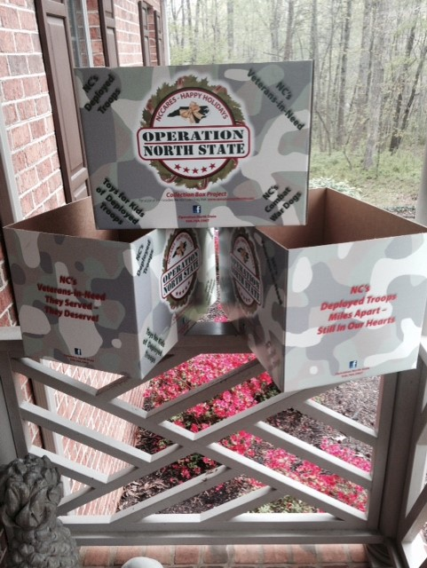 | 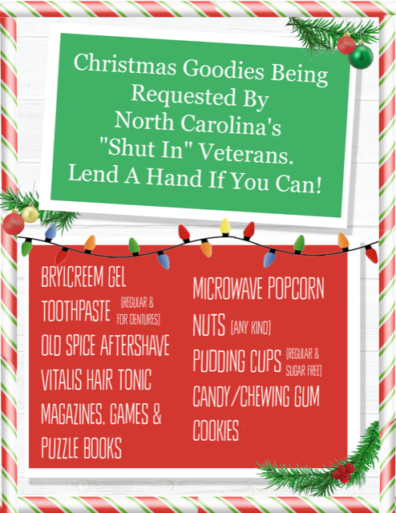  *POC: Mr. Terry Snyder c/o Martin D. Falls, Chief Deputy Secretary  North Carolina Department of Military and Veterans Affairs  984-204-2980 office

